Chapter 9 Project: Tropical Forests Forever?

Name ____________________________ Name _________________________

Name ____________________________ Name _________________________

Introduction
Compared to other major types of ecosystems, tropical forests contain the greatest amount of plant material or plant biomass per area. Biomass is defined as the total mass of organisms (plants, animals, and others), both living and dead, in a given area or volume. Tropical forests have a high plant biomass because of high rainfall, warm temperatures, lack of extreme seasons, and sequences of plants at different heights starting at the forest floor. There are many ways to express plant biomass, including the total mass or weight of all the vegetation. In this project, we will just use the mass of carbon found in plants, the carbon content, as a “proxy for” (i.e. a measure of) plant biomass.

1. Calculating hardwood carrying capacity
a) The mean (average) plant biomass on 1 square meter of mature tropical forest is approximately 20 kilograms of carbon (20 kg C).* Larger units of measure will be easier to work with in the up-coming calculations, so start by reconfiguring this number to reflect the amount of plant biomass in megagrams of carbon (Mg C) in 1 hectare of mature tropical forest. Show units and work. Note: 1 hectare = 10,000 m²; 1 Mg = 1,000 kg.
1m squared=20 Kg C, 1 hectare= 10000m squared
10000 m squared* 20kgc/1 m squared* 1 mg/1000Kg C= 200,000/1000=200 Mg/hectare

b) In this project you will compare various harvesting or logging strategies in a tropical forest. One strategy, the clear-cut, essentially removes all vegetation, while a second strategy, selective logging, removes only some of the valuable hardwood trees. To make a fair comparison between these two strategies, you will focus on just hardwood removal in both models. Start by assuming that 80% of tropical forest plant biomass is comprised of hardwoods. What, then, is the hardwood biomass in 1 hectare of mature tropical forest? In other words, what is the hardwood carrying capacity (K) of 1 hectare of mature tropical forest? K = _160_____ Mg C

c) Suppose that hardwoods in a tropical forest have a maximum annual growth rate of . Write a logistic difference equation, which models the annual growth of hardwoods in 1 hectare of tropical forest. Use the variables h and n to represent hardwood mass and years, respectively.
H(n)=1.1*H(n-1)-.1/160H(n-1)^2

2. The clear-cut
The logging practice in which all, or nearly all, of a forest is removed is called clear- cutting. Sometimes all trees are removed, with no action taken to regenerate the forest. Sometimes all trees are removed and seedlings are planted. Sometimes a few trees are left standing to naturally re-seed the forest.

a) Suppose that our 1-hectare of mature tropical forest is clear-cut rather thoroughly, leaving only 1.3 Mg C of hardwood biomass. Write this amount as an initial condition:
H(0)=1.3 Mg C

b) With this starting amount, let’s re-grow the hardwood forest. Enter the difference equation and initial condition into Excel, and create a table listing the amount of hardwood in the forest every 10 years. (Note: you will want to “run” the difference equation for 150 years but only copy the value of h every 10th year.) Complete the table below (round values to 2 decimal places).

Years | Hardwood  (Mg C) |  | Years | Hardwood  (Mg C)
0 | 1.3 |  | 80 | 153.2092921
10 | 3.332584783 |  | 90 | 157.5574573
20 | 8.389868783 |  | 100 | 159.1388356
30 | 20.21332933 |  | 110 | 159.6985569
40 | 44.19130343 |  | 120 | 159.8947498
50 | 81.00384733 |  | 130 | 159.963284
60 | 118.1437151 |  | 140 | 159.9871958
70 | 142.08807  142.08807 |  | 150 | 159.9955352

c) Generate a scatter plot of the solution of the logistic equation over 150 years vs. the number of years, and add another constant scatter plot at the value of K = carrying capacity. Copy and paste your graph from Excel into this Word document here:

d) Assume that the forest is fully restored when the hardwood amount is at least 99% of the hardwood carrying capacity. What level of carbon is this?
That would be 158.4 mega grams of carbon.
e) The time it takes for the tropical forest to grow back to the 99% level is called the recovery time. Use a table of values to determine the recovery time ( T ) to the nearest year. T = __94__ years.

3. Selective logging
A second strategy for logging is to harvest only selected trees in the forest. Selective logging usually targets the mature trees in the forest that will yield the most lumber or wood products for the least amount of effort. Sometimes younger trees will be harvested, if older trees are crowding them out, and sometimes certain species of trees (for example, mahogany) will be selected, regardless of age, for their economic value.

Selective logging strategy #1
a) Suppose the 1-hectare plot of tropical forest is mature, with the hardwoods at their carrying capacity. This means that the initial condition is ___160 Mg C______.
b) Now suppose that 3.2 Mg C of hardwoods are removed each year (about 1 mature tree). Modify the logistic difference equation to reflect the growth of the hardwoods with this annual harvest. What is the new equation?
H(n)=1.1*H(n-1)-.1/160H(n-1)^2-3.2

c) Use Excel to investigate what happens to the hardwood biomass in the long run, based upon this selective logging strategy #1. Explain what you find.
Overtime the levels of Carbon will level off at 115 Mg C.

Selective logging strategy #2
d) Again suppose that the 1-hectare plot of tropical forest is mature, with the hardwoods at their carrying capacity, i.e. ____160 Mg C____________.

e) What if the annual harvest is 6.4 Mg C of hardwoods—double the previous number or about 2 mature trees? What is the new difference equation?
H(n)=1.1*H(n-1)-.1/160H(n-1)^2-6.4

f) Again use Excel to explore what happens to hardwood biomass in the long run. Describe what happens to hardwood biomass over time. Hint: while investigating this difference equation, you may get an overflow message, which means that a calculated value became too large or too small for the device to work with. If this is the case, you’ll need to investigate n values which are not so larg
g) Use Excel to generate two scatterplots (using different colors) to illustrate how the hardwood biomass will change over time under these two selective logging strategies. Label the graphs clearly. Use the same horizontal and vertical scales that were used on the clear-cut graph. Copy and paste here:

4. Equilibrium values
a) Using algebra, find the equilibrium value(s) for the difference equation that models hardwood growth under selective logging strategy #1. Comment on the value(s) that you obtain. Hint: before using the quadratic formula, convert all fractions to decimal form.

H(n)=1.1*H(n-1)-.1/160H(n-1)^2-3.2
0=.000625n^2+.1n-3.2
The difference equation has a stable equilibrium.

b) Again using algebra, show that there is not an equilibrium value for the difference equation that models hardwood growth under selective logging strategy #2.
H(n)=1.1*H(n-1)-.1/160H(n-1)^2-6.4
0=.000625n^2+.1n-6.4

5. Comparing long-term strategies
a) In this section you’ll determine the average annual hardwood harvest for each of the 3 forestry practices discussed here. For selective logging strategy #1, this is easy—the average annual amount harvested is: _____3.2___________

It is a bit more difficult to determine the average annual harvest for the clear-cut strategy because after clear-cutting there is no additional harvesting until the forest has regenerated. To simplify the computations, we assume that (1) the clear-cut happens instantaneously, always reducing the hardwood amount from 99% of K to 1.3 Mg C, and (2) the forest recovers logistically over a period of T years before harvest can take place again. Three cycles of harvest and recovery are diagrammed below.
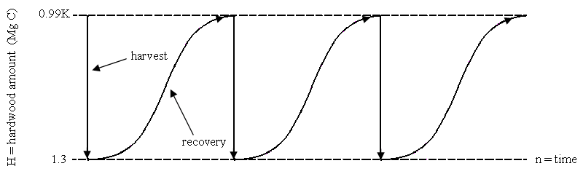
69
0
138
b) To determine the average annual harvest under the clear-cut strategy, start by numbering the time scale in the above diagram, starting with 0. (You’ll need to recall your value of T from question 2.) Then answer the following questions.

c) Under the clear-cut strategy, how much hardwood is harvested in 1 cycle?
146.78 MgC of hardwood is harvested in 1 cycle.
d) How many years does 1 cycle last?
One cycle lasts 5 years.
e) What is the average annual hardwood harvest for the clear-cut strategy?
The average annual hardwood harvest for clear cutting is 3.2 Mg C.

Analyzing selective logging strategy #2 is also a bit difficult because harvest and recovery take place in two stages. Again we make two assumptions to simplify the calculations: (1) the annual harvest reduces the hardwood amount from 99% of K to 1.3 Mg C, as in the second graph that you drew, and (2) the forest recovers logistically over a period of T years before annual harvesting can take place again. After recovery, selective logging strategy #2 resumes immediately at a harvest level of 6.4 Mg C each year. Two cycles of harvest and recovery under this strategy are displayed below.

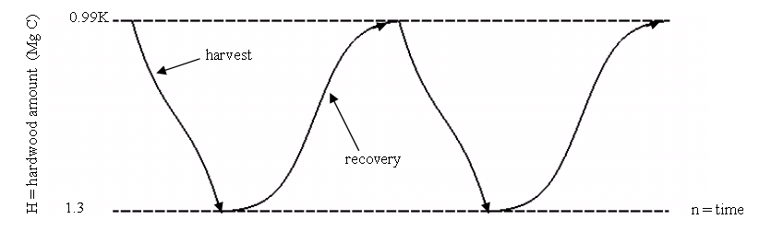
47
0

f) To find the average annual harvest under selective logging strategy #2, number the time scale in the diagram above, starting with 0. Then answer the following questions.

g) How much hardwood is harvested in 1 cycle? Why is this amount much higher than when clear-cutting?
h) How many years does 1 cycle last?
i) What is the average annual hardwood harvest for selective logging strategy #2?
The average annual hardwood harvest is 6.4 MgC.
j) Use the results of your computations to fill in the table below.
 | Clear-cut strategy | Selective logging strategy #1 | Selective logging strategy #2
Average annual harvest
(Mg C/yr)
Total harvest in 500 years (Mg C)

k) Which of the three strategies produces the most hardwood over 500 years?

l) What factors might make one of the strategies better than the other, in terms of tropical forest health? Discuss.

6. Sustainability
Selective logging strategy #1 is sustainable because the annual harvest of 3.2 Mg C can be maintained without end (at least according to the model). On the contrary, selective logging strategy #2 is unsustainable because harvesting 6.4 Mg C each year quickly leads to the complete removal of the forest hardwoods. Sustainable forest practices are thought to be more environmentally friendly, but there is often intense pressure to remove as many trees as possible for building and manufacturing needs. A balance must be struck.
a) As a forest manager, your task is to find the maximum sustainable annual harvest. This is the maximum amount of hardwoods that can be removed each year from the
1-hectare plot of tropical forest without having the forest “crash.” The answer lies somewhere between 3.2 Mg C and 6.4 Mg C. You may find this harvest level through a trial and error approach. If doing so, investigate the harvests over a 500-year period. Extra points will be awarded if you determine the level using an algebraic process. State your answer and summarize work below.

The maximum sustainable annual harvest is 4.05.

b) Under the level that you determined, how much hardwood is removed from the forest after 500 years?
500years*4.50 MgC= 2250 MgC

c) Add an extra column to the comparison table on the previous page, and label it selective logging strategy #3. Fill in the appropriate values using your answers from the previous questions.
d) Many environmentalists think that a sustainable harvesting strategy leaves the forest in a “virgin” state. Give an example (based upon what you learned in this project) in which this thinking would be false.

e) Many people who are “pro-harvest” think that reducing annual harvests today will result in lower total harvests in the future, and lead to the loss of jobs. Give an example in which this thinking would be false.

This thinking would be false because reducing the annual harvest today would allow or allow for a higher level of hardwood left and more hardwood left to be harvested in the future. So lower annual harvest wouldn’t necessarily result in lower total harvest in the future.

* Harte, J. (1988) Consider a Spherical Cow, A Course in Environmental Problem Solving, University Science Books, Sausalito, CA., p.232.

