Chapter 9 Project: Tropical Forests Forever?

Name ____Linnea Brandt______ Name _______Nick Lovullo

Name ______Annabella Perez________ Name____Marshall Lougee__

Introduction
Compared to other major types of ecosystems, tropical forests contain the greatest amount of plant material or plant biomass per area. Biomass is defined as the total mass of organisms (plants, animals, and others), both living and dead, in a given area or volume. Tropical forests have a high plant biomass because of high rainfall, warm temperatures, lack of extreme seasons, and sequences of plants at different heights starting at the forest floor. There are many ways to express plant biomass, including the total mass or weight of all the vegetation. In this project, we will just use the mass of carbon found in plants, the carbon content, as a “proxy for” (i.e. a measure of) plant biomass.

1. Calculating hardwood carrying capacity
a) The mean (average) plant biomass on 1 square meter of mature tropical forest is approximately 20 kilograms of carbon (20 kg C).* Larger units of measure will be easier to work with in the up-coming calculations, so start by reconfiguring this number to reflect the amount of plant biomass in megagrams of carbon (Mg C) in 1 hectare of mature tropical forest. Show units and work. Note: 1 hectare = 10,000 m²; 1 Mg = 1,000 kg.
(20 kg/1 m²)(1 Mg/1000 kg)(10000 m²/1 hectare)=200 Mg/Hectare

b) In this project you will compare various harvesting or logging strategies in a tropical forest. One strategy, the clear-cut, essentially removes all vegetation, while a second strategy, selective logging, removes only some of the valuable hardwood trees. To make a fair comparison between these two strategies, you will focus on just hardwood removal in both models. Start by assuming that 80% of tropical forest plant biomass is comprised of hardwoods. What, then, is the hardwood biomass in 1 hectare of mature tropical forest? In other words, what is the hardwood carrying capacity (K) of 1 hectare of mature tropical forest? K = ____160______ Mg C

c) Suppose that hardwoods in a tropical forest have a maximum annual growth rate of . Write a logistic difference equation, which models the annual growth of hardwoods in 1 hectare of tropical forest. Use the variables h and n to represent hardwood mass and years, respectively.

h(n)=(1.10)(h(n-1))-.000625(h(n-1))²

2. The clear-cut
The logging practice in which all, or nearly all, of a forest is removed is called clear- cutting. Sometimes all trees are removed, with no action taken to regenerate the forest. Sometimes all trees are removed and seedlings are planted. Sometimes a few trees are left standing to naturally re-seed the forest.

a) Suppose that our 1-hectare of mature tropical forest is clear-cut rather thoroughly, leaving only 1.3 Mg C of hardwood biomass. Write this amount as an initial condition:
h(0)=1.3 Mg

b) With this starting amount, let’s re-grow the hardwood forest. Enter the difference equation and initial condition into Excel, and create a table listing the amount of hardwood in the forest every 10 years. (Note: you will want to “run” the difference equation for 150 years but only copy the value of h every 10th year.) Complete the table below (round values to 2 decimal places).

Years | Hardwood  (Mg C) |  | Years | Hardwood  (Mg C)
0 | 1.3 |  | 80 | 152.49
10 | 3.03 |  | 90 | 157.29
20 | 7.66 |  | 100 | 159.04
30 | 18.57 |  | 110 | 159.67
40 | 41.14 |  | 120 | 159.88
50 | 77.01 |  | 130 | 159.96
60 | 114.91 |  | 140 | 159.99
70 | 140.37 |  | 150 | 159.99

c) Generate a scatter plot of the solution of the logistic equation over 150 years vs. the number of years, and add another constant scatter plot at the value of K = carrying capacity. Copy and paste your graph from Excel into this Word document here:

d) Assume that the forest is fully restored when the hardwood amount is at least 99% of the hardwood carrying capacity. What level of carbon is this?
160(.99)= 158.4 Mg C
e) The time it takes for the tropical forest to grow back to the 99% level is called the recovery time. Use a table of values to determine the recovery time ( T ) to the nearest year. T = ___95__ years.

3. Selective logging
A second strategy for logging is to harvest only selected trees in the forest. Selective logging usually targets the mature trees in the forest that will yield the most lumber or wood products for the least amount of effort. Sometimes younger trees will be harvested, if older trees are crowding them out, and sometimes certain species of trees (for example, mahogany) will be selected, regardless of age, for their economic value.
Selective logging strategy #1
a) Suppose the 1-hectare plot of tropical forest is mature, with the hardwoods at their carrying capacity. This means that the initial condition is __160 Mg C____.
b) Now suppose that 3.2 Mg C of hardwoods are removed each year (about 1 mature tree). Modify the logistic difference equation to reflect the growth of the hardwoods with this annual harvest. What is the new equation?

h(n)=(1.10)(h(n-1))-.000625(h(n-1))²-3.2

c) Use Excel to investigate what happens to the hardwood biomass in the long run, based upon this selective logging strategy #1. Explain what you find.

The equilibrium value decreases from 160 to about 116

Selective logging strategy #2
d) Again suppose that the 1-hectare plot of tropical forest is mature, with the hardwoods at their carrying capacity, i.e. ___160_________.

e) What if the annual harvest is 6.4 Mg C of hardwoods—double the previous number or about 2 mature trees? What is the new difference equation?

h(n)=(1.10)(h(n-1))-.000625(h(n-1))²-6.4

f) Again use Excel to explore what happens to hardwood biomass in the long run. Describe what happens to hardwood biomass over time. Hint: while investigating this difference equation, you may get an overflow message, which means that a calculated value became too large or too small for the device to work with. If this is the case, you’ll need to investigate n values which are not so large.

The biomass approaches and goes below zero after about 47 years of logging.
g) Use Excel to generate two scatterplots (using different colors) to illustrate how the hardwood biomass will change over time under these two selective logging strategies. Label the graphs clearly. Use the same horizontal and vertical scales that were used on the clear-cut graph. Copy and paste here:
With 3.2 Mg C taken out each year:

With 6.4 Mg C taken out each year:

4. Equilibrium values
a) Using algebra, find the equilibrium value(s) for the difference equation that models hardwood growth under selective logging strategy #1. Comment on the value(s) that you obtain. Hint: before using the quadratic formula, convert all fractions to decimal form.

1.1 E - .000625 E² -3.2 =E

E=115.777
This appears to match our graph quite well.

b) Again using algebra, show that there is not an equilibrium value for the difference equation that models hardwood growth under selective logging strategy #2.

Unreal with algebra because numbers become negative after 47 years, cannot have negative trees as equilibrium. Once past zero, we stop measuring.

5. Comparing long-term strategies
a) In this section you’ll determine the average annual hardwood harvest for each of the 3 forestry practices discussed here. For selective logging strategy #1, this is easy—the average annual amount harvested is: ______3.2 Mg C__________

It is a bit more difficult to determine the average annual harvest for the clear-cut strategy because after clear-cutting there is no additional harvesting until the forest has regenerated. To simplify the computations, we assume that (1) the clear-cut happens instantaneously, always reducing the hardwood amount from 99% of K to 1.3 Mg C, and (2) the forest recovers logistically over a period of T years before harvest can take place again. Three cycles of harvest and recovery are diagrammed below.
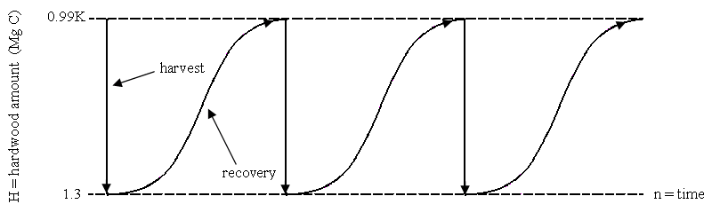
b) To determine the average annual harvest under the clear-cut strategy, start by numbering the time scale in the above diagram, starting with 0. (You’ll need to recall your value of T from question 2.) Then answer the following questions.
Recovery from one clear cut will take 95 years

c) Under the clear-cut strategy, how much hardwood is harvested in 1 cycle?
158.4 Mg C
d) How many years does 1 cycle last?
95 years
e) What is the average annual hardwood harvest for the clear-cut strategy?
158.4/95= 1.667 Mg C per year

Analyzing selective logging strategy #2 is also a bit difficult because harvest and recovery take place in two stages. Again we make two assumptions to simplify the calculations: (1) the annual harvest reduces the hardwood amount from 99% of K to 1.3 Mg C, as in the second graph that you drew, and (2) the forest recovers logistically over a period of T years before annual harvesting can take place again. After recovery, selective logging strategy #2 resumes immediately at a harvest level of 6.4 Mg C each year. Two cycles of harvest and recovery under this strategy are displayed below.

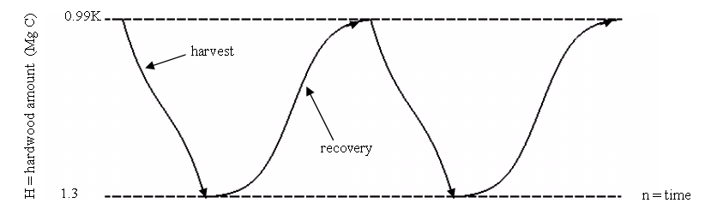

f) To find the average annual harvest under selective logging strategy #2, number the time scale in the diagram above, starting with 0. Then answer the following questions.
T of harvest= 47; and recovery is 95 years
g) How much hardwood is harvested in 1 cycle? Why is this amount much higher than when clear-cutting?
6.4 Mg C * 47= 300.8 Mg C; this is higher because it allows the forest to grow back some before they cut again
h) How many years does 1 cycle last?
95+47= 142 years
i) What is the average annual hardwood harvest for selective logging strategy #2?
300.8/142= 2.12 Mg C
j) Use the results of your computations to fill in the table below.
 | Clear-cut strategy | Selective logging strategy #1 | Selective logging strategy #2 | Selective logging strategy #3
Average annual harvest  (Mg C/yr) | 1.667 | 3.2 | 2.12 | 4.0
Total harvest in 500 years (Mg C) | 833.5 | 1600 | 1060 | 2000

k) Which of the three strategies produces the most hardwood over 500 years?
Strategy one produces the most hardwood over 500 years, taking out 3.2 Mg C each year.

l) What factors might make one of the strategies better than the other, in terms of tropical forest health? Discuss.

These strategies can vary the health of the forest because the health can depend on the climate of the forest, the species living in that environment, or maybe any natural disaster that could have caused a loss of hardwoods. Tropical forest health can be measured on the diversity of species.

6. Sustainability
Selective logging strategy #1 is sustainable because the annual harvest of 3.2 Mg C can be maintained without end (at least according to the model). On the contrary, selective logging strategy #2 is unsustainable because harvesting 6.4 Mg C each year quickly leads to the complete removal of the forest hardwoods. Sustainable forest practices are thought to be more environmentally friendly, but there is often intense pressure to remove as many trees as possible for building and manufacturing needs. A balance must be struck.
a) As a forest manager, your task is to find the maximum sustainable annual harvest. This is the maximum amount of hardwoods that can be removed each year from the
1-hectare plot of tropical forest without having the forest “crash.” The answer lies somewhere between 3.2 Mg C and 6.4 Mg C. You may find this harvest level through a trial and error approach. If doing so, investigate the harvests over a 500-year period. Extra points will be awarded if you determine the level using an algebraic process. State your answer and summarize work below.

Using the quadratic equation formula used to find our equilibrium value for selective logging, we set the value under the square root equal to zero.

The maximum amount of hardwoods that can be removed each year from the plot without having a forest “Crash” is 4 Mg C

b) Under the level that you determined, how much hardwood is removed from the forest after 500 years?

2000 Mg C

c) Add an extra column to the comparison table on the previous page, and label it selective logging strategy #3. Fill in the appropriate values using your answers from the previous questions.
d) Many environmentalists think that a sustainable harvesting strategy leaves the forest in a “virgin” state. Give an example (based upon what you learned in this project) in which this thinking would be false.

In selective logging strategy 1, which is noted as being a sustainable harvesting strategy, we chose to take out 3.2 Mg C each year. This is not leaving the forest in a “virgin” state because we are still taking out more hardwood trees each year.

e) Many people who are “pro-harvest” think that reducing annual harvests today will result in lower total harvests in the future, and lead to the loss of jobs. Give an example in which this thinking would be false.

If we use selective logging sustainably 2, we will continue to harvest hardwoods every year, and no annual change will be made in terms of the amount cut or jobs needed. Selective logging strategy #1 proved to provide us with the most ( Mg C over a period of 500 years.

* Harte, J. (1988) Consider a Spherical Cow, A Course in Environmental Problem Solving, University Science Books, Sausalito, CA., p.232.

