Robertho Gay
Mont 105-N
Prof. John Little
Mont Research Paper
03/24/13
The Butterfly Effect
When we think of chaos we tend to visualize disorder and commotion. The chaos that we are accustomed to is in its entirety random and lawless. In this paper I will introduce a variation of chaos that is ruled by order. This form of chaos we witness or are a part of, we observed this chaos through Darwin’s theory of evolution (process of selection, genes, traits, survival). We again notice this form of chaos in population (humans, animals, microorganisms, etc) and heart rate. We even notice this idea of chaos within human behavior. During the early stages of scientific development the brightest of minds stayed away from this chaotic behavior. But one meteorologist dared to explore this complex phenomenon.
As a child Edward Norton Lorenz loved completing math puzzles with his father. One day Lorenz and his father came across a mathematical puzzle that was unsolvable, his father upon realizing that it was unsolvable left Lorenz with a little a piece of advice that would be crucial to his studies of the chaos theory. Edward Lorenz studied mathematics at Dartmouth College in the town of Hanover in western New Hampshire. He graduated from Dartmouth College with a bachelor's degree in 1938, and then went to Harvard where he studied for a Master's Degree in mathematics. After his Master’s degree he join the U.S. Army Air Corps applying his mathematical skills to weather forecasting and looked to pursuit a Master’s degree at the Massachusetts Institute of Technology. It is during his time studying weather patterns that he discovered this behavior.
Weather as we all know can be unpredictable. But as technology developed this unpredictability decreased. Technology has made it easier for man to calculate to a certain extent the weather patterns of the Earth. This is possible through deterministic systems. But these deterministic systems are only plausible in the case where time is really small. As we go out further into time it gets harder to predict what weather will be like. This unpredictability as time increases is where we would observe what we now refer to as chaos.
Now that we have a well-developed understanding of weather and it’s tendency to become unpredictable, we understand why Lorenz was able to observe a chaotic behavior. Lorenz first moments of discovery were recorded in Chaos Making A New Science by James Gleick.
“One day in the winter of 1961, wanting to examine one sequence at greater length, Lorenz took a shortcut. Instead of starting the whole run over, he started midway through. To give the machine it’s initial conditions, he typed the numbers straight from the earlier printout. Then he walked down the hall to get away from the noise and drink a cup of coffee. When he returned an hour later, he saw something unexpected, something that planted a seed for a new science”(pg 16).
This excerpt describes the first steps towards discovering the chaos theory. After noticing this anomaly within his data Lorenz analyzed the data further more and noticed that the further out he went the bigger the divergence between his second values and the initial values.
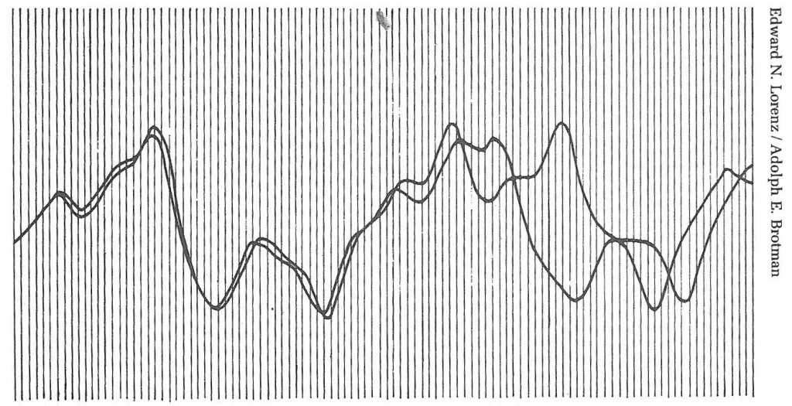
Fig. 1. Gleick, James. HOW TWO WEATHER PATTERNS DIVERGE. From nearly the same starting point, Edward Lorenz saw his computer weather produce patterns that grew farther apart until all resemblance disappeared. (From Loren’s 1961 printouts.)

The graph above demonstrates the increasing difference between the two data sets that Lorenz produced. If it were to continue out more the difference would only continue to increase. Lorenz ultimately deemed this behavior as sensitivity to initial condition.
He came to the conclusion that thus was sensitivity to initial condition during the review of the produced data set. Due to rounding of the numbers used for the initial conditions Lorenz realized that they proved to hold catastrophic consequences.
“The problem lay in the numbers he typed. In the computer’s memory, six decimal places were stored: .506127. On the printout, to save space, just three appeared: .506. Lorenz had entered the shorter, rounded-off numbers, assuming that the difference—one part in a thousand—was inconsequential” (Gleick, 16).
These small deviations may seem insignificant but they cause greater fluctuations as time goes by. For that specific reason this sensitivity is also referred to as the butterfly effect. There were a lot of ideas to what this discovery my mean for long-term predictions for weather patterns, but Lorenz had different interpretations for what this discovery would mean for science.
“White gave Von Neumann’s answer. ‘Prediction, nothing,’ he said. ‘This is weather control.’ His though was that small modifications, well within human capability, could cause desired large-scale changes.
Lorenz saw it differently. Yes, you could change the weather. You could make it do something different from what it would otherwise have done” (Gleick 21).
Some saw this discovery as an opportunity to gain more control over uncontrollable situations like weather, nut Lorenz pointed out the fact that in such a case change initial conditions to fit our needs might not make improve the outcome. As Lorenz said, “It would be like giving an extra shuffle to an already well shuffled deck of card. You know it will change your luck, but you don’t know whether for the better or worse.”
Over the years as our understanding of chaotic behaviors has developed, we have moved towards testing whether our luck will change for better or worse. Along with the legwork completed by Lorenz modern science has allowed us to apply chaos theory to the human body. It is speculated that the heart rate is chaotic but there is skepticism regarding whether or not this actually true. Chaos and Heart Rate Variability is an article shines light on whether or not there is any correlation between heart rate and chaos. Chaos and Heart rate Variability by Leon Glass discusses the probability of correlation between the heart rate. “Low dimensional chaos prevails in the intact heart.” In 1994 Elbert et al. made this statement amongst others. Leon Glass within this article decides to reinforce these statements.
“If Costa et al. are right in saying the normal heart rate variability is not chaotic. Then what is it? Stating the obvious gets us pretty far. The normal heart rate displays complex fluctuations in time in response to environmental factors (breathing, activity, posture, emotion) all of which are mediated by different feedback loops acting in parallel” (Glass 1359).
A lot can be observed from the human. So far its been observed that the human heart can produce these chaotic behaviors.
So far chaos has been applied to some of the most complex situations possible. But this behavior can be simplified even further for better understanding. For instance this chaotic behavior can be observed within the logistic difference equation for the population of locusts. The standard logistic difference equation that we would use would be:
This logistic difference equation describes the population of the locust in accordance to the carrying capacity as time goes by. In order for this equation to produce a noticeable chaotic the growth rate has to be greater than 2.57. With these parameters the graph produced would look like this:

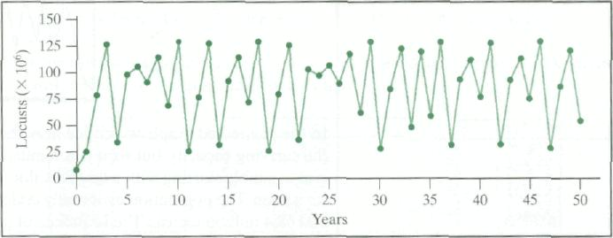
This turns out to be a simple representation of the chaotic behavior that can be observed within a population. But as we move into more complex and nonlinear system we find these fluctuations to be wilder.
Overall it is clear that large aspects of the human life display chaotic behaviors. It is also clear that as humans, we ourselves play a huge role in the production of this chaos. The chaos theory through its development over the years has allowed for greater understanding for many of the nature’s works (weather, population growth, process of natural selection, etc.). Through further development I’m sure that we can apply to our current methods of prediction for all the fields applicable.

Bibliography
- Gleick, James, Chaos: Making a New Science. New York: Penguin Group, 1987. Paperback.

- Leon Glass. “Chaos Theory, Heart Rate Variability, and Arrhythmic Mortality”. Journal of Cardiovascular Electrophysiology. 10, October, 1999. Web. 04/13/13

