Michael Ortlieb
Professor John Little
Mont 105N-01
7 May 2013
Duty Calls: America vs. Green Revolution
Imagine you are living in a world that has reached a point where its environment has experienced so many hardships and destruction that the effects become irreversible. Population size has exceeded the capacity that planet Earth can sustain. Global temperatures have risen too much that the world’s ice caps have melted causing a rise in sea levels and inundating billions of people worldwide. Countries’ borders have become almost non-existent as technology advances and an individual’s accessibility increases. These three issues as well as others are just the tip of the iceberg in terms of planet Earth’s environmental problems, and we as inhabitants must begin to alter the ways in which we consume and produce energy in order to salvage what we have left. In the book Hot, Flat, and Crowded, Thomas Friedman, a renowned American journalist and author who has written much on foreign affairs including environmental issues, addresses a number of matters that deal with the notion concerning why we need a green revolution and how it can renew America. Friedman first summarizes the three issues of hot, flat, and crowded and their effects on the environment. He also offers other possible solutions such as the Energy Internet and Code Green systems that he believes will revolutionize the crisis the world is subtly experiencing. Having said that, Friedman is quick to point out that in order for change to be made, America must take a leading role in pushing for a Green Revolution. According to Friedman, he believes America has lost its focus and national purpose ever since 9/11 and the global environmental crisis. He argues that there is great economic opportunity for the country that takes leadership in leading the United Nations. America has both the capacity and influential nature to accomplish such a feat.
At first glance, many would not think the world is experiencing a serious global climate change. More importantly, many would not think twice about making a difference and changing their ways of living in an effort to alleviate the strain put on the environment. In his book, Friedman points out some notable concerns we should all have when it comes to temperature change, accessibility and interference, and rapid population growth. In correlation with his title, he breaks up the issues into three categories: hot, flat, and crowded. The first category, hot, deals with the increasingly alarming rate of temperature increase. Scientific research has shown that the world is in the midst of a warming pattern. This can be attested to carbon dioxide and other green house gas emissions from various sources such as automobiles and plants and factories. In addition, with the presence of green house gases in the environment both the ocean and the ozone are at risk. Over the past couple hundred years, green house gas emissions have damaged the ozone layer to the point where there is enough radiation circulating to cause ill will. Furthermore, as ocean temperatures increase and general temperatures in the atmosphere increase, the polar ice caps that harbor a large percent of the planet’s fresh water are at risk of melting and ultimately flooding millions of people worldwide. Some quick fixes that Friedman suggests to Earth’s temperature rise are reducing the amount of commuting and driving, increasing nuclear power efficiency, limiting deforestation, and reducing the enormous amount of energy and electricity consumed in offices and homes. In terms of the second category, flat, Friedman points out how, “technology, [the] market, and geopolitical events in the last century have created thinner borders and made everything more accessible” (Friedman). He verifies this change by way of the introduction of the PC, or personal computer, the Internet, the evolution of software, and lastly to the fall of communism. In an already very populated world, having the ability and access to so much seems like a good thing but in reality it makes everything seem like somebody else’ s business and it appears as if everyone is interfering with everyone’s personal affairs, hence the “thinning of borders” remark. Lastly, the section, crowded, describes the rapid population growth. A statistic in Friedman’s book claims, “a person in 1953 arrived to a world of 2.7 billion people. A person born in 2053 is expected to arrive to a world of 9 billion – a tripling of the population in a mere 100 years” (Friedman). Throughout the book, Friedman consistently harps on the fact that America needs to take more of an active role in changing its habits as well as the world’s habits in an effort to benefit the environment. In Friedman’s eyes:
America has waited for the quick fix and the miraculous cure. Instead of fostering a sense of responsibility in its people, America has tried to subsidize it away. Instead of analyzing and acting upon the scientific data presented, the argument has become needlessly politicized and marginalized. The strategy in dealing with Climate Change has been “wait and see”. But America cannot wait and see any longer. It’s time for a fundamental change in the national approach when it comes to the changes that have happened to the ecosystem. (Friedman)
With help from both the government and private sector in the form of advertisement and funding, innovation for new environmental technologies is a very real possibility. Aside from the quick and easy solutions, Friedman proposes two alternative forms of energy production and consumption that he believes will re-write the script, as we know it.
“Do what is right, not what is easy”. My high school coach used to say this everyday at practice to us. I think it is fitting here because Friedman shares the same view. America has promoted the easy change, but not the right change. For example, in China when their population was growing at an exceedingly high rate they implemented a one-child limit per couple. Although a very drastic and what some one would argue an unethical measure, China took action and was successful in their effort to slow their population growth. Having said that, Friedman by no means is arguing that America implement the same standard; however, what he is saying is that America needs to be more assertive when it comes to going green. As an American, Friedman feels like he is doing his part by proposing new ideas, ideas such as Code Green and the Energy Internet.
We live in an energy-climate era where everything we do demands some input of energy. Code Green is a system that will not only benefit the environment but also foster economic growth. As stated in the book, “It’s moving from the old, inefficient system of extracting power from coal, oil, and gas, and into a new system where fuel and energy innovation will drive American and world markets” (Friedman). Code Green is a system that incorporates three different components that all correlate with one another: clean electrons, efficiency, and conservation. With the development of cost effective, clean electrons, Friedman argues that an increasing crowded world will emit less waste and carbon dioxide from factories and plants will be nonexistent. He goes on to say that deforestation would be less necessary, petrodicators would have less influence and power over energy and funding, education across the board would improve, and civil unrest and poverty amid the youth would be out of the equation. In addition to cleaner burning electrons, energy efficiency must improve with what we already have. As American’s, we are one of the biggest if not the biggest consumer of energy. If we are to set a good example, we must become “smarter with building design, packaging, refrigeration, air conditioning, and lighting” (Friedman). In Figure 1 below from an article written in 2009 by John Davidson, according to the numbers, we waste more energy than
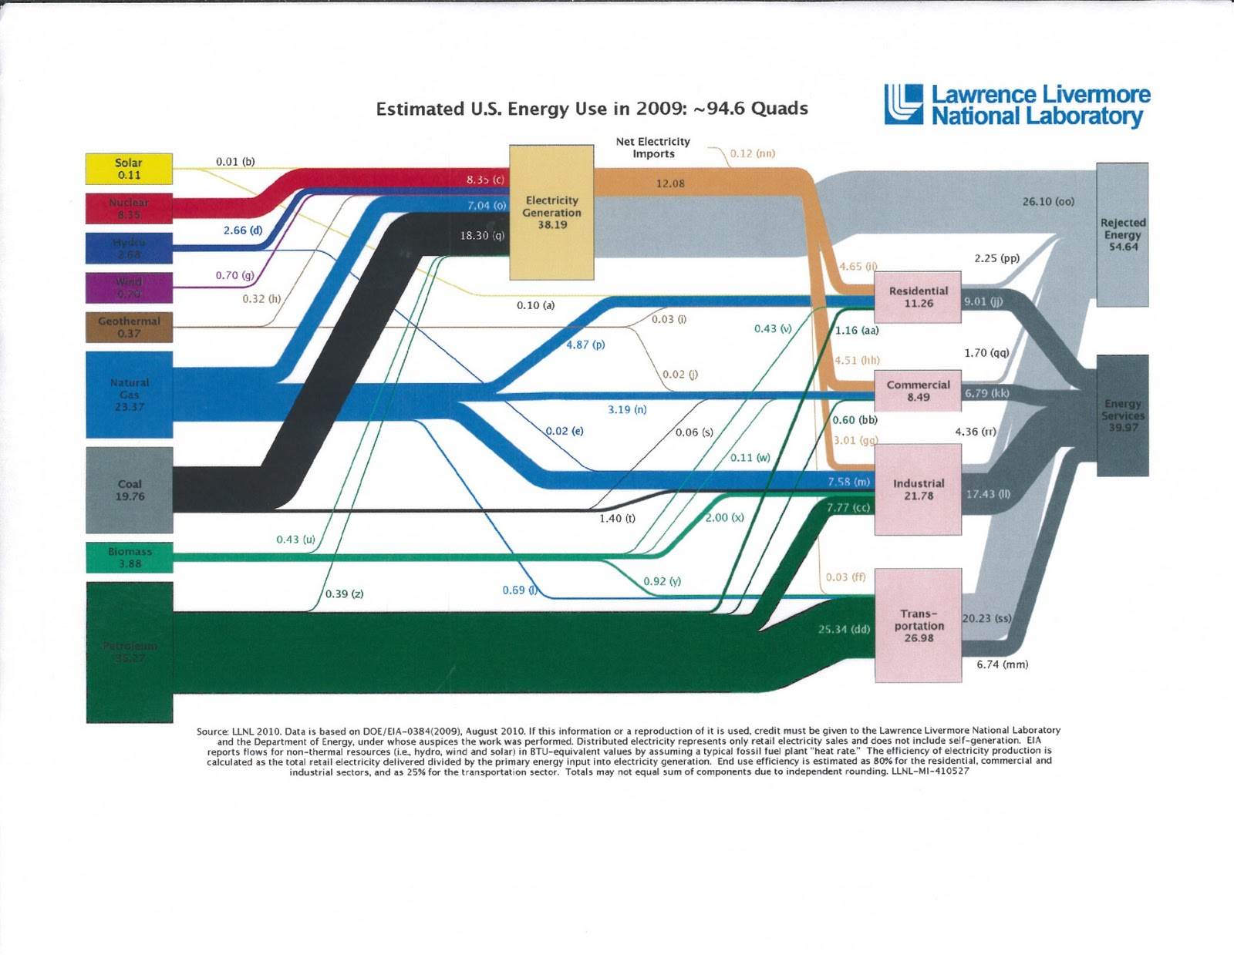
we actually consume. To be specific, in this particular year, the U.S. wasted 54.64 Quads of energy compared to the 39.97 Quads of energy we ended up using. In addition, the two most inefficient sources of energy, coal and petroleum are two of the three major sources of energy in the United States. Friedman is accurate in saying that we need to become smarter in our energy consumption as well as finding new sources of energy as opposed to coal and petroleum. The last component to Code Green is conservation. Friedman puts it perfectly when he says that cleaner electrons and better efficiency for the energy we currently have is all for not unless people take responsibility and demonstrate self control when it comes to energy consumption. As stated earlier, at our current rate, we are heading to a “point of no return”; yet with systems like Code Green and the Energy Internet we can resolve that.
Figure 1: Energy Consumption Grid
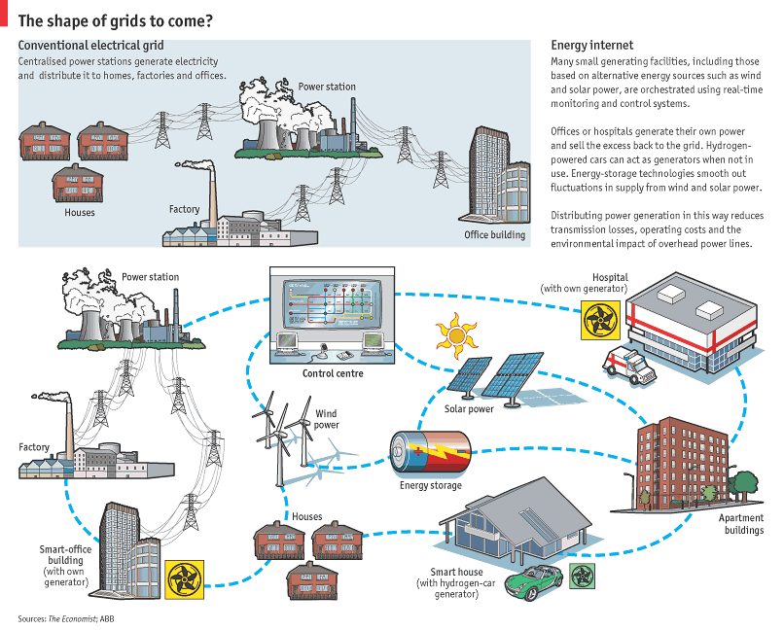
With a system like Code Green comes the demand for an Internet technology or what Freidman is an advocate of, an Energy Internet, or smart grid. A system like an Energy Internet would have the capability to provide real time information about prices per electron and the source of the power. It also would have the ability to sense peak hour and downtime electrons and charge accordingly for wind and coal resources. Furthermore, consumers and producers would have the ability to sell back any unused electrons if such a case were to be presented. Figure 2 below portrays the positive feedback that a smart grid technology could provide. Furthermore, as opposed to the ridiculous and arbitrary pricing of energy today, consumers would have incentives to switch over to such a system in order to pay the true price for say an electron or what have you. An Energy Internet would contribute to the “flattening” of the world but in a positive sense. By having everyone on the same page in terms of energy pricing both civil unrest and animosity between various nations could be avoided. The easy distribution methods and management of a smart grid system make it very appealing and applicable in today’s society.
Figure 2: Smart Technology Grid
Does America have what it takes to lead a group of nations through a Green Revolution? How realistic are Friedman’s arguments, or better yet solutions to the problem? In reality everyone, not just America will be called on to take part in a Green Revolution. In my opinion, I agree with Friedman when he criticizes America for charging its issues to the future. The time is now! With the support from both the Federal Government and Private Sector, ideas supported by Friedman such as Code Green and an Energy Internet are all viable options. As cliché as it sounds, if we put our minds to it and actually act on the various innovative technologies that are available to us then we can accomplish it. As stated earlier, China had the will power to slow their increasing population as well as implement a high-speed railway system that would limit the amount of automobiles and pollution. All it takes is some input from the Federal Government. Moreover, taking a lead role in going green would not simply be for the good of humanity as there is a huge economic incentive to produce new technology in the production and consumption of energy. According to a New York Times Sunday Book Review:
Friedman knows what is to be done. The United States needs to set an example for the world to follow, by starting over and constructing an entirely new Clean Energy System, one that will send “clean electrons” into its homes, offices and cars — generated not by dirty old oil or coal, but by solar, wind and nuclear power — and that will use many fewer of those electrons, thanks to greater efficiency. (“Eco-Nomics”)
Freidman and his arguments are provocative but at the same time have garnered the support of many. But as is with everything many dispute some of the claims Friedman makes. For example, it is easy to say that we all need to come together and find a mutual solution. However, is it realistic that we can all get along? Isn’t that why we are fighting in the Middle East today? Oil deposits in the Middle East have caused great civil unrest and turmoil. That is why I agree with Friedman when he says we need to find cleaner burning electrons that will replace the old oil, coal, and petroleum demands. If this innovative idea can grab governments’ attention, then there will be no need for fighting and we can ultimately get along well enough to accomplish a successful Green Revolution.
In conclusion, Friedman is accurate when he says that we, America, have the opportunity to restore our national purpose. We have the chance to take a leading role in the Green Revolution and have the opportunity to reap the economic benefits from it. In terms of hot, flat, and crowded, Friedman illustrates the issues from which we as a planet are suffering. He proposes the quick fix but in a way mocks them at the same time as he criticizes America for “doing what is easy and not what is right.” He challenges his fellow Americans to be innovative and push for new energy producing and more efficient sources. With ideas such as Code Green and the Energy Internet, or smart grid, he validates his stance as an advocate for change, serious change. In terms of how realistic his ideas and arguments are, he is on par. From the multiple book reviews I have read and even quoted above, Friedman knows what he is doing. As an acclaimed Pulitzer Award winner, Thomas Friedman has more then validated himself in that regard. What happens to be the independent variable in this equation and nobody really knows is us. The time is now for us Americans and in more general terms inhabitants of planet Earth to take a stand and make a difference. We have all the resources and innovation to attempt at the very least to make amends to the way in which we live. But I would argue and I would assume Friedman would as well, “attempting” isn’t good enough. In the words of Thomas L. Friedman, “[g]reen is the new red, white, and blue” (“The Power of Green”).

Works Cited
Estimated U.S. Energy Use in 2009: ~94.6 Quads. 2010. Photograph. Lawrence Livermore National Library and the Department of Energy, n.p. By Lawrence Livermore National Library and the Department of Energy.
Freedland, Jonathan. "Eco-nomics." The New York Times. The New York Times, 05 Oct. 2008. Web. 24 Apr. 2013.
Friedman, Thomas L. Hot, Flat, and Crowded: Why We Need a Green Revolution-- and How It Can Renew America. New York: Farrar, Straus and Giroux, 2008. Print.
Friedman, Thomas L. "The Power of Green." The New York Times. The New York Times, 15 Apr. 2007. Web. 07 May 2013.
Nye, Joseph S., Jr. "A Climate for Change." Washington Post. The Washington Post, 07 Sept. 2008. Web. 24 Apr. 2013.

