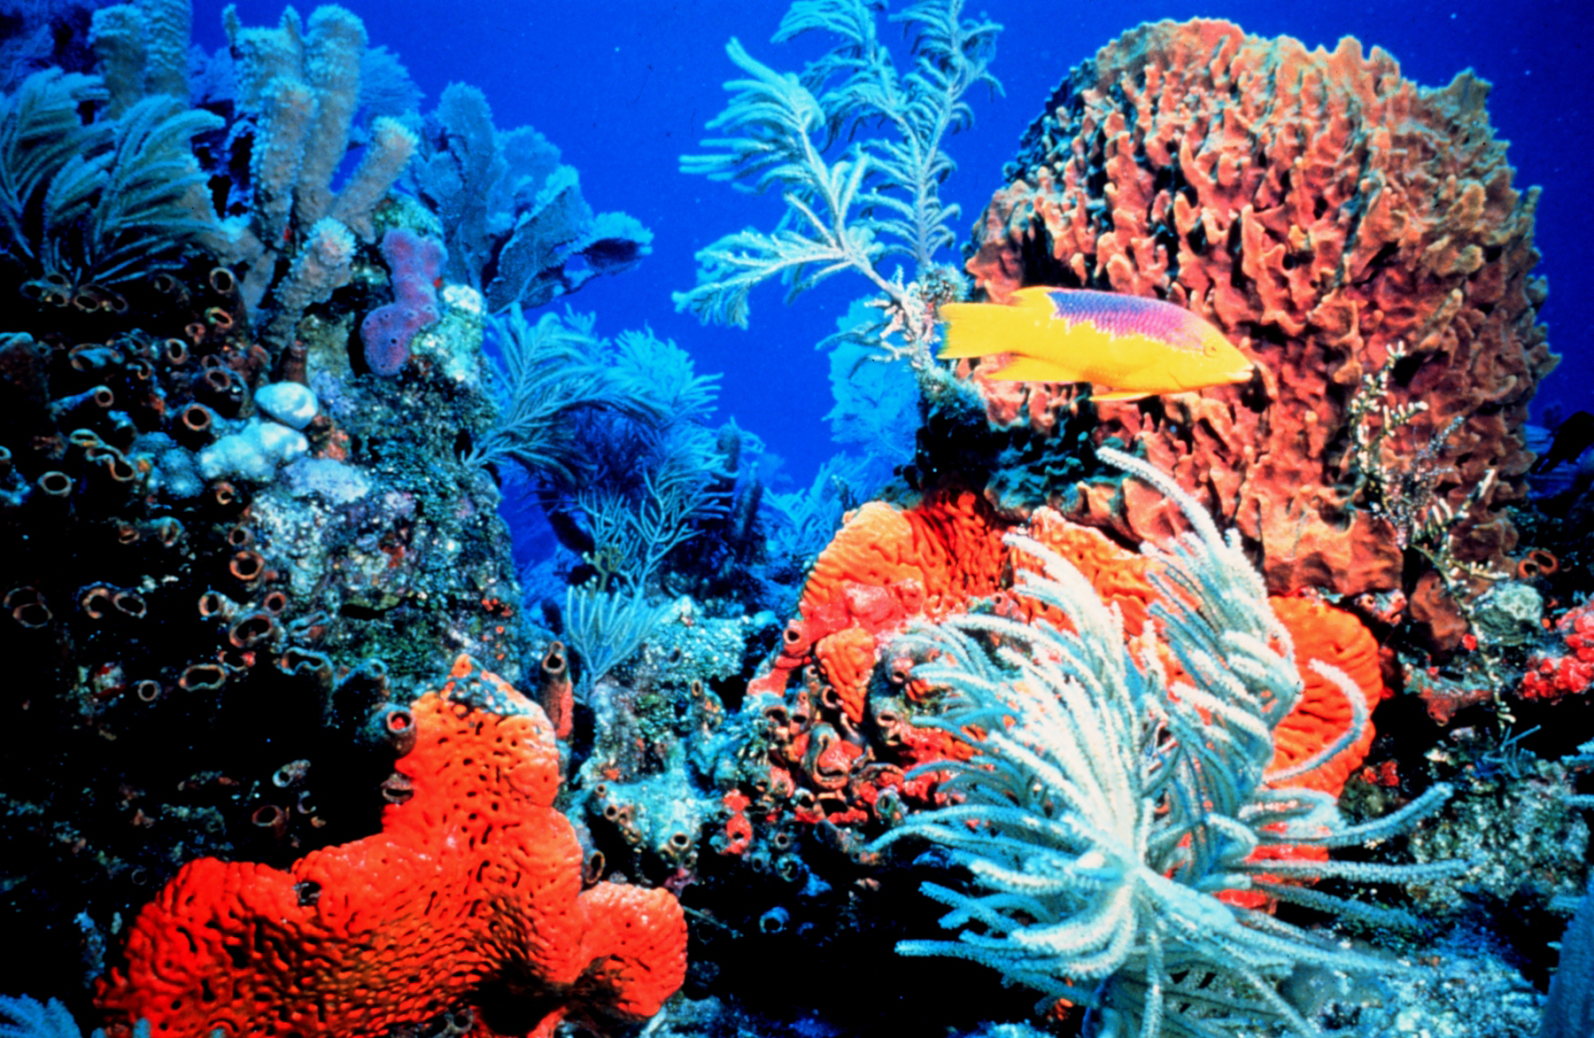

Rainforests of the Ocean

By: Marshall Lougee
Coral reefs are thriving ocean ecosystems second in diversity only to tropical rainforests. It is this characteristic that has often given them the name “Rainforests of the Ocean.” What makes coral reefs so incredible? What qualities do they have that make them different from any other living system on Earth? Reefs are a biological hotspot; containing millions of different organisms that each impacts one another. This highly specialized and sensitive environment is what accentuates the beauty of a reef. The coral reef ecosystem is 450 million years old, making it one of the oldest ecosystems on the planet. It has proven to be extremely adept at coping with changing conditions, and has long withstood the test of time. More recently however, reefs have experienced a great amount of stress from anthropogenic changes in the equilibrium of their ecosystem.
Humans have been putting stress on reefs in a number of different ways. Overfishing, tourism, pollution from land, increasing CO2 levels, and global climate change all have long lasting and serious consequences for the environment. These consequences are called anthropogenic, “human caused”, effects. Human actions upset the equilibrium of interactions between all of the different species in a reef. For example, removing a certain type of fish may cause an organism that is normally harmless to become a huge detriment to coral. Another way humans impact reefs indirectly is through global climate change and an increase in atmospheric CO2. Some would say that rising ocean temperature and CO2 have no effect on resilient coral reefs. On the other hand, there are many studies that refute this fact, and show a direct correlation between human caused climate change and reef destruction. In this way, mathematical models are useful in showing a correlation. A group of Cornell researchers have devised a model that replicates the complex interaction between beneficial and harmful pathogens in a reef environment. However, to understand this model and how humans alter reefs, we must first understand the basics of the intricate coral reef ecosystem.
Reefs are colorful ecosystems with millions of different organisms reacting in a very complex web. Strict competition for resources like food, space, and sunlight determine the relative diversity and abundance of organisms. In this way, a coral reef is a vastly interconnected ecosystem. Each and every organism has its niche, and these niches are constantly being vacated and filled by other organisms. This constant interaction makes reefs very vulnerable to internal changes, let alone external variations.
The backbone of a coral reef is the many different types of hard and soft coral that co-exist. Some types of hard coral are the brain, star, staghorn, elkhorn, and pillar corals. What makes these corals hard are the rigid exoskeletons excreted by the organisms living in them. These tiny organisms are what give coral their beautiful colors. Coral “polyps” have small cylindrical bodies with discs at the upper and lower ends. They have a mouth in the upper disc, and a digestive tract. They use their small mouths to catch free-floating food. However, in the absence of food these polyps may still find a way to survive. Coral polyps have also evolved to undergo photosynthesis, making them a highly adapted and special organism. Polyps are also capable of abstracting calcium from their environment and converting it into calcium carbonate (CaCO3). This calcium carbonate is the dense rock like structure we know as coral.
Hard packed coral is what makes the reef so special. It provides a home for animals, protection from predators, food for organisms, and even a breakwater for islands and beaches. Without coral many of the worlds most beautiful beaches would be washed away by the powerful ocean waves. Coral can be compared to the tall leafy trees of the rainforest that support their ecosystem. They are more than just a keystone species. They are intertwined with the ecosystem itself, and just as you cannot have a rainforest without trees, you cannot have a coral reef without coral. Coral are not just rocks at the bottom of the ocean. They play a pivotal role in the ecosystem as a whole. However, 93 of the 109 countries that have coral reefs have some type of reef damage. In order to stop reef damage a better understanding of reefs is necessary. We also need to know exactly what we are doing that is hurting reefs, and what we can do to help repair the damage done.
Climate change is one of the most highly debated topics in its effects on coral reef habitats. A rising climate and CO2 level can have numerous bad effects on coral. Some researchers say that reefs of the Paleocene and Eocene eras had a much higher CO2 level than now, and they were able to adapt perfectly fine. However, these reefs did not undergo such a rapid increase of CO2 in such a short period of time. As the CO2 levels gradually changed over a long period of time, the reefs of these eras were allowed to adapt and adjust to the current levels. With the rate of increase now, we are not giving reefs time to adapt to changing conditions.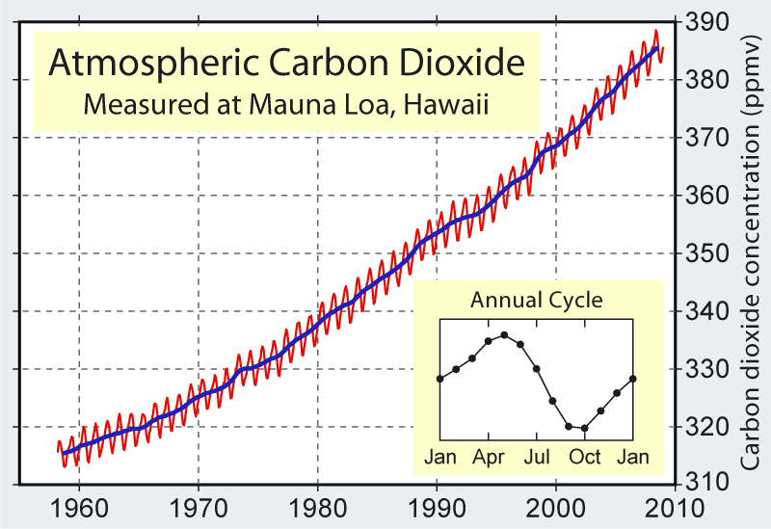
The Mauna Loa CO2 measurements can attest to the rising CO2 level. One can clearly see from the set of measurements, taken from the Mauna Loa Observatory in Hawaii, that atmospheric CO2 levels are on the rise. Yes, reefs are one of the oldest and most resilient ecosystems on the planet, but that is not to say that they are invincible. As CO2 builds up in our atmosphere the rate at which the ocean sequesters this gas, is directly proportional to the rate at which carbon dioxide is produced. This is usually good, as it helps to moderate the amount of atmospheric CO2. However, as the ocean recycles CO2, it produces an acid. This acid then goes on to react with calcium carbonate, which neutralizes it, stabilizing the pH of the ocean. A main source of this calcium carbonate is from the coral in coral reefs. This chain reaction is called ocean acidification and neutralization, and is a cause of decrease in coral.
Humans also affect reefs more directly through fishing, tourism, and runoff. One example of this interference came with the emergence of a species that is very harmful to coral. Acanthaster planci, A planci. for short, is a sea star that feeds on Scleractinian corals. It has come to be known as the “crown of thorns” as it is covered in many protrusions which somewhat resembles a crown. The sea star was first seen in the 1960’s in a coral reef area near Indonesia. Here it caused catastrophic degradation to the coral, killing nearly 50-90% of Scleractinian coral species. One hypothesis for the sudden onslaught of this coral killing species is the overfishing of Charonia, also known as grouper. Grouper are the main predators of A planci., and help to regulate their population. As the grouper population falls from overfishing, the amount of harmful sea stars goes up, resulting in greater reef loss. This is a perfect example of how humans can upset the delicate equilibrium in coral reefs. Unfortunately, some anthropogenic coral reef degradation is not as easy to understand, or foresee.
Whether or not humans have been influencing a global warming trend, and how this trend will affect the planet is still heavily debated. Many have agreed that the planet has been slowly warming, but some refuse to believe humans are the cause. Others simply think that the warming will not harm us in any way. One of the main sources of evidence for global warming is the Mann hockey stick graph. Mann’s graph shows that in the past 100 years, the temperature has been rising at an alarming rate. This graph is very accurate for this stretch of time because the measurements come from actual thermometer measurements with little to no error. With a rising global temperature come new threats to coral. As the water temperature rises, coral polyps expel the photosynthetic zooxanthellae that live in symbiosis with them. These zooxanthellae are what give corals their colors. So, as they are expelled, the corals lose their colors and become what we call “bleached.” The mortality rate of bleached corals depends upon the type of coral, but 60-90% of the more sensitive corals die. The upper temperature limit for coral’s natural growth is 29-31 degrees Celsius. Although they may endure short-term rises of up to 34 degrees Celsius, any more than 32 degrees for an extended amount of time causes extreme stress. Under this extreme stress, corals expel the symbiotic zooxanthellae that live with them and excrete large amounts of mucus. This mucus then causes microbial growth in the water and surface of corals, bleaching the corals and killing the polyps. This interaction can be modeled with a mathematical equation that helps us understand how much corals can take and just how sensitive they are.
In March of 2010 a group of Cornell researchers developed a system of differential equations to model the interactions of beneficial microbes and harmful pathogens that exist in coral mucus. Their goal was to test the dynamics of the microbial community in coral mucus, and to determine when coral are vulnerable to pathogen growth. Most corals have a complex layer of surface mucus. In this layer there are a variety of different beneficial microbes that act just as our immune system works. These beneficial microbes feed off the many nutrients present in the mucus layer. When the corals are stressed though, this mucus layer turns into a breeding ground for harmful pathogens. These switches from a beneficial microbe community to a pathogenic microbe community are directly related to why corals become bleached.
The researchers at Cornell have found a way to model this intricate interaction between beneficial microbes and harmful pathogens in the SMC (surface microbial community). A modeling approach is very useful because it allows us to see more clearly how something such as rising temperature will affect the growth rate of pathogens in the SMC. To model this phenomenon, they used a system of differential equations of the form:
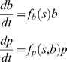
The first equation represents the growth rate of the beneficial microbes. This growth rate is a function of the beneficial microbes in terms of the substrate, taking into account the relative amount of beneficial microbes around. The second equation represents the relative growth rate of the pathogens in the SMC. This growth rate is a function of the current amount of pathogens based on the substrate and the beneficials (antibacterial), taking into account the amount of pathogens around. The beneficial microbes have an antibiotic function on the pathogens and this is why they are included in their growth rate. Without this interaction both populations would grow at the same rate, and the graph would be a set of parallel lines. By adding the beneficial antibiotic effect to the pathogen equation, they are making the slope of the pathogen line steeper, allowing the beneficials to eventually recover and overcome the amount of pathogens. These equations are represented and evaluated by a system of nullclines that look like this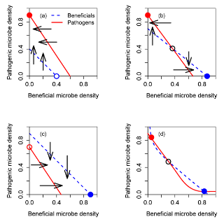
This system of nullclines is based on a set of solution values for each of the differential equations, and shows how each the beneficials and pathogens react with one another in the SMC. The graph clearly shows how a different amount of beneficials or pathogens affects one another. In the graph, stable equilibriums are shown as closed circles and unstable equilibriums are shown as open circles. These graphs simply display the interaction between pathogens and benificials with no external changes in the environment.
When conditions become stressful, the SMC favors a sudden and persistent takeover of the pathogens. One of these stressful conditions is a rising water temperature, or thermal stress. During colder months, the beneficial bacteria are able to outcompete the pathogens for substrate. This is because the pathogens are more suited to grow in a warmer temperature. Even when the water temperature becomes warm in the summer months the beneficial bacteria can outcompete the pathogens because of their antibiotic nature. However, there is a threshold where the beneficial bacteria are outnumbered and the pathogens takeover. This threshold can be exceeded by some type of thermal anomaly, such as a hurricane, where the antibiotic nature of the bacteria is lost and the SMC is overcome by pathogens. After this, the pathogens may remain dominant for as long as three months. The beneficial bacteria do not recover until there is a change in temperature during the colder months. The following graphs show this relationship between bacteria and pathogens: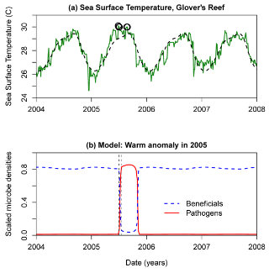
The graph shows a warm anomaly in an area called Glover’s reef in 2005. The anomaly allowed the pathogens to grow very fast and dominate the SMC. The beneficials also didn’t return until almost three months later when the temperature began to drop. What’s even scarier about this is the graph above. In this graph the areas of the thermal anomaly are circled in black. These areas are only 1˚C more than the highest temperatures of the previous years. The pathogens were able to overcome the SMC with a margin of 1˚C. As the global temperature rises, this change in temperature does not seem too far out of the realm of possibility. Furthermore, in order for beneficials to again dominate the coral, conditions must become considerably unfavorable for the pathogens. This means that even when normal conditions for the beneficial bacteria returns, the pathogens will still dominate.
The amount of antibiotic bacteria in bleached corals is often very low. Even when the corals recover and gain their zooxanthellae, the antibiotic bacteria have not fully returned. This means that the amount of pathogens and beneficial bacteria are directly related to coral bleaching. The Cornell model is a useful tool for highlighting the interactions in the surface microbial community of coral. It can predict how a habitat will respond to rising sea temperature, and exactly how much stress the coral can take before the change is irreversible. The model also shows that often times it is easier to prevent the SMC from becoming dominated by pathogens, than it is to reverse the process. Mathematical models are a good way to address problems and prove that there actually are problems. These models are a good direction for future coral reef research, and will aid in reef preservation techniques.
Coral reefs are under a lot of stress in the world today. Humans remove keystone species, alter the acidity and temperature of ocean water, and affect reefs in various different ways. Realizing the effects of global warming, as well as increasing CO2, is a crucial part in understanding coral reef degradation. Adding CO2 increases the pH of reefs seriously harming the CaCO3 structure of coral. Global warming raises the temperature of water, increasing the amount of pathogens in the surface microbial community. Part of the reason that very little has been done about these is that, to this day, global warming is a very political argument. As it is argued, less is being done to resolve the issues and the bad effects are compounding. 93 out of 109 countries with reefs have experienced some type of reef damage. Mild to severe bleaching is evident in almost every reef around the world. If reefs were to disappear, the world would lose a very important habitat, many important species would be lost, and something very beautiful would be destroyed. However, there are ways to help reefs. Through education, and increased public awareness, reef degradation can be put on the map. Mathematical models, such as the Cornell model, help to show what is happening to our coral. They are a very important step moving forward because of how they highlight problems that may not otherwise be very obvious. If more people could see and understand these models, then more could be done to help prevent coral reefs from being destroyed.

Wells, Sue/Hanna, Nick. The Greenpeace Book On Coral Reefs.
Ibid.
Coral reef ecosystems. Reef relief.
Roessler, Carl. Underwater Wilderness.
Ibid.
Ibid.
Wells, Sue/Hanna, Nick. The Greenpeace Book On Coral Reefs.
Ibid.
Aronson, Richard. Geological Approaches to Coral Reef Ecology.
Tans, Pieter. www.esrl.noaa.gov/gmd/ccgg/trends
Science Daily. Increasing CO2 threatens coral reefs.
Sorokin, Y.I.. Coral Reef Ecology
Sorokin, Y.I.. Coral Reef Ecology
Sorokin, Y.I.. Coral Reef Ecology
Mann, Michael. The Hockey Stick and the Climate Wars
Sorokin, Y.I.. Coral Reef Ecology
Ibid.
Mao-Jones J, Ritchie KB, Jones LE, Ellner SP. How Microbial Community Composition Regulates Coral Disease
Ibid.
Ibid.
Ibid.
Ibid.
Ibid.
Ibid.
Ibid.
Ibid.
Wells, Sue/Hanna, Nick. The Greenpeace Book On Coral Reefs.

