Lisa Balesano
May 6, 2013
Professor Little
Montserrat

Cultural Cognition: The Human Papillomavirus

The Cultural Cognition Theory is intertwined with one’s risk-perception. In the article, “Who Fears the HPV Vaccine, Who Doesn't, and Why?” the authors state, “According to that theory, individuals conform their perceptions of risk to their cultural evaluations of putatively dangerous activities and the policies for regulating them.” This article looked specifically at how culture influences the perceptions of risks and benefits of the Human Papillomavirus (HPV) vaccine. The study performed, and similarly discussed in this article, demonstrated that Cultural Cognition was a theory that resulted from people perceiving a risk, and acting in such a manner, due to preexisting beliefs, values, and the ideas that society instills in them.

To begin, it proved pertinent to examine the study from its origin. The researchers’ hypothesized, “that cultural worldviews so defined would generate competing predispositions toward the risks and benefits of mandatory HPV vaccination.” To simplify even further, it was predicted that some populations would view a mandatory HPV vaccination of young female children as having more risk. Contrary to this belief, a different population would perceive the vaccination with significantly much less of a risk, or in other words, beneficial to the patient’s health. The study differentiated those who viewed a higher risk as “hierarchy” and “individualists”, contrary to those who thought the vaccination beneficial were categorized as “egalitarian” and “communitarian”. The hypothesis attributed the beliefs of hierarchy and individualists stating, “the former because mandatory vaccination of school girls seems to condone sexual behavior that defies traditional gender norms, and the latter because mandatory vaccination intrudes on individual decision-making.” On the other hand, those who perceived less risk would likely do so because, “such a program seems to express tolerance for behavior that denigrates traditional, patriarchal norms and embodies collective commitment to the provision of a good essential to individual well-being.” In order to calculate the potential risk-benefit of the HPV vaccination, or of any vaccination for that matter, it would be valuable to examine the virus in its entirety.

The Human Papillomavirus was one of the most frequent sexually transmitted infections (STI) found in sexually active females. After years of research, the HPV virus has been classified in over 100 types, some being high-risk, while others were identified as being low-risk. The strands of HPV viruses labeled as being high-risk were done so because of the likelihood the contraction of the virus could possibly lead to cervical cancer. In the article, Risk Messages and the HPV vaccine, the authors stated, “Two high risk types (types 16 and 18) are responsible for about 70% of cervical cancer cases, and two low risk types (types 6 and 11) cause about 90% of genital warts. All cases of cervical cancer can be traced back to one of the cancer-causing HPV types.” The HPV virus has come to affect many females, and as the data suggested, the possibility of developing cervical cancer was certainly problematic, but even so, one of the most controversial issues at hand has been whether or not to institute mandatory vaccination for females age eleven to twelve (recommended by the Center for Disease Control). These ages were specified due to the infrequency of a girl of these ages to be sexually active.

Cultural cognition in relation to HPV has permeated society in large part through the social institution of religion. Since many religions and cultures gave weight to the absence of pre-marital sex, these populations would deem it unnecessary for their youth to be vaccinated against something they theoretically would not be exposed to until marriage. Alternatively, cultures in favor of the HPV vaccination programs would argue the fact that one’s ability to prevent 70% of cervical cancers outweighs any uncertainties that came with an individual’s choice to neglect the safety of their own daughter. One derivative of culture, which has attracted attention, was that of parents, and more specifically, mothers.

One of the most interesting concerns of the HPV vaccine was seen through the eyes of mothers. Having already discussed the major risks and benefits of the vaccination, a mother must weigh the pros and cons, and develop a stance either for, or against the vaccination of her daughter. A few thoughts a mother may have while determining an answer: If vaccinated before becoming sexually active, their daughter may be motivated to have sex; If vaccinated after becoming sexually active, her daughter may be naïve to think that they are immune to all STDs, and can therefore have increased amounts of sex and even unprotected sex; The second belief could lead to her daughter becoming pregnant and/or contracting other STDs; Finally, the vaccination may have unanticipated side-effects on her daughter. These developed reasons were seen as a result of Cultural Cognition. The mother generated her beliefs due to a variety of cultural ideals, whether it is religion, motherly instinct, or societies emerging studies having instilled fear.

Furthermore, there have been an abundance of arguments encouraging those against the HPV vaccination. Although cancers have been a leading cause of death across the world, people against the vaccination point out that cervical cancers amount to less than one percent of all cancer cases in the United States each year. Also, having mentioned that strands 16 and 18 account for 70% of cervical cancers, the HPV vaccination does not diminish the risk of the other 30% of cervical cancer cases. In elaboration, the vaccine would not sufficiently eradicate all strands of the HPV virus, and it would be inaccurate for the vaccinated females to believe it was impossible to contract any of the other HPV strands incorporated amongst the 30%. It was this false belief that allowed vaccinated females to have unprotected sex, increasing the odds of pregnancy, HPV, and other STDs or STIs.

In contrast, the arguments in favor of the HPV vaccine were quite extensive as well. First and foremost, approximately 50% of sexually active Americans contract the HPV virus, which, as was mentioned, was the leading cause of cervical cancer. Those who favor mandatory HPV vaccination argue it beneficial to prevent the 70% chance of contracting cervical cancer caused by strands 16 and 18. Also, this same group believed that it was crucial for girls to get vaccinated before they are sexually active, since once they have been exposed to HPV through sexual activity, the vaccine will not be effective. This was an important message to get across to those who were less informed of the virus itself. Finally, to contradict those who believed the vaccination would promote more prolific unprotected sex, supporters argue that since girls do not fully understand what HPV is at this age, it is irrational to claim that the vaccine will cause them to engage in more sexual activity after being vaccinated. The majority of material presented suggested that the most effective tool to introduce mandatory vaccination was to make the public, specifically young females and their families, aware of HPV and the risks that come along with the virus.

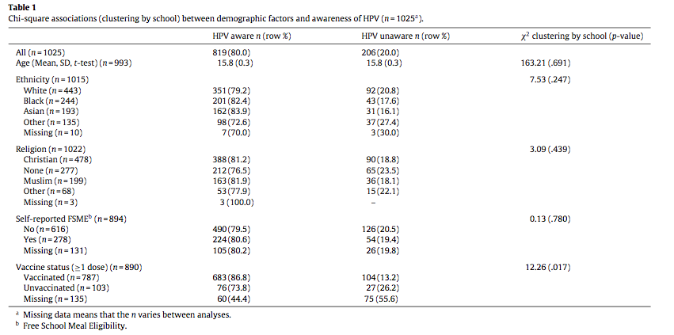

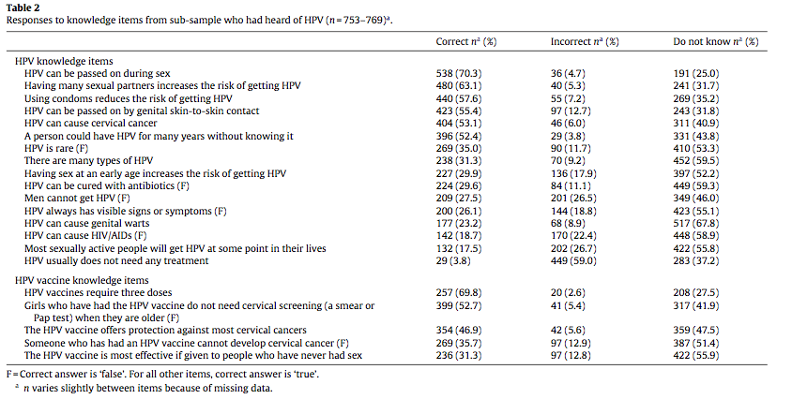

Tables 1 and 2 serve as an illustration of data determining the awareness of HPV amongst young females. Although the study demonstrated that out of 1,025 participants who had a school vaccination program in tact, 80% were aware of HPV and the subsequent 20% were not aware of the virus, these statistics did not tell the full, unpleasant story behind HPV. First, it could be noted when working with such a high profile element, the percentage of those aware of the virus should be much closer to 100% than what 80% truly exemplified. Next, table 2 depicted from a study of 753 to 769 participants that some females may have been aware of HPV, but they did not understand the full extent to which it was a problem. In this study, an alarming 59.3% of respondents did not know that there are many types of HPV. Similarly, only 17.5% of females were answered correctly, saying “most sexually active people will get HPV at some point in their lives.” It was also interesting to observe that in response to the question, “HPV can cause cervical cancer”, 40% answered that they did not know, and 6.0% responded incorrectly. Understanding that almost 50% of participants were unaware that HVP could cause cervical cancer illuminated the fact that these young women were not educated about all the issues the virus carried with it. Along with that, in relation to the vaccine itself, 53.1% of participants were not aware of the statement, “The HPV vaccine offers protection against most cervical cancers.” (47.5% did not know and 5.6% answered incorrectly) And finally, a mere 31.3% of females answered correctly to the statement, “The HPV vaccine is most effective if given to people who have never had sex before.” Even though the information provided from these tables illustrate a lack of knowledge of a prevalent STI amongst the affected population, informed knowledge of HPV would be possible to implement.
Upon returning to the “Who Fears the HPV Vaccine, Who Doesn't, and Why?” article, it was important to analyze the statistics found in the performed study. The authors returned back to their hypothesis by saying, “As expected, hierarchy and individualism, particularly when combined, disposed subjects to be more concerned, egalitarianism and communitarianism to be less, about the risks of HPV vaccination.” Furthermore, the authors believe that such a study, along with similar studies, promote arguments in favor of the cultural cognition theory. This was made more concrete when the writers’ said, “Large-sample surveys furnish support for cultural theory because they reveal that risk perceptions are distributed across persons in patterns that can be cogently explained only if individuals’ values are exerting an influence-one independent of myriad other factors associated with variance in risk perception- on individuals’ beliefs about societal dangers and how they should be abated.” In the Conclusion of this paper, the authors wrap up their thoughts by applying the findings of their study to the broader world. As a response, it was stated, “even when citizens share a commitment to tolerating ways of life that differ from their own, they are likely to divide into bitter cultural factions as they deliberate over policies to mitigate damage to the environment, repel external threats, and promote public health.” It was these cultural factions which society must address when determining whether or not mandatory vaccination for HPV would be more beneficial than harmful, or vice versa, to public health.

The discussion concerning mandatory vaccinations for the Human Papillomavirus has been scrutinized by a variety of groups and individuals. A parallel has been observed between different beliefs attributed to the vaccination and the culture one belongs too. In conclusion, having conducted this research, I feel informed enough to be confident in my decision to get vaccinated. Additionally, I believe that school vaccination programs would be beneficial in the sense that it would provide girls with access to the vaccine if they so desire. However, I feel strongly that it is important for girls to be well informed on HPV before they decide what is best for them.

References

ABDELMUTTI, N., & HOFFMAN-GOETZ, L. (2009). Risk messages about HPV, cervical cancer, and the HPV vaccine gardasil: A content analysis of canadian and U.S. national newspaper articles. Women & Health, 49(5), 422-440. doi:10.1080/03630240903238776
Arkush, D. J. (2008). Situating emotion: A critical realist view of emotion and nonconscious cognitive processes for law and legal theory. Brigham Young University Law Review, 2008(5), 1275-1366. Retrieved from http://ezproxy.holycross.edu:2048/login?url=http://search.ebscohost.com/login.aspx?direct=true&db=aph&AN=36605029&site=ehost-live
Bendik, M. K., Mayo, R. M., & Parker, V. G. (2011). Knowledge, perceptions, and motivations related to HPV vaccination among college women. Journal of Cancer Education, 26(3), 459-464. doi:10.1007/s13187-011-0200-8
Bharadwaj, M., Hussain, S., Nasare, V., & Das, B. C. (2009). HPV & HPV vaccination: Issues in developing countries. Indian Journal of Medical Research, 130(3), 327-333. Retrieved from http://ezproxy.holycross.edu:2048/login?url=http://search.ebscohost.com/login.aspx?direct=true&db=aph&AN=47029933&site=ehost-live
Bowyer, H. L., Marlow, L. A. V., Hibbitts, S., Pollock, K. G., & Waller, J. (2013). Knowledge and awareness of HPV and the HPV vaccine among young women in the first routinely vaccinated cohort in england. Vaccine, 31(7), 1051-1056. doi:10.1016/j.vaccine.2012.12.038
Cooper Robbins, S. C., Bernard, D., McCaffery, K., Brotherton, J. M. L., & Skinner, S. R. (2010). “I just signed”: Factors influencing decision-making for school-based HPV vaccination of adolescent girls. Health Psychology, 29(6), 618-625. doi:10.1037/a0021449
Griffiths, M., & Brooks, D. J. (2012). Informing security through cultural cognition: The influence of cultural bias on operational security. Journal of Applied Security Research, 7(2), 218-238. doi:10.1080/19361610.2012.656256
Kahan, D. M. (2010). Culture, cognttion, and consent: Who perceives what, and why, in acquaintance-rape cases. University of Pennsylvania Law Review, 158(3), 729-813. Retrieved from http://ezproxy.holycross.edu:2048/login?url=http://search.ebscohost.com/login.aspx?direct=true&db=aph&AN=49222726&site=ehost-live
Lechuga, J., Swain, G., & Weinhardt, L. (2011). Impact of framing on intentions to vaccinate daughters against HPV: A cross-cultural perspective. Annals of Behavioral Medicine, 42(2), 221-226. doi:10.1007/s12160-011-9273-1
Sopracordevole, F., Cigolot, F., Gardonio, V., Giuseppe, J., Boselli, F., & Ciavattini, A. (2012). Teenagers' knowledge about HPV infection and HPV vaccination in the first year of the public vaccination programme. European Journal of Clinical Microbiology & Infectious Diseases, 31(9), 2319-2325. doi:10.1007/s10096-012-1571-4
Wong, L. P. (2008). Young multiethnic women's attitudes toward the HPV vaccine and HPV vaccination. International Journal of Gynecology & Obstetrics, 103(2), 131-135. doi:10.1016/j.ijgo.2008.07.005

3

Who Fears the HPV Vaccine, Who Doesn't, and Why? An Experimental Study of the Mechanisms of Cultural Cognition
Ibid
Ibid
Ibid
Risk messages and the HPV Vaccine
Ibid
Table 2
Who Fears the HPV Vaccine, Who Doesn't, and Why? An Experimental Study of the Mechanisms of Cultural Cognition
Ibid
Ibid

