Clare Crowell
Prof. Little
Mont 104N-01
6 May 2013
Changes in Wildlife
Although change is normal and often a part of life, constant and drastic changes to the landscape can be detrimental both to the wildlife and human life. The landscape of New England is constantly changing both naturally and due to human manipulation. The amount and type of wildlife present in an area results from what we do with the land. Although natural disasters can alter the landscape, it is human actions that contribute to the most change over time. There have been transformations in the land over the years, but more recently the changes have been bigger and have contributed to issues with conservation and social issues. I agree with Foster and Motzkin that the Massachusetts and New England landscapes have been inconsistent over the years which has led to issues with the wildlife. I think we need to restore the land as much as we can to its original state while also finding a way to balance the growing human and wildlife populations.
Because humans have had such a large role in the change in wildlife, it is important to look at the changes in human settlement in Massachusetts over the years. Many Native American tribes occupied Massachusetts before the Europeans settled in 1620. During this time period they had a lot of plot lands and woodland territories for hunting game. These Native tribes were concentrated in coastal and riverine areas but hunted regionally for terrestrial, freshwater and marine wildlife. While the Native Americans coexisted fairly well with the wildlife, the clearing of the land for encampments hurt the surrounding habitats. Although when the Pilgrims first arrived to Massachusetts Bay in 1620 they lived similarly to the Native Americans, once construction improved the Europeans proved to be more destructive to the land. Not only did the Europeans destroy much of the habitat in the New England area, they also impacted much of the wildlife when they wiped out many of the Native Americans with the European diseases. This change in the Native American population led to decreased hunting pressure and change in the surrounding encampments. Although there were fewer Native Americans, more Europeans arrived at the New World and settled more land. Settlement at the base of Cape Cod led to harvesting lots of taxa and also led to efforts to get rid of “vermin” species. As these settlements became more populated and organized they turned into towns and then cities, which took up more space. The nineteenth century became an industrial economy, which led to a decline in the agricultural landscapes and forests. The forests that were still present were more spread out because the cities and towns were dispersed throughout the area. In Figure 1 it shows that during the late 1800s the amount of forest cover was at an all time low. During this time there became concern for conservation, which led to more conservation groups like the Commission on Inland Fishing. Now there are many cities in New England but still many forests, which has created more heterogeneous wildlife habitats.
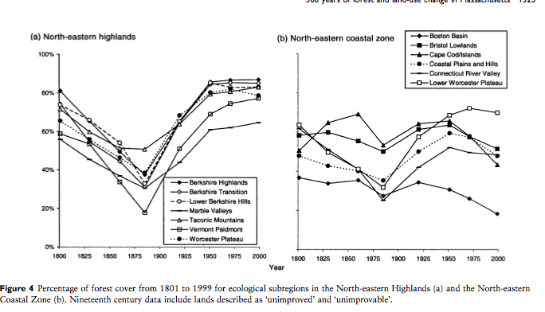Figure 1
When reading about the changes in the landscape of New England I wanted to look at what the changes in the wildlife were as a result of the change in landscape. I learned that Bobolink, Meadowlark and Whippoorwills were common birds that lived in the open land areas like meadows and old land cleared for farming. The forest dwelling species on the other hand included bears, deer, turkey, moose, eagles, herons, vultures, beaver and fisher. These animals are more commonly seen today.
Today there are not as many Open-land species because the landscape has become more forested. This is not the first time Open-land species have gone through changes over the years. In the beginning of the European settlement these birds and most other Open-land species were uncommon or absent. With increased settlement, however, their populations began to increase because more forest area was being cleared for farming. In the nineteenth and twentieth centuries the populations peaked and are now on the decline because of the increase in forests. This is causing concern for some conservationists because many of the early successional species that are important for forest growth are being wiped out. The early successional species are important for the beginning stages of forest regrowth but because the landscape is changing so rapidly it is hard for the animals to settle and flourish in an area for a long time. This is also a problem for the forest area wildlife.
The larger mammals that live in the wooded areas have experienced fluctuations in their populations because of these landscape changes as well. These large animals like moose, bears and deer need large mature forests to survive and were extensively hunted as the human population in the area increased. Like the Open-land species, the forest species exhibit long-term historical patterns of decline and recovery. The populations of the forest wildlife corresponded with the open-land species because when the open-land species had high populations, the forest animal populations were much lower. Today, the forest animals are increasing due to rebounding naturally or through reintroduction. There have been increased sightings of deer, moose and bears in yards, which have caused conflict between the wildlife and humans.
When reading about the animals that are currently becoming more populated in the Massachusetts and New England areas I was very interested because I have witnessed these changes. Having lived in a small town in Massachusetts my whole life I have grown up seeing deer in my backyard and have heard stories about bears roaming around neighborhoods in the area. In order to break down the changes in wildlife even more, I looked up the population patterns of several animals in the area.
Although I have not seen the effects of the increased beaver populations directly, they have become a major issue between humans and the wildlife in New England. When humans in rural areas used trapping and shooting methods of killing beavers the population was not very high. When the Massachusetts population began to increase it also led to a change in landscape and human attitudes and perception of nature. More and more people became focused on wildlife management laws and regulations. Recent restrictions on trapping regulations have resulted in a high survival rate of both juvenile and adult beavers and have also led to a consequent exponential growth in the population. This increase in the beaver population has led to significant problems with humans. When the beavers build their dams, they block water from flowing freely down a river resulting in water build up at the dams. Because homes are so close together and to the dams, the flooding has damaged basements and foundations of homes across the area. What is even more difficult is that the beavers are hard to remove because the pest control management is very time and area specific. Because humans are having trouble diminishing the population of beavers on their own, I think we also need to figure out more natural ways of lowering the population of beavers. When trying to think of natural ways these animals are killed, I wondered how predators control the beaver populations. I learned that because beavers are fairly large and live in a habitat with few enemies, they are not preyed on much by other animals. One piece of information I did notice was that bears are one of the predators of beavers, which led me to look into the bear population.
After discovering that bears were one of the predators of beavers I was interested to see how the bear population compared to that of the beavers. What I noticed was that although the bear population has increased significantly over the past few years, compared to the beaver population, the bear population is not as high. The figure on the left shows the bear distribution in Massachusetts in 2002. The figure shows that a little less than half of Massachusetts has bear present. In 1998, the beaver present in Massachusetts covers almost a third of the state. Comparing these figures helped me make sense of why the beaver population has gotten so big; there are not as many predators out to kill the beavers. Although the bear population is much lower than the beaver populations, the bears still pose a threat to the humans living in areas where the bears are present. This issue surrounding the increasing bear population is difficult because bears are an important part of the life cycle. If we get rid of a lot of the bears, there will not be as many animals preying on the smaller wildlife, which will lead to an increase in those populations.

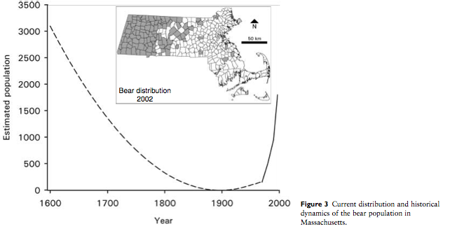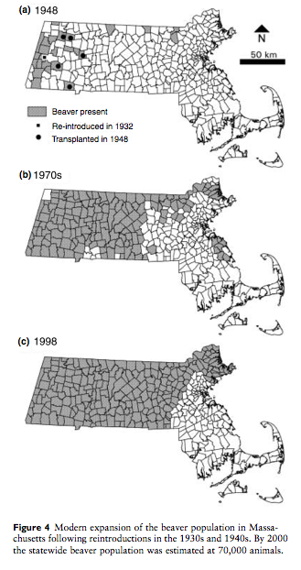
Figure 2 Figure 3
While bears and beavers have been on the incline, many birds that live in open areas have been on the decline. In 1839, there was the first attempt to study the bird populations. During the height of agricultural period around 1850 there were many upland sand-pipers. Later came the vesper sparrows, which were common in open fields and pastures in 1925. These trends were similar to the trends of the bobolink, meadowlark, northern bobwhite and red-wing blackbird. They all thrived in low intensity agriculture and open fields. The populations decreased when the land became more forested. Reading about the changes in the bird populations did not surprise me. Having read about the change in the landscapes and the other animals in the area, I knew that the bird populations would have changed similarly to the other populations. When looking at the graphs of the birds I wanted to see how the populations of the forested animals compared. I looked at the graph of the deer population and saw that just as the bird populations were increasing the deer populations were decreasing. I saw that in the mid-1800s the bird population was at its highest (Figure 1) while the deer population was at its lowest point (Figure 2). This further justified my idea that there could not be an overlap between the open-land species and the forest species. The landscape could not hold two opposing species at once, which leads to the diminishment of one.
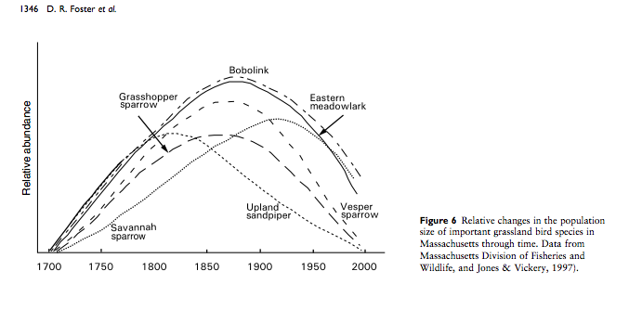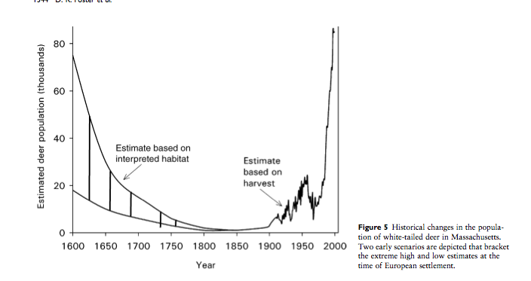
Figure 4 Figure 5
Because the landscape continues to change we can expect an increase in some species while a decrease in others. With these continual changes comes increasing conflict between humans and animals because the human and wildlife populations continue to increase. The problems with deer and moose altering forest composition and being hazards on the roads will be an issue that we need to address. In areas where humans live in highly wooded areas, we will need to help protect against bears and coyotes that have become accustomed to humans. While there are concerns for human safety and personal property because of the actions of various species, we also need to recognize that we are a threat to these animals and their habitats. We need to find a balance between maintaining prosperous lives for both the humans and wildlife.
After reading several articles and looking at numerous graphs, it is clear that there is a relationship between the change in wildlife and landscape that is mostly due to the actions of humans. I do not think this constant human manipulation of the land is healthy for the wildlife or the humans. I think the best solution to this problem is to try and restore as much of the land as we can to its original and natural state. New England is an area perfect for thick forests. There is a reason the land is not made up of great plains and a lot of open land. The world is made up of many different landscapes and we need to let these landscapes take their natural state. If we continue to change and manipulate these landscapes we will lose the rich and healthy habitats and wildlife that they contain.

References
DeStefano, S., Koenen, K. K. G., Henner, C. M., & Strules, J. (2006). Transition to independence by subadult beavers ( castor canadensis) in an unexploited, exponentially growing population. Journal of Zoology, 269(4), 434-441. doi:10.1111/j.1469-7998.2006.00160.x
Foster, D. R., Motzkin, G. "Ecology and Conservation in the Cultural Landscape of New England: Lessons from Nature's History." Northeastern Naturalist 5.2 (1998): 111-. ProQuest. Web. 19 Apr. 2013.

Foster, D. R., Motzkin, G., Bernardos, D., & Cardoza, J. (2002). Wildlife dynamics in the changing New England landscape. Journal of Biogeography, 29(10), 1337-1357. doi:10.1046/j.1365-2699.2002.00759.x
Jonker, S. A., Organ, J. F., Muth, R. M., Zwick, R. R., & Siemer, W. F. (2009). Stakeholder norms toward beaver management in Massachusetts. Journal of Wildlife Management, 73(7), 1158-1165. doi:10.2193/2004-160
Lent R. 2003. Breeding Bird Species at Harvard Forest 1993. Harvard Forest Data Archive: HF058.

MCDONALD, J. E., CLARK, D. E., & WOYTEK, W. A. (2007). Reduction and maintenance of a white-tailed deer herd in central Massachusetts. Journal of Wildlife Management, 71(5), 1585-1593. doi:10.2193/2006-490
"New England." History of. N.p., n.d. Web. 06 May 2013.

