Montserrat Natural World
Final Paper

“An Inconvenient Truth”: Are hurricanes being caused by Global Warming or are they just a correlation?

By: Robert Indeglia

Our world is under the impression that it is going to be destroyed by Global Warming. Many people believe that yet many people oppose that same statement. Al Gore is one of those people who believes it is a major problem. He wants to draw every government to his cause so that the problem can get fixed. Whatever his cause is, he is right because glaciers are melting, sea levels are rising, and many climates are changing. However, in his movie “An Inconvenient Truth” some of his information is not correct. While the movie is very educational and can draw an audience’s attention to the problem at hand, some of the things he is saying are not true. Al Gore states, in “An Inconvenient Truth”, that storms are increasing and increasing in strength due to global warming but that statement is not true. While data shows that storms may be increasing and have occurred more recently in the past that does not mean they are caused by global warming, they are simply a correlation between global warming and an increased amount of storms.
In this movie Al Gore talks about storms and how he believes they are directly caused by global warming. Well that has not been scientifically proven yet, so therefore, they can only be related or have a correlation between the two. The difference is simple; storms and global warming are simply a correlation and may or may not be caused by one another. Later on we shall see why Al Gore is wrong and how they truly are just a correlation.
“An Inconvenient Truth” was created by Al Gore to educate the general public about Global Warming and Climate Change. His goal was to educate the public and make them more aware of what was going on in the world. He also wanted governments to take the movie seriously so that they could respond and take the problem more seriously. Al Gore references many scientific opinions on the matter and talks about how the approach should not be political but moral. He says that we all have a moral duty to fix the problem otherwise the planet will suffer and eventually we will suffer.
The main point of Al Gore’s presentation was that we as humans were responsible for what is going on. Through the excessive amounts of CO2 gases that we have released into the atmosphere we have sped up global warming. Through the increased amounts of CO2 we have destroyed our ozone layer, allowing more heat to enter our planet which in turn results in many different scenarios. Gore uses a graph from his book (26-27), the Mauna Loa Observatory, to show how much CO2 is in the atmosphere. It dates back to about 1960. Clearly, in the graph, there was a lot less CO2 in 1960 than 2005. This would seem that this has certainly caused global warming but it has not been fully proved. It just seems that way. Like many of the topics that Al Gore talks about, a lot of them are just related to global warming not caused by global warming.
Al Gore talks about storms, glaciers melting, rising sea levels, droughts, torrential rains, and the effects all of those things will have on our planet. One common cause of all these events is temperature. Temperature to a person who believes Global Warming is a problem, like Al Gore, is essential in proving how Global Warming is affecting our world. All the events that Gore talks about have a correlation to temperature. But are they really caused by temperature and Global Warming?
A topic that will be briefly touched upon is the glaciers and rising sea levels. Many scientists believe and support Al Gore’s idea behind this. The scientists in today’s world believe that we must find a way to keep sea levels down and stop glaciers from melting otherwise there will be severe consequences. One of the ways that scientists have studied this is through ice cores. They have measured ice cores which have helped them determine CO2 levels from centuries ago. They have determined that the CO2 levels of today are higher than what they were centuries ago. This makes Gore believe that CO2 levels are causing an increase in temperature which in turn is causing glaciers to melt. With glaciers melting the result is higher sea levels which are endangering many coastal areas. Scientists believe that this is one of the soundest arguments about global warming, that glaciers are melting due to the rise in temperatures.
In order to find out why hurricanes are increasing, according to Al Gore, knowledge of how they form is essential in determining exactly what part of the hurricane is being altered. Meaning is it the wind, water, or heat that is causing hurricanes to increase. A hurricane forms only over warm ocean waters usually nearest to the equator. The reason being for this is that hurricanes need warm, moist air to form. This warm, moist air just above the surface of the ocean rises upward creating less air near the surface. With that air rising there is an area of lower air pressure left behind thus allowing air from high pressure areas to push into the low pressure area. The air that filled into the lower pressure area becomes warm and moist and also rises. With this process repeating surrounding air swirls around and actually cools the warm air which causes water to form within the clouds. Then the clouds begin to swirl and grow from the incoming moist air generating a powerful hurricane. A hurricane grows in intensity if it travels over warmer waters; however, if it travels to colder waters the storm will weaken and eventually turn into just a rainstorm.
The focus of my argument is when Al Gore talks about how Global Warming has caused an increase in hurricanes and other storms. He also says that the intensity of these storms has also increased over the years. The reason being Gore said this is because of the warmer water in the southern oceans, like near the Gulf of Mexico, has caused more hurricanes. According to Gore, the water is warmer because the temperature of our atmosphere has increased that it has to increase the water temperature as well. In the book, An Inconvenient Truth, Gore states a lot of facts and data about hurricanes. He throws numbers around the pages to make it seem like hurricanes are such a big problem and are being caused by Global Warming. He does not provide any hard, scientific evidence backing up what he says. He is mainly trying to get his point across that Global Warming is an issue.
The first thing that Gore talks about when he mentions hurricanes is how a hurricane hit South America. The hurricane hit Brazil and many people were shocked by it. He even goes on to say “They (science books) said it was impossible to have hurricanes in the South Atlantic, but that time for the first time ever a hurricane hit Brazil.” (Gore, 59). He goes on to talk about Hurricane Katrina and how it got stronger over the waters of the Gulf of Mexico. He shortly explains that Hurricane Katrina was one of the worst hurricanes in more recent history. It was one of the most devastating hurricanes during the first decade of the 21st century. Gore uses this section to alarm the general public about what could happen if nothing is done. He wants the public to react to his film and if he can get the public scared a bit by having them realize that hurricanes are increasing by Global Warming. And if the public realizes they are the reason Global Warming is increasing then they certainly will want to do something to prevent hurricanes especially if they are growing in intensity.
Al Gore continues with a few more statistics that make it seem like hurricanes are a direct result from Global Warming. He said in 2004 there was a record year for typhoons that hit Japan. The year before there was only six typhoons that hit Japan, in 2004 there were ten. A typhoon is the same thing as a hurricane it is just named differently than a hurricane in the Pacific Ocean. Also, Gore said that in 2005 for the World Meteorological Organization they had to go through the entire list of names for hurricanes and tropical storms. There were over 25 tropical storms that year which caused the World Meteorological Organization to have to go through the Greek Alphabet for the first ever.
So with this information Gore has given the public through his book and his movie it would seem that Global Warming is certainly causing an increase in the amount of hurricanes and its intensity. However, the one thing Gore has failed to mention or even provide is proof. He is lacking scientific evidence proving his claims. What Al Gore is saying about Global Warming is not wrong but certainly not right. It is much more accurate to say that there is a correlation between Global Warming and hurricanes.
One of the best findings was a graph that contained information on hurricanes that have hit the United States since 1850. (See Figure 1 at the end of the paper) The graph was broken up into decades and had two columns; one column for total amount of hurricanes and another column for hurricanes that hit with a category of three or higher. During the late 1880s and into the early 1900s there was an excessive amount of hurricanes. However, from 1960 to 2000 the numbers are much less. According to this graph the amount of hurricanes that have struck the United States has been pretty low, compared to what Al Gore said about hurricanes. When the graph reaches the year 2000, the amount of hurricanes jumps back up to just over twenty, indicating that there really is no pattern to how often hurricanes form. Even the intensity of the hurricanes has not risen drastically over the time period of this graph. Again, the graph does not indicate any patterns or any indication of an increase or decrease in the intensity of hurricanes. In fact, on average it looks as if the amount of hurricanes (category three or greater) that have hit the United States has been about the same for almost 150 years. The moral of this finding is that numbers do not lie.
That was the first piece of evidence that I used to back up my claim that Global Warming is connected to hurricanes. The next piece of evidence I consulted was a graph from the NOAA National Climate Data Center (Figure 2). This graph is of temperature anomalies over the past sixty years. Without a doubt the temperature of our planet has increased from 1950. In some cases the temperature is only .5 degrees Celsius or .6 degrees Celsius above the average temperature. The point of consulting this graph is to see if the temperature of the world has increased and it has. But still Al Gore did not show any data like this when he was talking about hurricanes. He mentioned it earlier in the book but only in regards to Global Warming. If Al Gore used a graph like this and was able to relate this graph to a specific part of the process in how a hurricane forms then that would provide more evidence to a reader that Global Warming really does cause an increase in hurricanes. However, that has not been done because it is very “far-fetched.” What is far-fetched is that while the temperatures are steadily increasing (some years are lower than others, but the over graph is increasing) the number of hurricanes are not increasing with the temperature.
Connecting the last two paragraphs together shows that Global Warming is not causing an increase in hurricanes, in either the amount of hurricanes or the intensity of hurricanes. The numbers just are not there. The temperatures of the world do not match up with the amount of hurricanes. Even if you looked at hurricanes in one part of the world, you would still not see a pattern. While temperature is easier to predict than weather, finding patterns in weather is extremely tough. Just looking at so much data of temperature and hurricanes one can see that it is very difficult to pick up on a pattern.
While I just talked about hurricanes I am now going to talk about heat waves, droughts, and rainfall. Al Gore alluded to this in his book and movie as well. Gore stated in his book that Global Warming has caused excessive dry spells and floods. He provided a graph that showed the amount of floods worldwide has increased since 1950. He also showed on a picture of the world, through blue and orange dots, how precipitation in many parts of the world has changed. The blue dots represent an increase in precipitation and the orange dots represent a decrease in precipitation. However, here is how this data is actually flawed. In parts of the world, especially Africa, it does not rain nearly at all. So in some cases the areas that get hardly any rain and now are getting maybe ten more inches than they usually do (originally get like 6-8 inches per year) which makes the data look worse than it actually is. Also, this data table does not give us a time table which makes it hard to compare the precipitation changes with previous years.
One of the examples that I used in my presentation was the Australian Climate. In Sydney, Australia each year the climate is very unpredictable. Some years there is almost no rain and other years there is a lot of rain. It is not because of the Global Warming but rather because that’s how their climate is. Australian scientists have not connected it with Global Warming or Climate Change because it is natural for them. While they are getting hit with a lot of hot days and breaking a lot of records in the heat category, scientists still have not connected the weather to Global Warming. This is just one example of how some climates have not been affected by Global Warming.
The third graph (Figure 3) I chose to use contains information about rainfall in the city of Los Angeles. Los Angeles is an incredibly large city and a very busy one. The point is, a lot goes on there and if the climate was to change the city will certainly be impacted. So I took a look at the amount of rain that Los Angeles has received on average to determine whether the climate there has changed. The average amount of rain per year in Los Angeles is about 14.95 inches. The graph dates back to 1875 and clearly shows that the amount of rain that Los Angeles has received does not have a pattern. In certain years it was way above average and other years it was just below average. Recently it shows that the last few years were right around the average. Two out of the last three were below the average. But like the amount of hurricanes per year there is not a pattern. The amount of rain is not constantly decreasing or increasing. It is like a roller coaster, going up and down.
So in conclusion Global Warming has not caused an increase in hurricanes or an increase in the intensity of hurricanes. Global Warming also has not had huge effects on many climates. In the data that was looked at the graphs do not show patterns that would indicate Global Warming has a direct effect on weather. There certainly is a correlation because otherwise Global Warming would not be such a huge issue. With what Al Gore is saying regarding hurricanes and heat waves and rainfall is not entirely true. His information is not backed up (as I have stated before) and the information that he does not include goes against what he is saying. Many scientists have refuted his argument that hurricanes are increasing due to Global Warming. Also, some scientists are on board with what he has to say about rainfall, droughts, and heat waves, but they say that he needs work and more evidence to get the backing of scientists. “Gore makes reference to the extreme heat wave that affected Europe during the summer of 2004, and I was glad to see that he didn't blame the heat wave on global warming--he merely said that more events of this nature will be likely in the future. The biggest failure in the movie's presentation of science comes in the discussion hurricanes and severe weather events” (Jeffrey Masters). Jeffrey Masters criticizes the movie and said this about it. He supports what he says but like me, is saying it might be a correlation rather than an effect. He then goes on to bash Gore and criticize him for even thinking of making the connection between hurricanes and Global Warming.

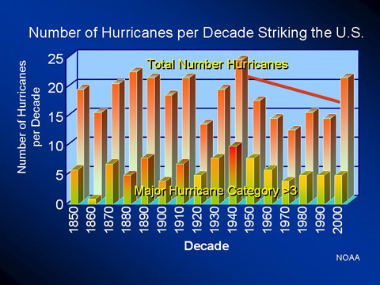
Figure 1

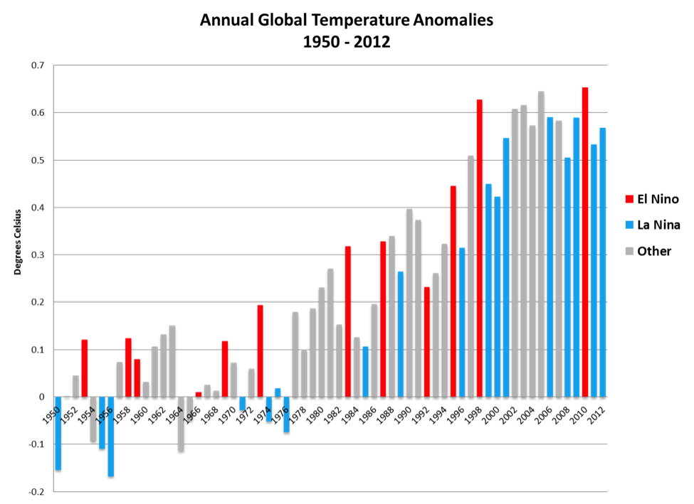

Figure 2

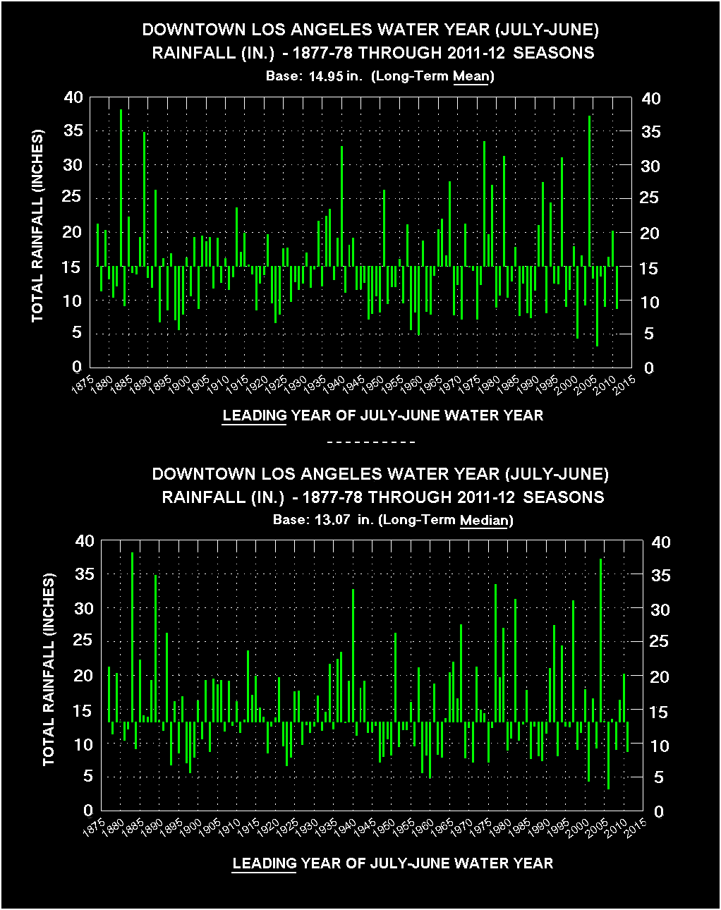
Figure 3

Works Cited Page
- Casola, Joe. "Global Temperatures." Center for Climate and Energy Solutions. , 5 May 2012. Web. 21 Apr. 2012. http://www.c2es.org/blog/casolaj/global-temps-are-still-above-average

- Gore, Albert. An Inconvenient Truth: The Crisis of Global Warming. New York: Viking, 2007
- Masters, Jeffrey. "Al Gore's An Inconvenient Truth." An Inconvenient Truth. Web. 06 May 2013. http://www.wunderground.com/resources/education/gore.asp?MR=1

- Siegel, Matt. "Report Blames Climate Change For Extremes in Australia." New York Times. , 4 Mar. 2013. Web. 23 Apr. 2013. http://www.nytimes.com/2013/03/05/world/asia/australian-government-blames-climate-change-for-angry-summer.html?_r=2&

- How Do Hurricanes Form?” NASA's The Space Place. Web. 06 May 2013. http://spaceplace.nasa.gov/hurricanes/
- NOAA Website for graphs
- “An Inconvenient Truth”, Movie, Albert Gore, Paramount Pictures 2006

