Anabella Perez
Montserrat
Research Paper
Professor Little
May 6, 2013

Climate Change takes a toll on Natural Disasters: Are Humans to blame?

Natural disasters have affected and transformed the way we live. Every year people are constantly impacted by the wrath of natural events. Natural disasters have destroyed property and caused major damages. However, over the past years these weather related storms have increased in numbers and in level of intensity causing millions of lives and leaving many people homeless. Due to the increase in temperature the Earth has been experiencing lately and the increase of greenhouse gases into the atmosphere; humans have seen a lot of changes in the weather. Since natural disasters have become more severe over the years, it has taken a toll on our expenses. Billions of dollars have been spent in order to recover from the damages caused by natural disasters. Anticipated changes might be seen in the years to come, such as heavier rainfalls and extreme droughts and flooding due to the rapid changes in our Earth’s temperature. Over the years natural disasters specifically in the United States have doubled and as the Earth heats up it is more likely that we will be seeing more destructive weather. Therefore, changes in the earth’s climate are taking place and cannot be explained without taking into consideration human influence, through the emission of greenhouse gases.
Nevertheless, these extreme weathers can be identified as tornadoes, earthquakes, tsunamis, volcanic eruptions, floods, droughts, etc. Although humans have always been greatly affected by natural disasters, these past decades have brought extreme weather related storms that humans were not prepared for. These storms have not only cost lives but has cost people around the world billions of dollars in repairs. There has been enough evidence collected over the years to indicate that our climate is changing, and all the fingers seems to be pointing towards the increase of greenhouse gases. The Intergovernmental Panel on Climate Change has assessed the theories of climate change to provide enough information on the correlation between climate change and natural disasters. They also take into account how human activities have influence the increase of greenhouse effects and the huge increase in temperature. Since many of the causes of global warming have been due to anthropogenic activities, it has to be taken into consideration how humans also may have an effect on natural disasters.
Humans are the main contributors to climate change; their influence therefore has been more significantly in the increase of greenhouse effects. “The largest known contribution comes from the burning of fossil fuels, which releases carbon dioxide gas to the atmosphere” (IPCC). As we all know Carbon dioxide (CO2): is a minor but very important component of the atmosphere, when released through natural processes such as respiration and volcano eruptions and through human activities such as deforestation, land use changes, and burning fossil fuels can cause drastic changes toward our environment. Humans have increased atmospheric CO2 concentration by a third since the Industrial Revolution began. This is the most important long-lived "forcing" of climate change. Despite this information there is even a greater concern about the Earth’s atmosphere. Altering the properties of greenhouse gases is the cause of the warming and cooling of the climate. It would be hard to ignore these signs that indicate that humans play a big role in climate change.
Climate scientists have been carefully monitoring natural disaster to see what causes such storms to become more destructive. On the one hand it can be said that climate change is causing these extreme weather storms. It can also be a coincidence that it so happens to be that at the same time the Earth is warming up , natural disasters seems to be increasing too. However, this poses a lot of questions, since there must be a connection to why both events seem to be occurring at the same time. “Most climate scientists agree the main cause of the current global warming trend is human expansion of the "greenhouse effect"-- warming that result when the atmosphere traps heat radiating from Earth toward space.” (NASA) It is known that when greenhouse gases are trapped in the Earth’s atmosphere this tends to also cause an increase in temperature as well. Since Earth absorbs the sun's heat and radiates it back towards space. Then it is the greenhouse gases that counteract that heat loss, trapping the heat, and reflecting it back towards the Earth. If there are more greenhouse gases in the atmosphere, then more of that heat becomes trapped. Therefore, this cannot be good for the environment and the life that is sustained in it.
As the environment is constantly changing so is life around it. If something changes in the environment then that means life in it must adapt to these changes, and if it cannot keep up then it usually becomes extinct. Now such changes have become correlated with weather related storms. Climate change has posed secondary effects such retreat in glaciers, decrease in snow cover, increase in sea level, and etc. Climate scientists therefore, predict that if human activities continue the same trajectory then the future consequences will be pretty drastic. Not only will we probably experience more natural disasters, but the level of damage would be expected to increase as well. If this happens the amount of damage these natural disasters would cause would be something that no humans have ever experienced before.
However, today we can agree that we have experienced warmer weather than usual. Scientists have been able to conclude that the Earth has warmed up by a full degree Celsius. To come to these conclusions scientist have set up computer models to be able to generate data related to climate change. These computer models indicated that natural disasters can bring drastic damages unto our environment if a solution is not found to deal with climate change. National Geographic aired a documentary titled, Six Degrees Could Change the world. This documentary focused on the incremental effects of climate change around the world. It emphasized how changes in the Earth temperatures can be devastating for our environment. For example in the documentary it is quoted that “warming of one degree can turn some of America’s most fertile ranches into deserts” (National Geographic). Humans’ dependency on fossil fuel is a great concern due to the fact that burning fossil fuels contributes to global warming. Humans have depended so much on it that it would take time to change and manage the amount of fossil fuels used on a daily basis. However such measurements have to be taken in order to maintain a healthy and sustainable ecosystem.
Nevertheless, these changes are not only affecting humans but are also affecting the biodiversity in the ocean. The warmer temperatures in the ocean can cause an unequal balance that harms the sea animals that live there. If climate change continues we will see an even greater impact on the marine ecosystem, “we’re likely to lose the fast majority of the world’s tropical coral reefs” (National Geographic). The ocean has been known to take in carbon dioxide which helps distribute the amount there is of it in the atmosphere. However, too much of it can cause the water to become very aesthetic causing the creatures shells and skeletons to dissolve. This then prevents them from also absorbing more CO2. There is also great concern about the rising of sea levels. If ice sheets continue to melt there will be a lot places around the coast that will experience flooding. For example the “yakusa open glacier is the fastest moving high-skilled on the planet more than forty meters per day melting in the scene twice as fast a decade ago” (National Geographic). The scientists have constantly been monitoring the climate change effects on glaciers. They use machines built directly into the glacier to keep track of the glaciers that are disappearing into the sea. If sea levels continue to rise there is a chance that it could rise up to seven meters in the next years. This can be enough to flood a multitude of cities at once. This is crucial since it brings great concerns to how the environment will be able to adapt to such changes. It even raises questions as to where will people live if they are forced to evacuate the coastlines due to over flooding.
One of the theories that have been used to explain the increase in temperature in the Earth’s atmosphere is the Industrial Revolution. It is believed that the Industrial Revolution created machines that led an increase in greenhouse effect and even more during this time period there was also an increase in deforestation. (EPA) Such drastic change in the way society has chosen to live creating machines to make our lives easier has taken a toll in future. “The industrial activities that our modern civilization depends upon have raised atmospheric carbon dioxide levels by about one-third, from 280 parts per million (ppm) in 1750 to 368 ppm in 2000” (NASA). This shows that before the industrial revolution the level of carbon in the atmosphere was not something be concerned about. High level of CO2 can be critical to the wellbeing of humans since it is known that too much of it is not good for the environment.
Nevertheless, if we take a look at the greenhouse gases we can see how each one has a role in impacting the Earth’s atmosphere. For example water vapor is one of the most significant greenhouse gases on Earth. Being the most abundant greenhouse gas, it increases as the Earth's atmosphere warms, but so does the possibility of clouds and precipitation, making these some of the most important feedback mechanisms to the greenhouse effect. Since water vapor is directly affected by temperature increase this causes water to evaporate and it then becomes vapor. (NASA) There is a chart provided by de Sherbinin, A., Warner, K., & Ehrhart, C. that briefly glances over the percentage change in very heavy perception.
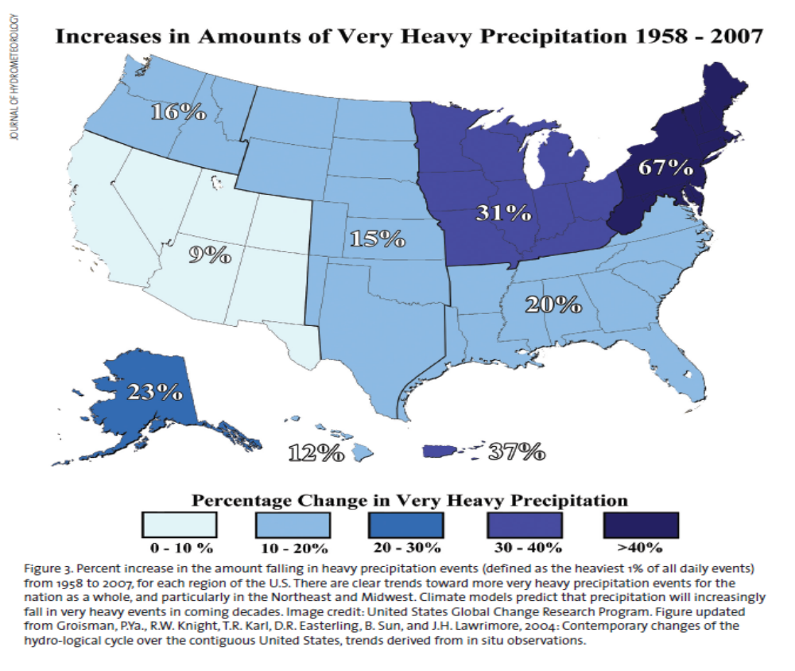This chart specifically focuses on the years of 1958 to 2007. This is a climate model that predicts that rain will increasingly fall in very heavy events in coming decades. This can eventually lead to an increase in coastal flooding if rain becomes heavier in the years to come.
Weather related storms are heavily impacted by the changes in temperature in the Earth’s atmosphere. Severe weather is due to the “source of moisture/humidity for energy source, changes in wind speed and/or direction with height, dynamic forcing such as a cold front” (Knox, Slide5). In a particular analysis on cyclone a researcher named Emmanuel has observed that:
“Global temperatures have risen about 0.5 degrees C since the 1970s, sea surface temperatures in hurricane zones by about the same amount. Emanuel's analysis of past storm data shows this has fueled the cumulative violence of cyclones, far beyond what his initial theories predicted. The overall power dissipation of Atlantic storms rose by about 60%, according to a 2007 paper. The potential intensity, a measure of the upper limit of a storm's strength, had gone up by 10%. Both the average duration and the top speed of storms had also increased, the latter by 25%” (McQuaid).
This indicates that a change in climate is greatly affecting these weather related storms. Storms are becoming stronger than expected and the damages are becoming uncontrollable as well.
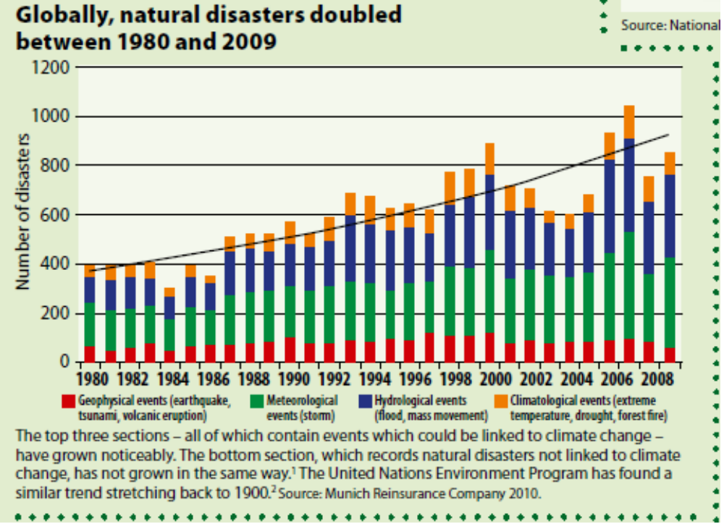Another chart provided by New Internationalist showed the number of natural disasters between the years 1980 to 2008.

This chart indicated that over this period of time natural disasters had double in amount for example in the year 1980 the number of natural disasters was roughly 400 while around the year 2000 we can see that the amount quadrupled and in 2006 it increased even more. Therefore this chart indicates that there are factors contributing to the increase of natural disaster every year. There are colors provided to represent a natural disaster. Red signified the geophysical events such as earthquakes, tsunamis, and volcanic eruptions. Green represents meteorological events such as storms. Blue represents hydrological events such as flood and mast movements and lastly orange represents climatological events such as extreme temperatures, droughts, and forest fires.
Despite the amount of skepticism generated by many anti- climate deniers, there has been research that explains the effects of warm and cold temperatures.
“Meta-analysis combining world regions indicate that cold and warm extreme temperatures are rising globally, possibly with greater warming at the cold end (Alexander et al., 2005). In Europe, daily high temperatures are rising more in summer than in winter (Moberg and Jones, 2005), and warm extreme temperatures are rising twice as fast as cold extremes are warming (Klein Tank and Können, 2003). A Spanish study looking at the longer time scale 1894-2003 found the rise in warm days is particularly pronounced since 1973” (Brunet et al., 2005).
This indicates that over the next decades if temperatures continue to increase it is more likely that we will have a warmer period than usual and our winters will be warmer as well. This will take a great toll on our environment for many of the biodiversity will be greatly affected, since many of the animals will be forced to adapt to such changes.
Anti- climate deniers may say otherwise about the climate change having an impact on natural disasters. Of the most controversial graphs is the hockey stick graph by Michael Mann. The hockey stick graph became such a contentious issue in the climate change debate after the IPPC published a report on the graph. Climate change deniers became furious that the graph was indicating that the changes in temperature were due to human contributions. Climate change deniers as we all know found a way to use this graph toward their advantage indicating that this graph was not accurate enough because it did not date further back in years. The hockey stick graph was created to show temperatures that dated back to 1000 A.D. it was originally generated by proxy data that helped Michael Mann and his colleagues be able to extend their graph to a millennium. However, the changes in temperature represented in the graph showed that this was due to human contributions something the climate changed deniers would disagree on. Nevertheless, other studies have confirmed the general pattern in the graph and have used it to explain other studies that are related to the topic of climate change.
There is also a chart supported by climate change deniers it specifically references to the number of tornadoes during the years 1950 to 2011. It is titled “is climate change to blame?” for a specific reason. Scientists believe that because there is not a decade’s long increasing trend in the numbers of tornadoes stronger than EF-0 we cannot imply that climate change has a noticeable impact on U.S tornadoes.
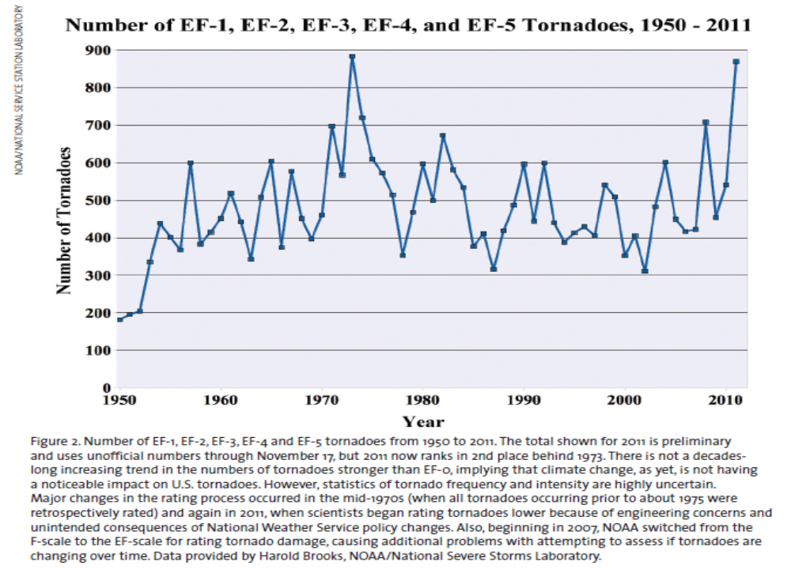

This chart emphasizes that the increase in tornadoes has nothing to do with the increase of temperature or natural disasters. Tornadoes are usually caused by “a violent, dangerous rotating column of air that is in contact with the surface of the Earth and a cumulonimbus cloud” (Evans). When tornadoes tend to get large one can tell that they can become more severe because there is more wind speed in larger tornadoes. Even though scientists do not have sufficient evidence to perhaps indicate that climate change has anything to do with the intensity of tornadoes, we cannot ignore the fact that climate change is however affecting other weather related events.
However, even though climate change deniers do not believe in climate change having an in impact on natural disasters over there the next decades we will be seeing abrupt climate changes. Gradual rises in temperature will continued to been seen if the greenhouse gases continue to rise as well. This will lead to catastrophic changes that perhaps no one will be anticipating when the time comes. If we think back to Hurricane Katrina and the impacts it had on our society one can see how devastating natural disasters can become. International researchers based at Beijing Normal University used “modeling data focused on the conditions in which hurricanes are formed” (National Geographic). They were able to observe that for every 1.8 º F rise in the atmosphere the number of hurricanes in the Atlantic would be much stronger than in the time of hurricane Katrina. This can bring great concern to the general public because if such storms would have immense increase how well prepare can we be when these storms hit? This study correlates with other studies that have found that hurricanes strength is greatly affected by the warmth of water; this warmth is typically where these storms form. This leads back to the impact of greenhouse gases such as the effects of water vapor on our environment.
Adjacent to the topic of climate change is the famous documentary of Al Gore titled An Inconvenient Truth. Gore uses this documentary to educate the general public of the future catastrophic events that could occur if the Earth continues to increase in temperatures. In showing this documentary he hopes to encourage the general public in going green. This documentary touched upon topics related to the rising of seas level due to the collapse of ice sheets, intensity of weather related storms and the increase of temperature due to anthropogenic activities. Gore backs up his theories on climate change with visuals such as detailed graphs and flow charts that project the possible outcomes of natural disasters due to climate change. One of the graphs he mentions in his presentation is titled the Kneeling Curve:
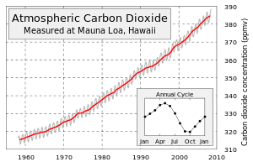

This graph shows an increase in the amount of carbon dioxide in the atmosphere dating back to as far as the year 1958. This graph is specifically based on data from the Mauna Loa Observatory. The increase of CO2 is related to the release of fossil fuels into the Earth atmosphere. Although many may argue that Al Gore or even in general that climate change itself is more of a correlation then a causation towards natural disasters there are still some evidence that may prove otherwise. Even if we don't have final proof of how rising global temperature might cause these things, if there is a chance that those effects are real, it is safer to be prudent and take action to minimize the chances.
In conclusion we can say for now that climate change has greatly impacted the intensity of natural disasters over the past decades and will continue to do so if a solution is not properly executed. Also these changes are producing great risk towards our ecosystem threating the lives of many animals that can possibly become extinct over the years. Although there are many uncertainties of whether humans are actually contributing to global warming there is still evidence that can indicate such theory. Over the next years we will more likely see how climate change is greatly affecting our environment and we will see how variations of life forms will probably cease to exist if temperatures continue to rise. We can also expect climatological events such as extreme temperatures, droughts, forest fires and other natural disasters that will cause a lot of damages in our environment.

Work Cited
Ibarrarán, M., Ruth, M., Ahmad, S., & London, M. (2009). Climate change and natural disasters: macroeconomic performance and distributional impacts. Environment, Development & Sustainability, 11(3), 549-569. doi:10.1007/s10668-007-9129-9
van Aalst, M. K. (2006). The impacts of climate change on the risk of natural disasters. Disasters, 30(1), 5-18. doi:10.1111/j.1467-9523.2006.00303.x
Masters, J. (2012). 2011's Billion-Dollar Disasters: Is Climate Change to Blame?. Weatherwise, 65(2), 12-19. doi:10.1080/00431672.2012.653934
Helmer, M., & Hilhorst, D. (2006). Natural disasters and climate change. Disasters, 30(1), 1-4. doi:10.1111/j.1467-9523.2006.00302.x
CLIMATE CHANGE - KEY FACTS. (2011). New Internationalist, (442), 22.
de Sherbinin, A., Warner, K., & Ehrhart, C. (2011). Casualties of Climate Change. Scientific American, 304(1), 64-66.
Besel, R. D. (2011). Opening the 'Black Box' of Climate Change Science: Actor-Network Theory and Rhetorical Practice in Scientific Controversies. Southern Communication Journal, 76(2), 120-136. doi:10.1080/10417941003642403
(2006, July 14). Hockey Stick Hokum. Wall Street Journal - Eastern Edition. p. A12.
Climate History: Exploring Climate Events and Human Development The Past 10 Years. (n.d.) http://www.ncdc.noaa.gov/paleo/ctl/cliihis10.html
McQuaid, John. Hurricanes and Climate Change. Nova. Posted 11.15.12. Web. 4 May of 2013.
Evans, Michael. Natural Disasters. The Earth’s Time. 14 May 2011. Web. 4 May of 2013.
Stone, Daniel. Rising temperatures may cause more Katrinas. National Geographic News. 19 March of 2013. Web. 4 May of 2013.
National Geographic: Six Degrees Could Change the World. Dir. Ron Bowman. National Geographic. NTSC. 2008. Film.
An Inconvenient Truth. Dir. Davis Guggenheim. Participant Media. 2006. Film.

