|  |
| --- |
|  |
| Looking For Trends In Climate Change |
| Montserrat Final Project |
|  |
| **Michael Drebot and Andrew Bechard** |
| **5/8/2012** |

The planet earth has a wide variety of climates, ranging from the arid Savannah deserts in northern Africa, to the cold, snow-capped mountains of the Himalayas. The population of humans throughout time has grown to scatter themselves throughout the earth and have settled down to live in different climates about the earth. The United States alone is a country that sits on a number of different climates within its borders. From the cliffs of California on the west coast of the Pacific Ocean to the east coast of the New England shores, and from the border of southern Texas to northern Minnesota, climates are noticeably different. One thing noticeably different about the areas around the United States is the change in temperature from the southern states to the northern ones. As the temperature changes, so does the climate precipitation. The hot temperatures down in Texas are also the same areas known for the dry areas that lack precipitation. Similarly, the cold weather up north is recognized as areas of wet precipitation. In comparison of the two different areas and their differences in climates, one relationship can be thought of; does the temperature in an area affect the amount of precipitation that falls throughout a given period? The belief is that global warming has a lot to do with this rising trend. Global warming takes the sun’s rays, and makes a layer of gas around the atmosphere, thus trapping the heat from the sun inside on earth. The heat is trapped by a layer of gas known as the greenhouse gases. They are gases that are in abundance at unnatural levels up in the atmosphere and form a wall-like barrier of gas that heat cannot penetrate. The gases come from things like our carbon emissions, such as driving a car or factory buildings releasing all their smoke directly into the atmosphere. Though the heat of the sun is what gives everything on earth life, instead of the excess light that is not needed escaping the atmosphere, it is trapped by these deadly gases that can, and are heating up the earth beyond natural temperatures. Data from the research conducted can show how global warming and rising temperatures are changing two cities, and also how they are changing the earth. Using statistical equations such as Mann-Kendall analysis tests and linear regressions, interpretation of the data leads to mathematical results that can easily be communicated through simple graphs and tables. The results computed show that temperature in a defined area affects the amount of precipitation that falls in a time period.

The research conducted to compare the different areas with the same relationship between temperature and precipitation was chosen arbitrarily, trying to highlight to very different climate and temperature regions. The best way to gather research for distinct and separate climates was to contrast the northern and southern parts of the United States, one city in each region. The city in the south chosen to be studied for its hot and dry climate was El Paso, Texas. The city, consisting of over eight hundred thousand people is located in the western part of Texas near New Mexico and also lies on the banks of the Rio-Grande River and subsequently on the border of the United States and Mexico. Its location is considerably southern and thus the reason why El Paso is considered one of the hotter places in America (Nielsen-Gammon).

Over two thousand miles north of El Paso, Texas lies the other city chosen for our research. Buffalo, New York contrasts El Paso with its place near the equator and is the main reason for its chilly temperatures. The city of over two hundred and sixty-one thousand is six hundred feet above sea level, and with its plethora of lakes, notably Lake Erie, could be the reason for its low temperatures (Vermette).

These two cities are very different in climates and average temperatures, however we hope that they will lead us to a definitive answer about the relationship between the rise of temperature in a city, followed successively by rise in precipitation levels. Using data from the history of each city, we will try to interpret the data mathematically and communicate our findings through graphical analysis. The relationship between each data point will hopefully show a correlation throughout the given period of time for each city, and relate the constant increase over the time interval.

To prove our thesis correct, we needed to collect data from the temperature and precipitation levels in the two cities, El Paso, Texas and Buffalo, New York. In order to see our thesis ratified, we chose to gather data from a wide time period, spanning forty seven years, from nineteen sixty-five, to two thousand eleven. This large range of years is needed to find sufficient correlations and results within the data because it will help to more easily identify outliers and prevent a lot of skewed data on the graphs.

The first method we used to interpret our data was using linear regression with a program that would help compute calculations that would otherwise be slow and tedious. The program performs simple calculations that are similar throughout the data, so that results can be produced quickly on a large scale, or in our case, the time period of forty seven years. The computing program we used was called Microsoft Excel by the Microsoft Company, and it computed many statistics for us and produced intricate and aesthetically pleasing graphs. The way Excel is used is quite simple. All the data is plugged into a spreadsheet and then the program can execute calculations using logarithms based off of the data. Some calculations that can be done using Excel include finding the mean, median and mode for various data points. These data points on the spreadsheet can also be plugged into a graph and the program can give a visual interpretation of the data. For our research, we used Excel to find the helpful points of a box and whisker plot, which includes the mean, median, mode, maximum and minimum value, and the first and third quartile values. We also then found the z-scores related to each of the data points. All of these calculations will then help us in turn to construct graphs of the data, one modeling the seasonal variance of the two cities temperature and precipitation levels, and the other graph representing the graph of the normal distribution curve, or at least a skewed curve.

A data point was made for each year from nineteen sixty four up to and including two thousand eleven, totaling forty seven data points in all. The calculations were made, and then graphs were made with the plotted data points. In order to see just how well each year of data related to the whole group, we used a linear regression test. Also using this data, we conducted a hypothesis test, where we tried to confirm our null hypothesis by using data statistics and mathematical tests to prove the validity of our thesis. All of these calculations, graphs, and tests were done for both cities, El Paso, Texas and Buffalo, New York, and there were separate spreadsheets for the yearly temperature averages, and the yearly precipitation average.

To compare our results of the linear regression tests of the data, we also used this data to perform a Mann-Kendall test, another form of statistical calculations that help us relate the data to visual graphs with the help of mathematical equations. This form of statistical analysis varies from the linear regression test because mainly it helps in giving a more uniform similarity to the data points. The Mann-Kendall systems of equations and tests takes into account the mean as the central point, and bases the relationship with data points, as three things; either the point is above the mean, below the mean, or equal to the mean. The data points that fall into these categories are given a value of one, zero, and negative one respectively. This method is not affected so much by outliers unlike the linear regression tests whose values for the correlation coefficient between data points can be skewed by outliers that influence the data, even if only in the slightest. The Mann-Kendall test was used to calculate again the similarities between the average temperature per year and the average precipitation per year in the two cities. We also used this to solidify our null hypothesis and thesis, and hopefully could relate these results with those of the linear regression test in a close manner (Trend Analysis).

We looked at the data from El Paso and Buffalo through the use of both linear regressions and Mann-Kendall tests. By examining data from the hydrological year, Oct 1st-Sept 30th, from the years 1964-65 until 2010-201, which we obtained from the US Historical Climatology Network (Menne). The first data we looked at was the change in Buffalo temperature over time.

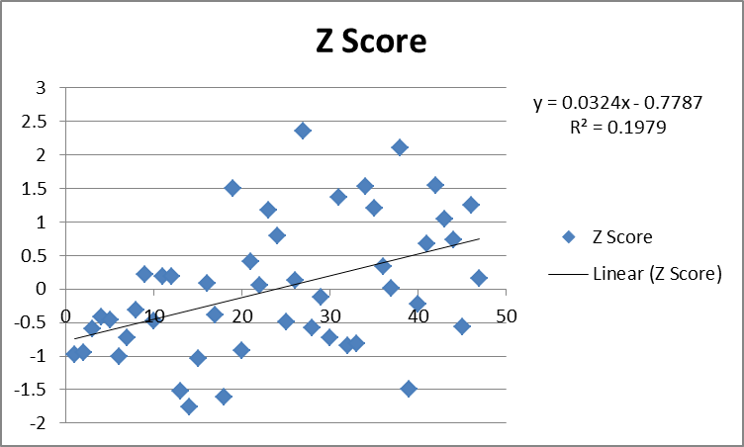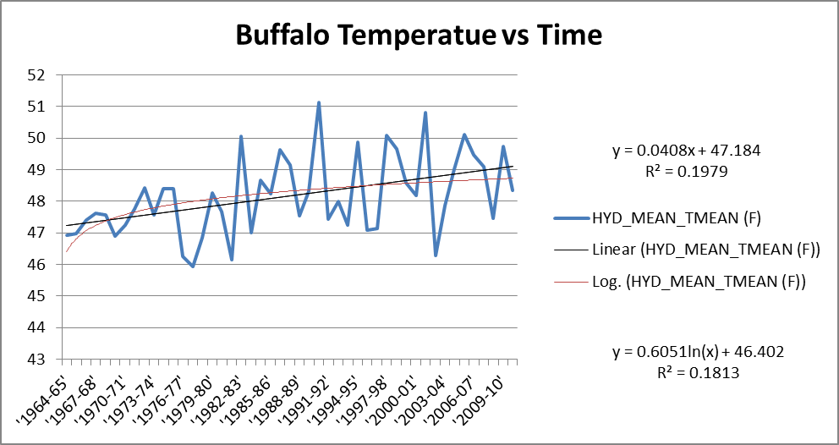We then computed the mean temperature over that time, the standard deviation and various other statistical elements. We also converted all the scores to z-scores as another way of examining the data, and looking at it. After doing this used the regression abilities on excel to do linear regressions for both the mean temperatures and the z-scores.

Doing the regression we found there to be a positive slope of .0408, with an R2 value of .1979, which signifies that while the temperature seems to be increasing that the linear isn’t a great fit for the data. After doing this we did hypothesis testing to determine if there was enough evidence to do an increasing trend over time.

 By making the null hypothesis μ=0 and the alternative μ>0 and using the Data Analysis program on excel to determine the z-score, we determined a z-score of 3.33. Since this z-score is greater than 1.645 then this means we have enough evidence to reject the null hypothesis and say that there is a trend between time and temperature.

 After doing this we did the same type of analysis for time and precipitation in Buffalo over the same period.

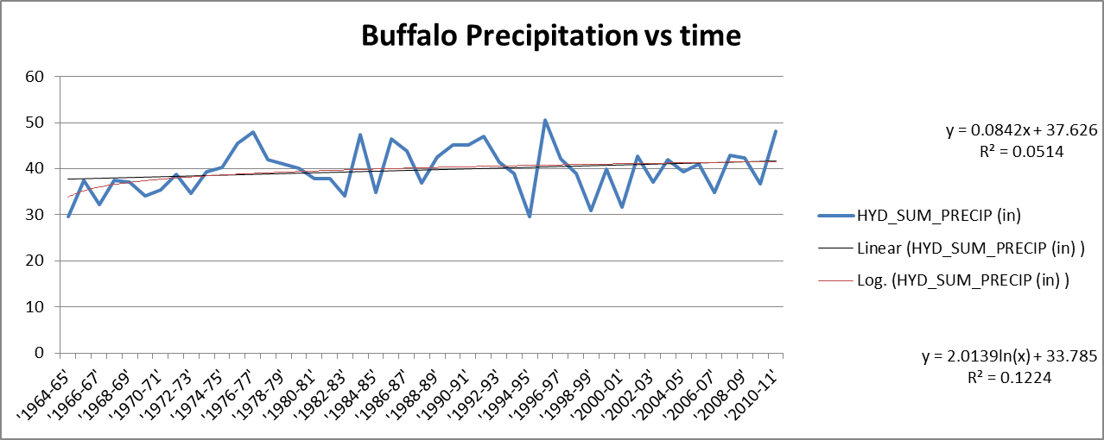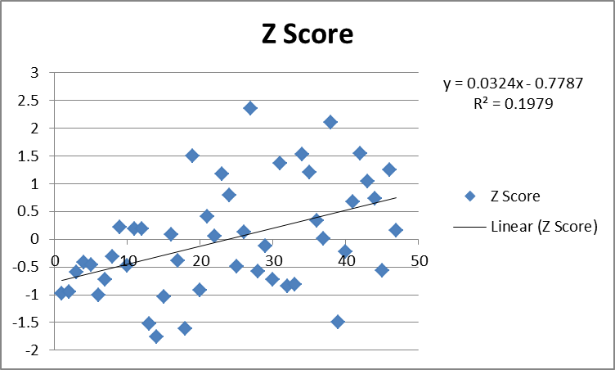 After doing this data collection we then preceded to again take a linear regression of the data and the z-scores.

Doing the regression we found there to be a positive slope of .0842, with an R2 value of .0524, which shows a trend toward increasing precipitation, but that the linear regression is not a good model for the data.

We then did hypothesis testing with this data to determine for sure that we could determine if there was a trend in precipitation with time. By setting the null hypothesis to μ=0, and the alternative hypothesis to μ>0 and using the data analysis function on excel to determine a z-score we did not obtain enough information to reject the null hypotheses. We obtained a z-score of 1.56 which is less than 1.65 and gives us a p value of .125.

We then did a Mann-Kendall test for our data that helps us to determine if there are trends in the data. This type of test places less emphasis on outliers and just helps to determine just if there is either an increasing or decreasing trend in the data. This works by calculating an s score for all the data points. You calculate s by giving all values after the first year either a value of 1(if higher), 0(if the same), or -1(if lower) than the value of the next term. You then proceed to do this for all of the next terms until you have no terms left. You then calculate the variance through the formula V=(1/18)(n(n-1)(2n+5)-∑tk(tk-1)(2tk+5)), and then calculate the z-score through the formula z=(s-1)/(v^(1/2)).

For Buffalo temperature we did this through the following calculations:

Ho: μ=0

Ha: μ>0

S=(-1)369+(1)703=334

V=(1/18) (47(46)99)=11891

Z=(334-1)/((11891)^(1/2))=3.05

p=.5-.4989=.0011

These calculations show a z-value that is greater than 1.645 which means that the data is significant and that we can reject the null hypothesis and determine that there is a positive trend in the data points.

Then for Buffalo precipitation we did these calculations:

Ho: μ=0

Ha: μ>0

S=(-1)416+(0)1+(1)656=240

V=(1/18)(47(46)99-2(1)9)=11890

Z=(240-1)/ ((11890)^(1/2))=2.19

P=.5-.4857=.0143

These calculations show a z-value that is greater than 1.645 which means that the data is significant and that we can reject the null hypothesis and determine that there is a positive trend in the data points.

We then looked at El Paso’s temperature data to determine if there was enough information to signify a trend.

We then looked at linear regressions for both these values and the value of z-scores.

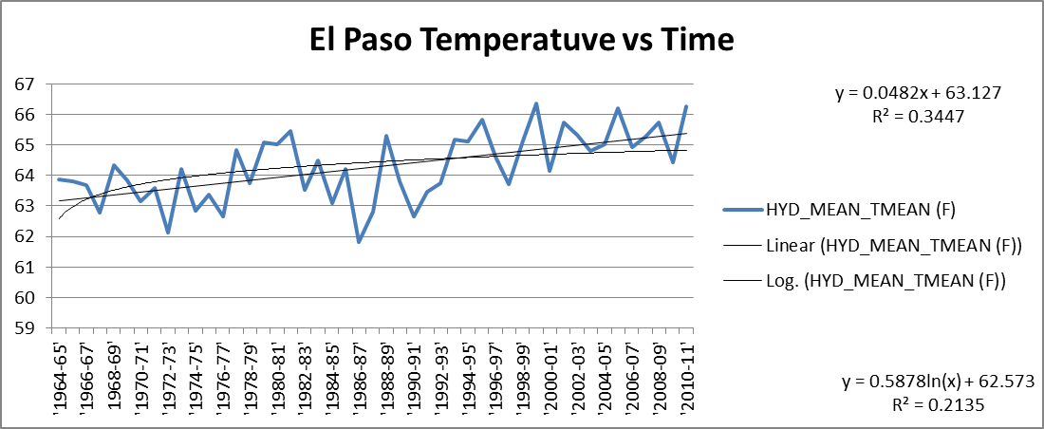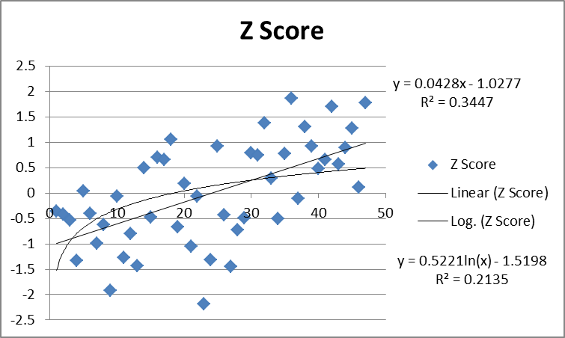

Doing the regression we found there to be a positive slope of .0482, with an R2 value of .3447, which shows a trend toward increasing temperature, but that the linear regression is not a good model for the data, but as of now the best R2 value that we have calculated.

We then did hypothesis testing with this data to determine for sure that we could determine if there was a trend in precipitation with time. By setting the null hypothesis to μ=0, and the alternative hypothesis to μ>0 and using the data analysis function on excel to determine a z-score we were able to obtain enough information to reject the null hypothesis and accept the alternative. We obtained a z-score of 4.86 which is greater than 1.65 and gives us a p value of approximately 0.

After doing this we did the same type of analysis for time and precipitation in El Paso over the same period.

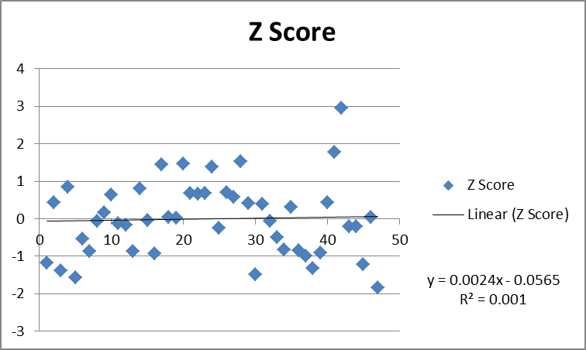We then looked at linear regressions for both these values and the value of z-scores.

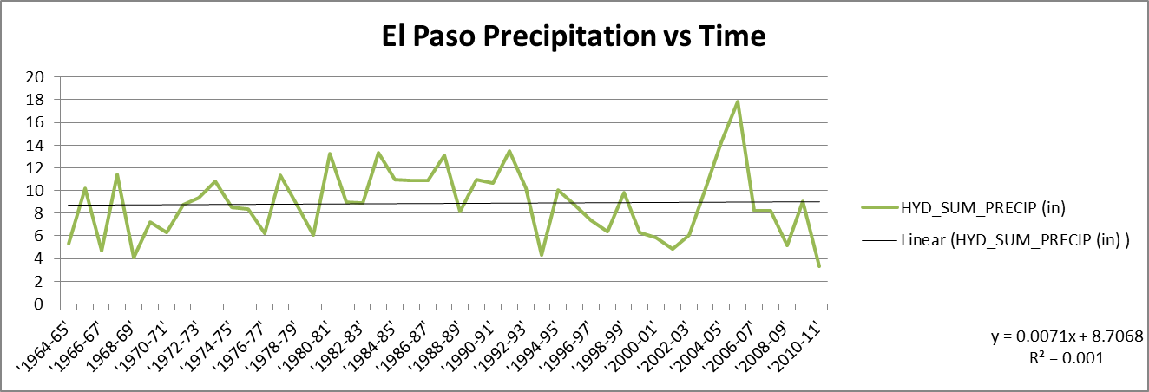

Doing the regression we found there to be a positive slope of .0071, with an R2 value of .001, which shows an extremely slight positive trend toward increasing precipitation, almost 0, and that the linear regression is not a good model for the data.

We then did hypothesis testing with this data to determine for sure that we could determine if there was a trend in precipitation with time. By setting the null hypothesis to μ=0, and the alternative hypothesis to μ>0 and using the data analysis function on excel to determine a z-score we did not obtain enough information to reject the null hypotheses. We obtained a z-score of .22 which is less than 1.65 and gives us a p value of .829.

Then we did Mann-Kendall tests for both temperature and precipitation in El Paso.

For El Paso temperature we did this through the following calculations:

Ho: μ=0

Ha: μ>0

S=(-1)346+(1)734+(0)2=388

V=(1/18)(47(46)99-2(1)9)=11890

Z=(388-1)/((11890)^(1/2))=3.549

p≈0

Shows Trend since the Z>1.645

These calculations show a z-value that is greater than 1.645 which means that the data is significant and that we can reject the null hypothesis and determine that there is a positive trend in the data points.

Then for El Paso precipitation we did these calculations:

Ho: μ=0

Ha: μ>0

S=(-1)548 +(0)1+(1)561=13

V=(1/18)(47(46)99-2(1)9)=11890

Z=(13-1)/ ((11890)^(1/2))=.11

p=2(.5-0438)=.9124

Doesn’t show trend since Z<1.645

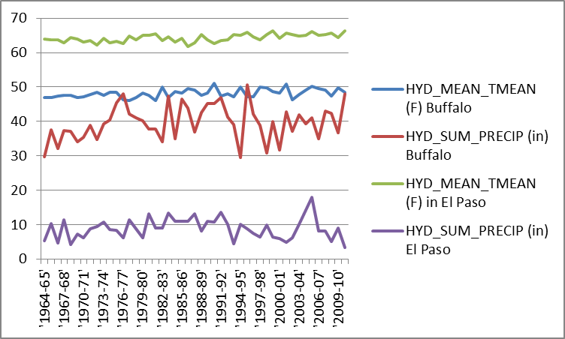 The linear regressions and Mann-Kendall tests for temperature in Buffalo and El Paso provide ample evidence to suggest the existence of a trend. This suggests that there is a definite increasing trend of temperature in Both Buffalo and El Paso. In Buffalo for precipitation while there wasn’t enough evidence through the linear regression to suggest a trend, when doing the Mann-Kendall test there was enough evidence. A possible reason for this would be the variability of outliers and that often there are both positive and negative outliers that would skew the data, which would explain why it would be unaffected by Mann-Kendall. In El Paso there wasn’t enough evidence to suggest that precipitation was increasing over time. A possible explanation for this is that since El Paso was such a low precipitation place to begin with that environmental changes wouldn’t necessarily impact the region in regards to precipitation because as a historically hot place precipitation has very few means of reaching there.

The world around us, especially here in the United States is changing. Many times we do not stop to think that the temperature is rising every year, or that we are getting more precipitation because we are harming the earth every time we release carbon dioxide into the air (Program, U. G.). The change is so minimal every year and it is happening so slowly that it very hard to present a case for this being an important issue to a busy society, especially a country like our United States, whose success has been and still is toady fueled by the use of gases and high amounts of energy. Not many people are willing to listen to problems with our way of life, nor will they be willing to accept the fact that there is a problem and the earth is changing for the worst with little to no visual evidence of climate change (Guggenheim).

In order to get the attention of at least a few members of a listening audience, we needed to show evidence for temperature and precipitation change. We also kept in mind for our data interpretation on a global scale that not everyone on the earth, who originally doubted the facts, would be intelligent enough to understand this type of evidence. Using mathematical equations, we were able to find enough evidence to prove that both temperature and precipitation are changing over time. In the last forty seven years, there has been a noticeable and evident rise in the average temperatures and average precipitation. Our data and evidence also shows that this trend of rise in both temperature and precipitation is not going away, but will continue to rise perhaps even at a quicker pace.

There are also many skeptics who would disregard our information as facts, and still stand by their thoughts that there is no change or that even if there is the earth will straighten itself out. We did only research two cities out of the entire world and this could be seen as not enough data to present an argument. However, we feel that global warming is not a misnomer, and that this change is happening globally. What is occurring in El Paso, Texas and in Buffalo, New York could very well be the same change that is occurring in Beijing, China or Mumbai, India.

Another thought of skeptics is that if global warming is happening, and that harmful temperature and precipitation levels are coming upon us, that this type of chaos will not happen in their lifetime so they should not worry about it. However, global warming is happening now, and there are already changes to be seen. We are changing the earth so quickly that it does not have time to adapt and give itself to us so that we can live in the same destructive manner. The question should not be if we can hold on and let the earth fix itself to save us. The question should be are we going to recognize this problem and act on it so that we can save ourselves? We believe that there is a growing concern out in the world and things are being done to conserve on gases and energy. However the negative impact we produce still outweighs the positive changes we have made. More has to be done, and hopefully it will benefit the earth and bring things back to normal, if that is even possible with this hectic world. If we as a whole earth and society overlook this problem, we will have to face the facts presented head on, and we will suffer because of it.

**Bibliography**

Guggenheim, D. (Director). (2006). *An Inconvenient Truth* [Motion Picture].

Trend Analysis. In D. Helsel, & R. Hirsch,(2002) *Statistical Methods in Water Resources.* US Geological Survey.

Menne, M., Williams, C., & Vose, R. (n.d.). *UNITED STATES HISTORICAL CLIMATOLOGY NETWORK.* US Department of Energy

Nielsen-Gammon, J. W. (2011). Chapter 2. The Changing Climate of Texas . In *The Impact of Global Warming on Texas* (pp. 39-68).

Program, U. G. (n.d.). *National Climate Change.* Retrieved 4 11, 2012, from http://www.globalchange.gov/images/cir/pdf/National.pdf

Vermette, S., & Bittner, C. (2010). *SEASONAL TEMPERATURE AND PRECIPITATION FORECASTS USING A CLIMATE PROBABILITY APPROACH: BUFFALO, NEW YORK.* Buffalo St College, Department of Geography and Planning, Buffalo.