Water Runoff at Holy Cross

Jake Youso Luke Barrett Matt Ginn

5/8/12

One topic that has been starting to get more attention from society and the government is pollution and the negative effects that it has on the environment and people’s quality of living. With issues such as global warming and greenhouse gases becoming more of a prominent discussion point, the issue of pollution has started to become a central focus on many people’s agendas. One aspect of pollution that our group focused mainly on is water runoff and where it is prevalent on the campus of Holy Cross.
What is water runoff?
Water runoff, or surface runoff, happens when soil, or other surfaces are permeated to their full capacity and the water that falls from precipitation runs onto the land. Oceans are “large storage units” of water and as a result, surface runoff is also carried into these storage units and act as a form of pollution. Much of the water in rivers comes from surface runoff, and since a lot of the water in oceans comes from rivers this surface runoff is also carried into these oceans. When rain hits an impermeable surface, such as concrete or asphalt, the water begins to flow downhill due to the influence of gravity. When the water is rushing downhill, it collects soil and other sediments that hurt the quality of the water where it eventually ends up. Runoff is affected by both geographical and meteorological factors. Some meteorological factors include the type of precipitation, the intensity of the precipitation and the distribution of the precipitation over the drainage basin. Examples of physical factors are the land use, vegetation, soil type and the drainage area. Together, these elements affect how severe the surface runoff is, and ultimately how much the water is becoming polluted.
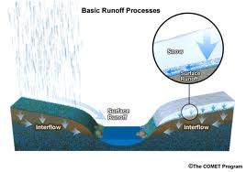
Human Influence
The influence that humans have on pollution and water runoff is not just as simple as polluting by littering or other means. One of the big factors is the urbanization and development of many different landscapes. The natural landscapes that were in place are now becoming replaced by impervious surfaces like houses, roads and parking lots just to name a few. These surfaces act as a catalyst to accelerate the rate that the runoff to ditches and bodies of water because they do not “soak up” the water like a natural landscape would. In a natural landscape, some of the water is absorbed into the surface, while some runs off into a ditch or stream. When the natural landscapes are replaced with an impervious surface, the surface does not absorb any of the water so more water will runoff and at a quicker rate. This leads to a greater occurrence of floods and also a more greatly polluted body of water around the location. Also put into the equation is the effect that with buildings and parking lots and the human influence, more pollution is put into the air. Whether it is pollution from buildings, cars, or whatever, it does not necessarily “runoff”, but is nonetheless detrimental to the environment.
Campus of Holy Cross
One of the most noticeable traits of the College of the Holy Cross is that it is located on a large hill. The fact that the campus is on a hill is not a good thing when discussing the effects of surface runoff in the area. Another problem is that the Blackstone River runs along the bottom of this hill. There are a lot of natural landscapes on campus, but the areas that contain impermeable surfaces or do not have many drains can be very problematic to the quality of water in the Blackstone River. With the knowledge that these impervious surfaces act as a sort of catalyst to the speed and amount of water that runs to the River, the fact that the school is located on a hill with the River on the bottom just adds another dimension. Thinking about the natural force of gravity, the water would already drain downhill and with the added element of an impervious surface the water travels much more quickly. As a result, the water would also pick up natural sediments and soil along the way to track into the Blackstone River. This is obviously damaging to the quality of the water in the Blackstone River. The many roads that run throughout the campus only contribute to the degradation of the water quality. One factor that would be extremely debilitating to the Blackstone River would be if the science departments did not dispose of their waste materials safely. However, as a school it is ensured that this waste is handled carefully and does not contribute to the surface runoff into the Blackstone River or the environment at all.
Due to the location of Holy Cross being in Worcester, Massachusetts we receive a lot of snow during the winters. As a result, to make the campus safe lots of salt and gravel are put down. Once the snow melts and the water runoff begins to occur, the salt and gravel is left behind and picked up by the running streams of water. The salt is damaging to the Blackstone River when it is picked up and carried into it. As a safety measure, it would be beneficial to lay down less salt to try and limit the amount of damage done to the Blackstone River.
Another problematic area on campus for harmful sediments and chemicals carried into the Blackstone River are the athletic fields. These fields need specific and frequent care to be able to host NCAA Division 1 sports, which include putting down pesticides and other chemicals that can be harmful to the water quality. There is no real way around this other than using substances that are more environmentally friendly. Along with the chemicals used on the actual field are the chemicals that are given off by the cars of the spectators and fans that are parked in the parking lot. Anytime there are large parking lots there will be oil and other leaks that find their way onto the pavement. These are very damaging to the quality of water in the Blackstone River, especially brought into the equation the impermeable surface that they will fall onto. This means that they travel at a much quicker rate downhill into the Blackstone River.

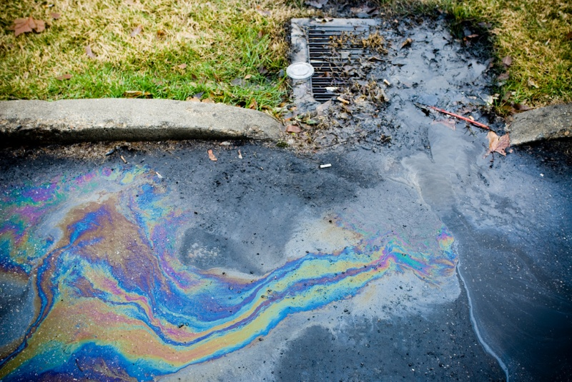

Runoff and our Campus
The terrain on our campus poses a unique problem when it comes to dealing with runoff. The overwhelming issue is that our entire campus is essentially one giant hill, but it has been terraced to support buildings. As a result whenever it rains, or whenever we are struck with any other form of precipitation or snowmelt, there are strong streams of runoff that can be easily identified throughout campus. These streams can wreak havoc on the landscaping of the college among other issues that can be created.
In order to identify how runoff would be created and how it would affect our campus our groups went around campus and measured the surface area of different types of surfaces that cover our campus. To begin we chose categories of surfaces, each of which has a different impact upon the amount of runoff created during rain or other precipitation. These areas that we chose to measure are as follows, buildings, streets, walking surfaces, gravel, and grass. In addition we attempted to get an estimate of the number of trees in a given area. All of these factors have a direct effect on the severity of runoff on our campus. They are ranked in the order of which they can absorb water and thereby prevent runoff. Buildings cannot, or should not for that matter, absorb water, they have gutters to channel the water to the ground and it runs off their roofs. As a result buildings do nothing to lessen the severity of runoff. Streets are much the same, little if any water is able to sink into the streets on our campus which is why they are fitted with storm drains and other holes to prevent the pooling of water, although they are not always successful. Walking surfaces are the next category that was chosen, surfaces such as brick pathways, stairs, and other paths fall into this category. They are better at absorbing water than the street due to being under less pressure and less lightly packed. These also often have drainage solutions within them such as rock-lined ditches, or covered channels that can be walked on but still allow water to flow. Gravel is another surface that we measured the area of. Gravel allows water to flow down through it and this makes it much less of a contributor to runoff. However there were not a large amount of gravel-covered grounds on campus. The last type of ground that we measured was grass. Grass is useful because not only does the water seep down into it, but also it actually uses the water and thus lessens the amount and impact it has. Grass is by far the best category when it comes to decreasing the negative affects that runoff can have.
After establishing the index and creating charts that display the information on the areas of the campus and how they relate to the index I felt it was important to find a more visual way to display this information. In order to do this I set about creating a number of pie charts. The first displays the different percentages of campus that were covered in the sections. This is important because it gives a sense of the weight that each section carries as to the different surfaces it contains. I then created another chart that has the percentages of each surface within the sections as well as the percentage of the campus that the section was. From that I made four pie charts that display the percentage of each section that each surface represents. I simplified from the original chart because some of our information was incomplete or delivered in a different fashion. In order to do this I just focused on the two main factors seen in our measurements, buildings and street. I then created another section to incorporate any other surfaces that were measured. It is still useful however because the streets and buildings are the major contributors to runoff while everything else tends to help stop it.
It is clear from our data that our campus faces a daunting task when it comes to dealing with runoff as it must produce a great deal of it. As was already discussed earlier our campus is on a fairly vertical hill, which by itself creates strong runoff streams. It also appears from the data that we collected that a good deal of the campus is covered by either streets or buildings. These are the largest contributors to runoff, as water cannot permeate them at all. Despite drainage systems in place this characteristic causes clear streams of runoff all throughout campus whenever it rains. Three of the four areas, assuming they were measured correctly, show buildings as the highest percentage of area. In addition in three out of the four streets are the second highest percentages. The fourth area of campus, the only one where grass and other surfaces outnumber streets and buildings, is the largest but it still cannot hope to offset the majorities seen in the other sections. It is worth noting that different groups had various methods in measuring the campus that may or may not account for some features and as such the data might not be completely accurate but nonetheless this data present a grim picture for anyone charged with managing runoff on the campus.

 | Section 1 | Section 2 | Section 3 | Section 4 | Total
Buildings | 21150 m² | 54594m² | 16005.372m² | 10,000m² | 101749.372m²
Streets | 17563.8668 m² | 17, 297.37 | 2170m² | 5,600m² | 42631.2368m²
Walking Surfaces | 559.45m² | 4560.06 m² |  | 865m² | 5984.51m²
Gravel |  | 1270.16 m² |  |  | 1270.16m²
Grass |  | 528.65 m² |  | 25,350m² | 25878.65m²
Total | 39273.3168m² | 78250.24m² | 18175.372m² | 41815m² | 177513.929m²
Trees |  | 290 |  | 50

 | Section 1 | Section 2 | Section 3 | Section 4
Buildings | 53.85% | 69.76% | 88.06% | 23.91%
Street | 44.72% | 22.1% | 11.93% | 13.39%
Other | 1.42% | 8.12% | 0.00% | 62.69%
% of Campus | 22.12% | 44.08% | 10.22% | 23.55%

Preventative Techniques
Preventative techniques are applied to reduce the amount of runoff in a given area. These techniques are used to preserve the land and soil from erosion and gradual changes in shape over time. Many techniques used are not only beneficial to the environment but also to people who use it. In most cases, many runoff techniques practiced are hardly noticeable and add to the scenic views of the campus. Here at Holy Cross many of the techniques used every day contribute to maintaining the shape of campus. The biggest challenge facing Holy Cross is that the school is located on a large hill, which has spots of severe runoff. The large slopes that make up the campus are susceptible to runoff from heavy rains, snow fall, pollution from vehicles, and other chemicals used to treat plants and trees. Locating areas susceptible to runoff and erosion pose a challenge to finding preventative runoff solutions, which is a task the grounds management staff at Holy Cross has focused on for decades.
Of all techniques used to prevent runoff and erosion, the most effective practice used at Holy Cross has been the planting of several hundred trees throughout campus. This practice began over one hundred years ago and has been the main component to keeping the Holy Cross Campus intact. Trees have many important roles in the reduction of runoff and erosion. Upon being planted trees serve as a stalwart in the ground and keep soil from shifting. Tree roots grow deep into the ground and spread throughout the soil to keep it stable and from shifting. Tree roots also serve as a filter, taking many pollutants and unhealthy toxins from the ground into their base. Wind reduction is another benefit to having trees which helps top soil from being eroded and blown away. Lastly trees serve as scenic beauty and provide shade which is beneficial to anyone interested in seeing the beauty of nature. Shrubs, gardens, and other plants are also being used around the Holy Cross campus to contribute to the reduction of runoff and erosion.
Retaining walls are a technique that is vital in the preservation of Holy Cross’s campus. Retaining walls divide larger slopes into smaller sections which allows for easier maintenance. Using retaining walls, Holy Cross divided its campus into five different levels to ensure the campus will keep its shape as a whole. Having cement retaining walls ensures that banks will be preserved for a very long time. Retaining walls reduce the flow of ground water significantly and maintain the shape of banks. Underground piping can also be inserted into retaining walls, which extracts ground water from slopes to further contribute to reduction of flowing water in the soil. Like trees, retaining walls also have a scenic look and make the campus look more distinguished.
Drains are another common tool used to slow the effects of runoff and erosion of soil. Drains make it possible for ground and surface water to be distributed to other areas to prevent the buildup of too much water in or on top of the ground. The Holy Cross campus has dozens of drains at every level of the campus which all provide an outlet to catch water and distributed it to other places below the school. Drains also serve as a benefit to grass areas because of their ability to remove toxin and other harmful chemicals from the ground. Drains improve aeration and nitrogen contents in soil which allows for the vegetation to grow in a healthy environment. Like other techniques used at Holy Cross, drains are not very visible and are advantageous because they help prevent soil erosion and runoff while blending in with many of the beautiful sights here on campus.
The fourth technique currently being used at Holy Cross is proper grounds management which is being used to ensure that all plants, trees, and grasses on campus are properly cared for. The Holy Cross grounds department has implemented many techniques to help accomplish this goal. Proper disposal of hazardous chemicals is one way the grounds department had ensured the preservation of the campus. By having safe areas to dispose of chemicals, the campus is free of hazardous waste and other bad byproducts. Using safe pesticides and chemicals to treat plants, grasses, and trees is another method being used to treat the grounds at Holy Cross. The integrated pest management program (IPM) was implemented to use less hazardous chemicals to treat plants and grasses while still improving their growth and care. Under the IPM all chemicals being used are biodegradable and are applied by a trained technician who inspects all trees and plants treated. Lastly the maintenance department has adopted a deicing program that uses less salt around Campus during the winter time. This practice results in a less polluted environment and allows for streets and sidewalk areas. Deicing areas are limited to steep slopes and hills which reduces the actually amount of salt used throughout campus.
Using preventative techniques has helped Holy Cross keep the grounds on campus intact. Implementing the planting of trees, building of retaining walls, installation of drains, and upkeep of grass areas has allowed the campus to keep its current shape for a longer period of time. Recognizing where runoff is happening is an important aspect to reducing erosion and runoff and is something the maintenance crew at Holy Cross has mastered in order to keep the campus in its best possible shape.

