Ed Schwendemann and Andrew McAward 4/29/12
Professor Little Montserrat
Final Paper
Water pollution continues to increase every day and is an issue of great concern in our society. Many of our water ecosystems are being polluted and destroyed at an alarming rate as we speak. Often, people believe that water pollution comes from toxic waste and raw sewage being dumped into lakes, oceans and other bodies of water. Although this is true, surface water run-off undoubtedly damages the water quality more than any other source of water pollutant. Run-off from impervious surfaces such as roads, parking lots, and sidewalks, as well as from agricultural fields and lawns, contribute to the growing water pollution problem. As surfaces that are impervious (those that cannot be penetrated by water such as concrete and asphalt) increase by ways such as urbanization, the amount of rainwater that is naturally filtered through the soil and slowly put into bodies of water decreases dramatically. Water, running off these impervious surfaces, tends to pick up contaminants such as heavy metals, trash, sediments, fertilizers, and pesticides, all which discharge in municipal storm sewer systems and eventually into lakes, oceans and streams. As more and more land is being paved over, it is a necessity for every attempt to be made to limit polluted runoff from these impervious surfaces so that our rivers, lakes, and oceans will not be used as human waste reservoirs.
Because of the dramatic decrease in slope on our campus, Holy Cross naturally must put in a large effort in controlling runoff, with the Blackstone River located at the bottom of the hill collecting the pollution produced from our campus. By breaking down campus into each of the seven categories assigned, we looked for the areas around campus with the worst runoff problems. Next, we sought out ways in which Holy Cross can increasingly control this issue in order to save the Blackstone from further pollutants.
With its origin in Worcester, Massachusetts and its end in Pawtucket, Rhode Island, the Blackstone River was characterized by the United States Environmental Protection Agency in 1990 as, “the most polluted river in the country with respect to toxic sediments.” "Originating as a series of streams in the hills of Worcester, Holden and Paxton the Blackstone River flows 46 miles southeast into Rhode Island, dropping 438 feet before emptying into the tidal Seekonk River in Pawtucket and eventually Narragansett Bay." Since 1790, when Samuel Slater opened the first successful water powered cotton mill in America, the Blackstone River has long been associated with industry and the legacy of pollution that follows. As more and more factories were harnessing the power of the river, the Blackstone earned the nickname “America’s hardest working river.”
As a result of this intense industrial usage of the river, there are centuries worth of pollution in the water. Early industrial manufactures discharged items such as varnish, solvents and paints from textile mills and woodworking industries into the Blackstone. Many of these pollutants lie trapped in the sediments of the river still to this day. This industrialization and resulting contamination of the river has led to Blackstone’s identification as being the main source of Narragansett Bay’s pollution. The river’s industrial history led to its damaged water quality and the physical destruction of the beautiful Blackstone River.
The Blackstone watershed corners 500 square miles and 29 communities and includes 1300 acres of lakes, ponds, and reservoirs. Over time land use has directly impacted water quality of the river. Still to this day the Blackstone River faces many major issues such as storm water runoff and contaminated sediments. The river flows through several cities such as Worcester, Millbury, and Pawtucket. Through these urban and suburban areas, water flows across impervious surfaces such as roads, buildings, and sidewalks entering storm drains and other storm-water systems, which eventually feeds various bodies of water.
Throughout the watershed, water runoff collects pollutants from fertilizers, pesticides, sediments, solid waste and numerous other sources. These sources are known as nonpoint sources. Nonpoint source pollution, unlike pollution from industrial and sewage treatment plants, comes from many different sources. Nonpoint source pollution is caused by rainfall or snowmelt moving over and through the ground. As the runoff moves, it picks up and carries away natural and human made pollutants, finally depositing them into rivers such as the Blackstone River. Nonpoint source pollution is difficult to control because it can come from many different places. As such, storm water runoff is one source that presents a tremendous threat to the Blackstone River.
As discussed earlier, the Blackstone River was known for its industrial discharges that still present themselves in the sediments in the water today. Citizens who use the river have been told not to eat the fish caught there due to the high levels of pollutants in them. Over the years, pollutants in the river have definitely decreased, but because of the runoff’s rapid flow, there are times when toxic pollutants pour into the river making them accessible to the aquatic ecosystem.
In the past 20 years, Blackstone River has experienced drastic changes, both in residential and commercial development. As more and more people inhabit the land near the Blackstone River, there has been an increase in the number of buildings, roadways, and parking lots. Subsequently, there has been a drastic decrease in agricultural land and forests. As a result of the increase in impervious surface area, more and more polluted runoff is being directed to storm-water systems, then to waste-water treatment plants and finally directly into the river itself. Due to the increase of impervious surfaces, the amount of non-point source pollution increases which has lead to the poorest water quality conditions. Consequently the Blackstone River was labeled “the most polluted river in the country with respect to toxic sediments,” according to the United States Environmental Protection Agency.
Today, the Blackstone River is classified as a class C river, which means it is suitable for “secondary contact” activities only. Activities like boating. In recent years there has been a large push to clean up the river. Groups like the Blackstone River Coalition is a non-profit organization that has partnered with numerous organizations that are working together to restore the Blackstone River and to improve the health of the Blackstone River watershed. In 2003, the Blackstone River Coalition launched the Campaign for a Fishable/ Swimmable Blackstone River by 2015, in response to the seven-million gallon sewage spill from the Upper Blackstone treatment plant in Millbury, and in order to marshal the resources needed to actually clean up the Blackstone River. The Campaign began with the goal of making the river and its tributaries fishable and swimmable by 2015.
To start the project off, the campus was broken up into 4 different zones with each of the 4 groups having their own zone. Our zone consisted of all the dorm buildings from Figgie Hall to Healy Hall, Hogan Campus Center, the Field house, the Hart Center parking lots, the roads surrounding the dorms, and the road leading up to the Hart Center. Within our zone we found the area of the 7 selected categories (see table of areas). In order to calculate the run-off index, we first took each of the 7 land use categories and weighted them based on environmental ratings that depend upon water runoff characteristics. The categories that negatively impact surface water runoff should get the lowest weight, while those that help manage surface water runoff get the highest weight.
- 1) ground area lying under roofs of buildings (“building footprint”)= 0.006
- 2) surface area of impervious (concrete, asphalt, closely packed brick) pedestrian pavement= 0.003
- 3) surface area of vehicle pavement =0.001
- 4) surface area of gravel or more pervious brick walkways = 0.09
- 5) surface area of grass = 0.5
- 6) surface area of shrubs = 0.1
- 7) number of large trees = 0.3
When adding up all of these numbers they equal 1.
0.006 + 0.003 + 0.001 + 0.09 + 0.5 + 0.1 + 0.3 = 1

Next, we would break up our zone into small areas known as blocks. Within each block we would find the area of each of the 7 surface categories. After finding the area of both the pervious and impervious surfaces, we would find the percent of the total block area for each of the 7 surface categories within each block. By finding those percents for each block we could calculate the mean and standard deviation of the 7 surface categories.
These are two tables we created to help get a better understanding of how we would go about calculating the run-off index. In the first table we organized our 7 categories into impervious and pervious surfaces. In the second column are the areas in square meters that we found for all the 7 categories. In the third column we found the percent of the total block area that each category would make up of impervious and pervious surfaces.
Here is how we calculated percent of the total block area for the buildings footprint:
12,215 m²/44,595 m² = 0.2739 x 100 = 27.4%

Block # | Total Block Area:
Impervious Surface | area in square meter  (rounded to nearest 1 sq. m) | % of total block area  (recorded to 1 decimal place)
Buildings | 12,215 m² | 27.4%
Pavement - pedestrian | 2,797 m² | 6.3%
Pavement - vehicles | 29,583 m² | 66.3%
Total Impervious Surface | 44,595 m² | 100%
Pervious Service | area in square meter  (rounded to nearest 1 sq. m.) | % of total block area  (recorded to 1 decimal place)
Gravel | 118.43 m² | .4%
Grass | 27,160 m² | 98.3%
Shrubs | 362 m² | 1.3%
Total Pervious Surface | 27,640 m² | 100%
Number of Large Trees: | approx. 121 large trees

As stated previously we would break up our zone into smaller blocks in order to find where on campus had the highest amount of surface water run-off. Within each block we would calculate the total percent area for each of the 7 categories using the formula shown before. The table below shows an example of the total percent area of impervious surface area of buildings within each block. After finding all the total percent area of impervious surface area of buildings within each block we can then calculate the mean and standard deviation. Using the mean and the standard deviation we are able to calculate the z-scores for each block.
Category 1: Impervious Surface Area of Buildings
Block # | % | Block # | % | Block # | % | Block # | %
1 | 48 | 6 | 26 | 11 | 43 | 16 | 65
2 | 12 | 7 | 42 | 12 | 75 | 17 | 73
3 | 67 | 8 | 66 | 13 | 36 | 18 | 86
4 | 34 | 9 | 38 | 14 | 11 | 19 | 90
5 | 83 | 10 | 92 | 15 | 17 | 20 | 39
*These numbers used are made up just as an example to show how to calculate all the formulas.

Mean 52.15 standard deviation 26.2
Formula to calculate z score:

Example z-score for block #1: z1 = (52.15-48)/26.2 = 1.6

After finding the z-score for each block number, using the formula:
RI = w₁z₁ + w₂z₂ + w₃z₃ + w₄z₄ + w₅z₅ + w₆z₆ + w₇z₇

We would multiply the z-score found for that block by the weighted values we assigned to each category, which would give us the Runoff Index (RI) for that block's surface.
  - Example: 1.6 x .006 =.0096, RI for block #1
We would repeat these steps for each category (1-7) finding the RI for each block's surface. Next, we would add up all the block's total RI for each category to find the total runoff index for that area. Using the block technique we could figure out which areas on campus have the highest amount of surface water runoff.
B#1 Total RI = RI B#1 Buildings + RI B#1 Pedestrian + RI B#1 Vehicle + RI B#1 Gravel + RI B#1 Grass + RI B#1 Shrubs + RI B#1 Trees
*Note: because our weighted system is set up in the manner that the categories that negatively impact surface water runoff should get the lowest weight, and those that help manage surface water runoff get the highest weight, the area with the lowest value run-off index has the greatest amount of surface water runoff.

Preventing this pollution from entering bodies of water is much easier and more inexpensive than any options to clean polluted water. Therefore, we must look for ways in which the campus can change in an attempt to further limit runoff. By looking at the numbers above, it is clear that much of our designated area
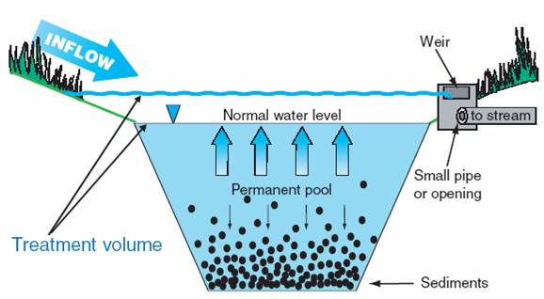
Another alternative to decreasing the runoff problem on campus would be the idea of a detention pond. Although somewhat costly, detention ponds seen to fit the landscape of the campus perfectly, as they need largely sloped land as seen on out campus. Their idea resembles the mechanics of a bathroom sink, that cannot fill up beyond a specific limit because of the multiple holes that drain the water. First, the water would run off the land into an ditch-like structure. This structure could either have water filled up to a specific level as seen in this figure or completely empty. The water would eventually fill this trench to the highest capacity, as all of the sediment that it carried starts to fall to the bottom of the pond. The weir then drains the overflowing pond and carries the water into a nearby stream using a large pipe. The use of a detention pond had many advantages, as it would naturally clean the water by dropping the sediments carried off of the land into the bottom of the pond, thus leaving the cleanest water at the top. This structure would work best at the bottom of campus, as it could then collect the most runoff. Also, the constructing of the detention pond towards the lowest part of campus would be cheaper, as the pipeline into a body of water would not be as long to reach the Blackstone River.
Figure 1 - Mechanics of a Detention Pond
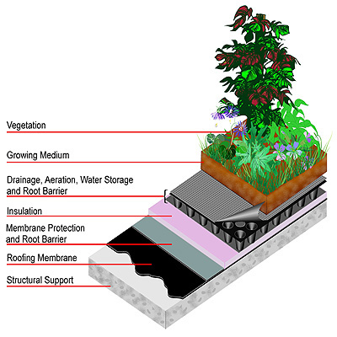
With the plans for new buildings near the Hart Center, Holy Cross will only decrease the amount of pervious surfaces on campus. Therefore, green roofs can be seen as a possible option used as a way to counter the addition of impervious roofs. Green roofs greatly limit the rainfall falling off of roofs, and instead use the water for plants that are in trays on top of the roof structure. With the addition of these plants absorbing the water, the flow of rain down the drains would dramatically increase. A second option to consider with this problem would be the creation of roof water cisterns, where rain water is bottled and slowly dispersed into pervious areas.
Strategic planting of trees around campus has a dramatic impact on the runoff problem. Each part of the tree works together to help to limit the harmful effects of rainwater. The leaves catch rainfall and partially absorb it on contact. Some store the water completely using the vessel space between the leaves, while other only can use the water for a very thin layer of coating. Specific leaves trap the water from collecting on the ground easier than others, especially those that are cup-shaped or use leaf hairs to collect fluid. Adding trees with these types of leaves that would more easily collect rain would assist the limiting of runoff. For an example, the addition of a pine tree (having needle-like leaves) would not have as drastic of an effect as an added oak tree (having flatted leaves) . The roots of trees act as vacuums to gather the moisture in the soil, thus as a tree is planted in the group, the capacity of the soil to hold rainwater is increased. Trees decrease the amount of puddles being formed on the surface, giving less volume to the runoff. Branches of trees act as canopies, shielding the soil below the tree from the effects of erosion upon the rainfall's contact. In the same way, trees with larger extensions of canopies have a greater effect on the runoff problem. http://www.fs.fed.us/psw/publications/documents/psw_gtr201/psw_gtr201.pdf
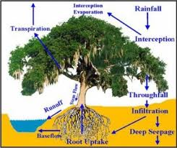

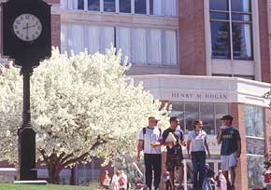
Another way of attempting to limit runoff would be to select trees with high absorption rates. It is important to understand that not all trees absorb water at the same rate, and therefore this concept can be used strategically in controlling the problems associated with rainwater and melting snow. Having over 121 trees in our designated area, the types of trees varied dramatically from dogwood, pine, spruce, birch, chestnut, and many more. As we walked around campus, we noticed many instances where Holy Cross has already dealt with the runoff issue by planting multiple trees in places where the grass rapidly declines in slope. We spotted one particular tree in the back of Hogan and, after viewing the Holy Cross Arboretum, we found out that this was a Crabapple tree. As seen in the picture above, this tree is standing alone in the courtyard, leaving it as the main response towards avoiding puddles by absorbing the water in this area. Unfortunately, this type of tree is a dry-state tree, usually found in areas of the country with little precipitation, and therefore has a low absorption rate, relying on a small amount of rainfall each season. Although this may not be as fashionable, another type of tree in place of this Crabapple would have a much more dramatic effect on the condition of the courtyard and the formation of many puddles in this area. For an example, the existence of a willow tree in this area would work to soak up these puddles in a much more efficient manner.
A large amount of the pollutants found in storm water runoff has its origins in the winter. As snow and ice form on roads and pathways, the use of salt is relied upon to counteract the slippery surfaces and give some traction. To understand how great our dependence is as a nation in using salts, the Connecticut Agricultural Experiment Station concluded after gathering data that 40-80 tons of salt are used on most highways per mile for ice control every winter. The two most commonly used salts for this purpose are sodium chloride and calcium chloride. Although sodium chloride is cheaper and therefore more commonly used, it is harmful to the environment, as it breaks down into sodium ions and chloride ions in water. This effect destroys plant foliage and leaves drinking water contaminated. On the other hand, calcium chloride does not have the same effect on runoff and even melts the snow at a faster rate. The switch from sodium chloride to calcium chloride, although it may be more expensive, would help Holy Cross's efforts to limit pollutants running off the land from the winter season.
In 2000, Holy Cross started a new program towards limiting negative effects caused by de-icing. In this plan, the college stated that now it will only use salts on areas with large changes in landscape elevation, and the use of sand as a substitute for salt will be used on roadways around campus. In the areas where salt use is unavoidable, soil will be injected with gypsum in order to counteract the harmful effects that salts have on plant foliage. The dispersion of salt around campus will be much more accurate as a result of an upgrade in technology that the trucks use to disperse the salt. Another change is the increased use of granite for the curbs in areas where the runoff problems are the most drastic. Because of the new ideas being implemented, the salt use on campus has been cut in half while many trees that were previously damaged by runoff now have returned to a healthy state. As we have seen as we walked around campus, Holy Cross has already put into place a strong attempt to limit runoff into the Blackstone River. The use of retaining walls is clearly well established, as there are 5 or 6 just in our designated area on campus. These walls block the flow of soil, as they are usually found just before a large drop in slope. Clearly, the runoff problem is prevalent in the minds of those involved in the new construction.
Figure 1- Retaining walls outside of Hogan
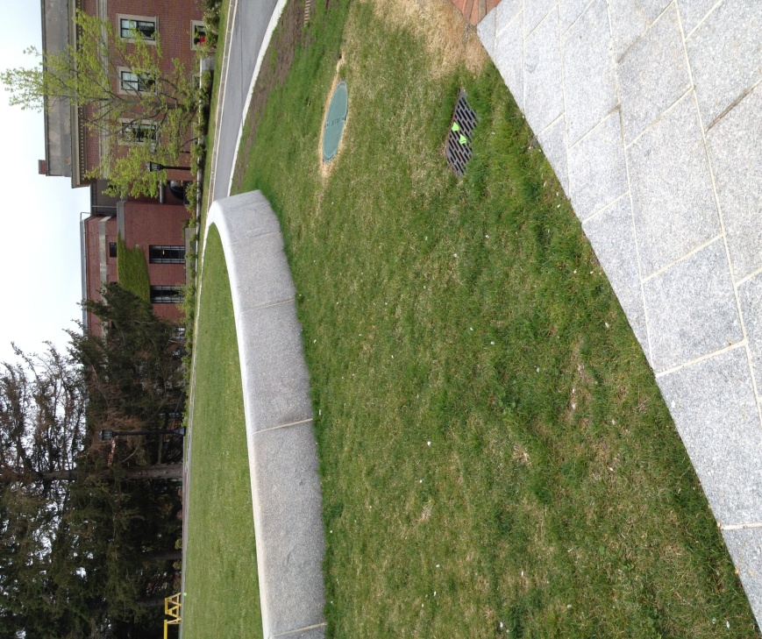
After reviewing the runoff problem here at Holy Cross by collecting data around campus, it is clear that Holy Cross has clearly taken steps to limit surface runoff (retaining walls, new salt regulations, etc.) Although this may be true, there are always new ways in which we can prevent the polluted runoff from entering the Blackstone River.

Retaining Walls
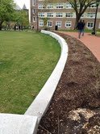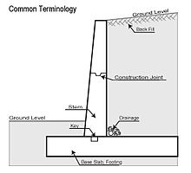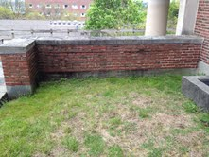

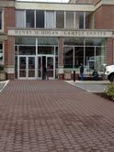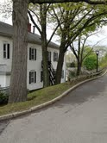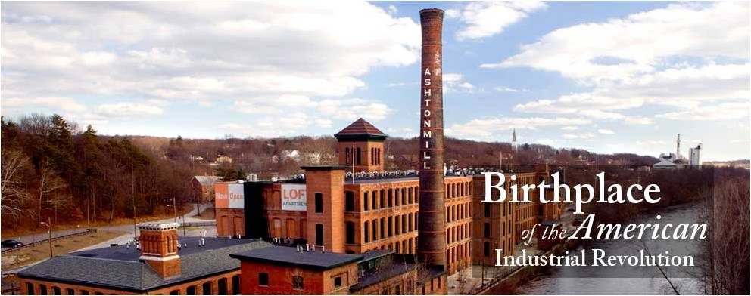
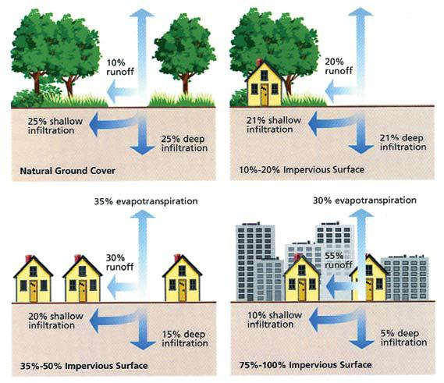
Figure 2 - Here we see the effects of an increase in impervious surfaces. Clearly, the urbanization process of increased impermeable surfaces drastically decrease the soil's ability to collect rainwater. Before starting any more construction for the future, Holy Cross must take into account the impact of decreased porous surfaces.

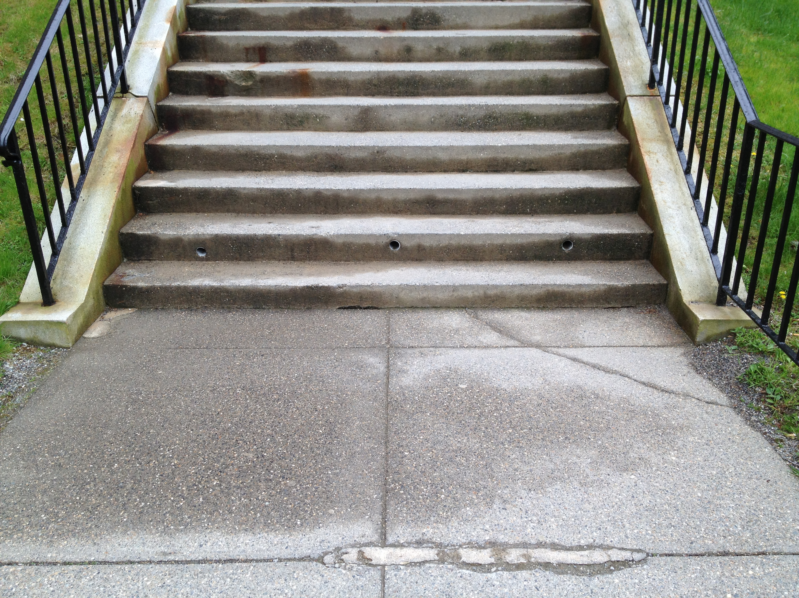

Works Cited
Blackstone River Coalition. The Blackstone River ~ Clean by 2015. Worcester: Blackstone River Coalition, 2008. Print. Discusses the goals of the Blackstone River Coalition as well as examines the major issues the Blackstone River faces today. This source will be very useful.
"Google Maps." Google Maps. Web. 12 Apr. 2012. <http://maps.google.com/>. This source helps to measure the land used to find the sources of water runoff. This source will be extremely useful.
Jekel, Martin, and Thorsten Reemtsma. Organic Pollutants in the Water Cycle: Properties, Occurrence, Analysis and Environmental Relevance of Polar Compounds. Weinheim: Wiley-VCH, 2006. Print. This book covers properties, pollution sources, occurrence in wastewater, surface water and groundwater as well as water treatment aspects. This source may be less useful than the others.
Levia, Delphis F., Darryl Carlyle-Moses, and Tadashi Tanaka. Forest Hydrology and Biogeochemistry: Synthesis of past Research and Future Directions. Dordrecht: Springer, 2011. Print. This book discusses how surface water pollution is formed in runoff surfaces and water paths. This source may be less useful than the others.
"How to Manage and Control Storm Water Runoff." EQM102F (Fact Sheet). University of Missouri Publishing, Apr. 2001. Web. 13 Apr. 2012. <http://extension.missouri.edu/p/EQM102F>. This pamphlet gives an excellent explanation of how to define rainwater runoff. It gives us specific types of areas in an area such as a college campus to look for in order to find the most severe runoff issues along with a way to assess the runoff problem here at Holy Cross. This source will be very useful
Liebl, David Solid S., and Solid and Hazardous Education Center (SHWEC). Managing Storm Water Runoff. Board of Regents of the University of Wisconsin System, 2007. Print.This pamphlet discusses urban growth and storm water problems as well as how to control storm water runoff. It describes specific ways on how to estimate storm water runoff, identifies sources and types of contaminants, and understand the different types of runoff management practices. This source will be very useful
McPherson, E. Gregory, James R. Simpson, Paula J. Peper, Shelley L. Gardner, Kelaine E. Vargas, Scott E. Maco, and Qingfu Xiao. Coastal Plain Community Tree Guide- Benefits, Costs, and Strategic Planting. Davis, California: United States Department of Agriculture Forest Service, Pacific Southwest Research Station Center for Urban Forest REsearch, 2006. Print.This pamphlet discusses the benefits, costs, and strategic planting of trees in order to add value to the community. This source will be very useful
Long, James D. "College of the Holy Cross." Grounds Maintenance. Penton Media Inc. Web. 08 May 2012. <http://grounds-mag.com/snow_ice/1998_august_college/index.html>.James D. Long, superintendent of grounds at the College of the Holy Cross, discusses about when the college began to experience cost overruns and plant damage from salt use, and its implementation of a five-step plan in order to solve the problems. This source will be very useful.

http://www.ririvers.org/wsp/Watersheds/BlackstoneRiverWatershed.htm
Blackstone Pamphlet
Blackstone Pamphlet
http://www.ririvers.org/wsp/Watersheds/BlackstoneRiverWatershed.htm
http://www.ririvers.org/wsp/Watersheds/BlackstoneRiverWatershed.htm
Blackstone pamphlet
Blackstone pamplet
http://www.epa.gov/owow_keep/NPS/index.html
Blackstone pamphlet
http://www.epa.gov/owow_keep/NPS/index.html
Blackstone pamphlet
http://cfpub.epa.gov/npdes/stormwater/menuofbmps/index.cfm?action=factsheet_results&view=specific&bmp=67
http://runoffinfo.uwex.edu/pdf/BusinessSelf-Assess.pdf
Forest Hydrology /pg 372/
FH /372/
http://www.fs.fed.us/psw/publications/documents/psw_gtr201/psw_gtr201.pdf
http://www.ct.gov/caes/lib/caes/documents/publications/fact_sheets/plant_pathology_and_ecology/de-icing_salts-_damage_to_woody_ornamentals.pdf
http://grounds-mag.com/snow_ice/1998_august_college/index.html

