Abigail Lang & Colby Lohrey
Professor Little – MONT 103N
Final Project – Area 1
May 2012
Analyzing Water Runoff on the Holy Cross Campus: Finding Solutions and Preventative Actions to Improve the Blackstone River’s Pollution
For decades, America, among the rest of the world, has come to realize that the environment we live in is breaking down. It has been established that polar ice caps are melting, a hole in the ozone layer is forming, and that there has been a major climate change due to many of our actions –such as technological advances – in society. Many regulations have been put in place to limit pollution that is damaging the environment, along with many environmental organizations; which are beginning to take action on making the world more aware of what is slowly happening to the environment (Clean Water Act, After the Storm, Blackstone River Valley). These organizations are also trying to clean up the mess that has already been made. However sometimes it isn’t always as obvious as nuclear waste, which is contributing to what is slowly breaking down the environment. Our natural world also adds to the mix through damaging weather; however, with the society that mankind has created over past centuries, we seem to have added to the issues that have been risen. Sometimes, with this generation, it is hard to understand or become interested in the environment that appears to be so perfect. For example, a local river is currently being destroyed. Although we have been a major part as to why that is happening, it has taken until now for use to fully realize that the environment is in fact changing for the worst. With powerful storms, rain pours down hills headed into many areas such as rivers. In Worcester, Massachusetts, the runoff water from the campus of the College of the Holy Cross finds its way into the Blackstone River – a river that runs from Worcester, Massachusetts to Pawtucket, Rhode Island (Blackstone River Valley). This river is currently unable to be used for activities such as swimming due to the pollution problem caused by runoff (Blackstone River Valley). After analyzing the campus and its diverse factors, which have positive and negative inputs on runoff water, a current runoff index was determined and future steps towards preventing harmful waste have been developed.
When it rains outside, the rain water is absorbed by what is defined as pervious surfaces. A pervious surface is one that is able to absorb water such as grass areas, shrub areas, and plants, such as trees, are also able to absorb water with their roots (After the Storm). With the development of landscapes due to mankind over the past centuries, more and more pervious surfaces have been eliminated and replaced by impervious surfaces (After the Storm). Impervious surfaces are defined as surfaces that cannot absorb water but instead redirects water into other pervious surfaces or into bodies of water such as rivers, lakes, oceans, etc. (After the Storm). These surfaces include things such as road ways and buildings, but include anything that is made of cement, tightly packed brick, concrete, etc (After the Storm). The impervious surfaces have being a major factor in water pollution due to the fact that it causes runoff water. Runoff water (see Appendix A for example pictures) is water that is not absorbed back into the earth and carries different types of pollutants with it such as: extra sedimentation, excess nutrients, harmful bacteria, and improperly disposed debris and hazardous waste (After the Storm). The water can cause extra sediments (which make rivers appear to be especially cloudy), nutrients and minerals, and harmful bacteria and pathogens to be in the water – all which are extremely harmful to ecological environments (After the Storm, Mosczynski 10). It can also carry debris, in which is also harmful to ecological life and can also back up drainage systems. These pollutants are not as obvious as major industries dumping waste materials into rivers, but all can still be just as harmful (Moczynski 9).
There are many contributing factors to water pollution that the human lifestyle in a community does including: landscaping and lawn care, automobiles, construction, septic systems, and general improper disposal of trash. These are also known as “nonpoint” locations (Clean Water Act). Landscaping plays a major role because of the use of chemicals (After the Storm, Mosczynski 10). Harmful chemicals, such as pesticides and fertilizers, can be carried by runoff water into bodies of water. But also, landscaping leads to over watering, specifically with the use of sprinklers (After the Storm). Sprinklers can cause flooding on pervious surfaces, such as grass, which leads to the creation of water runoff (After the Storm). If the sprinklers cause runoff in areas that contain the fertilizers and pesticides, those particular chemicals are essentially being brought to bodies of water. Automobiles are also a contributing factor for often times there are oil leaks or other fluid spills (After the Storm). Although vehicles are often thought to be a greater contributor to air pollution, the fluids spills add to water pollution because run off water can carry the oil (or other car fluids) into bodies of water (After the Storm). Construction sites are often times messy and with the equipment used, similarly to cars, spills contribute greatly to water pollution (After the Storm). Septic systems also play a role because leaks can occur from improper installation or typical wear and tear over time (After the Storm, Clean Water Act). However, a main issue of construction is more often than not, is eliminating pervious surfaces and replacing it with impervious surfaces. General improper disposal of trash leads to backups in drainage and sewage systems and also causes great harm to ecological life when runoff water brings the water to the bodies of water (After the Storm).
In order to improve the environment’s problems, such as pollution, it is important to understand the environment’s history. In this case, runoff water from the hill of the College of the Holy Cross’s campus leads directly to the Blackstone River (Blackstone River Valley – History). The Blackstone River was originally used for transportation of heavy materials and products up and down the area and is known as “Birthplace of the American Industrial Revolution” (Blackstone River Valley, Mosczynski 10). From Pawtucket, Rhode Island to Worcester, Massachusetts, the river runs and has runoff water being drained into it. Today, the river is specifically classified as Class C approving it for secondary contract recreation (Blackstone River Valley, Mosczynski 11). This includes actions such as boating, fishing, or industrial processing and cooling; but does not deem the river safe enough to do things such as swim, because of the river’s higher levels of pollution (Blackstone River Valley). To limit pollution in the environment, the government developed a national department called the Environmental Protection Agency (EPA) in order to achieve an overall healthier environment (Does the EPA Handle all Environmental Concerns). The EPA on a national level, researches new ways to eliminate pollution, raises awareness to the citizens of the United States of the environmental problems that exist around our country, supports activist groups trying to help the environment, and develops new ways for the individual to make positive impacts on the current environment along with teaching how to take preventative actions for the future of the environment (Does the EPA Handle all Environmental Concerns). On a more local level, there are approximately thirty- five environmental activist groups that are local and specifically focus on the Blackstone River (Blackstone River Valley). Examples of the groups include the Corridor Commission, Zap! the Blackstone, and Eastern Mountain Sports (EMS). All the groups have local campaigns running in order to make the locals more aware of the environmental damage that has been done. However, part of their overall goal is to make the individuals take preventative actions in order to stop continuing to damage (Blackstone River Valley). The Corridor Commission, in 2000, took a four day expedition down the Blackstone River in order to raise awareness, to analyze the current environment of the river, and to clean up what was possible (Mosczynski 10). And on many occasions, Eastern Mountain Sports has donated materials and supplies, such as canoes, in order to ease the ability to perform cleanups on the river (Blackstone River Valley). In June 2011, the first ecological restoration project on the Blackstone River was funded $2.05 million (Mosczynski 9). Known as the “Lonsdale Drive-In Restoration Project,” the money (65% was donated by the US Army Corps alone) was put towards restoring an out of business Drive In to the original marsh condition (Mosczynski 9). By restoring this area, the marsh area contributes greatly to restoring the river to be a ‘fish run river’ (Mosczynski 10).
The College of the Holy Cross has a local connection to the river since the river lies at the bottom of its campus. The river receives all the runoff water that comes off the hill, which is often due to its rainfall, which is quite consistent in Worcester, Massachusetts. In order to recognize how much the campus is a contributing factor to runoff water and water pollution, one can do so by analyzing the campus, determining the most problematic regions of campus and take preventative steps in order to minimize water runoff and water pollution.
The College’s campus consists of a hill with over 38 buildings, multiple road ways, sidewalks, staircases, trees, etc. – basically a landscape filled of pervious and impervious surfaces. To analyze the campus, we divided the surfaces into seven groupings: buildings, pedestrian sidewalks, roadways, pervious gravel walkways, grass areas, shrub areas, and large trees. With the extent of how big campus is, we mainly focused on the lower fourth of campus (images can be found in Appendix A). Different tools were used in order to obtain measurements of the campus. To measure buildings and grass areas, satellite images were used to receive the estimated measurements. To measure sidewalks, roadways, and shrubs, GPS tracking was used to physically measure distances. In order to receive a tree count, the school’s Arboretum was obtained (College of the Holy, 14). With these measurements, many calculations were done in order to convert and to determine areas. Below is an example of how the area of a roadway was found (and the rest of the calculations can be found in Appendix B):
- Area of Roadways in front of Loyola dorm
  - Length
    - .11 km * (1000 m/1 km) = 110 m
  - Width
    - 22 footsteps * 24.5 cm (size 7 ½ women’s shoe) = 539 cm
    - 539 cm * (1m/100cm) = 5.39 m
    - 32 footsteps * 24.5 cm = 784 cm
    - 784 cm * (1m/100cm) = 7.84 m
  - Areas
    - 5.39 m * 110 m = 592.9 m²
    - 7.84 m * 110 m = 862.4 m²
    - 592.9 m² + 862.4 m² = 1,455.3 m²
After all of the measurements were taken a Runoff Index (RI) could be formed. By developing a RI, one can statistically analyze different regions of the campus first through the total areas and types of surfaces, then by comparing regions, and then concluding which areas are most problematic through the greatest contribution to runoff water. After all the total areas of each of the seven groupings were totaled (for only the lower fourth of campus), the seven groupings of surfaces were weighted (percentages adding up to one hundred or decimals adding up to one) according to how impervious they were. The more impervious the surface is and with a larger overall area, the larger the weight of the grouping. Therefore if a surface is pervious the weight is really low or is negative. It was taken into consideration that grass can only absorb so much water, therefore flooding can occur resulting in runoff. The total areas and weights of each grouping resulted in:
- Buildings A₁ = 22,255.45 m² W₁ = .30
- Roadways A₂ = 19,436.468 m² W₂ = .53
- Pedestrian Walkways A₃ = 1,813 m² W₃ = .20
- Grass A₄ = 70, 420.55 m² W₄ = .05
- Shrubs A₅ = 548.6542 m² W₅ = .01
- Gravel/Pervious Brick A₆= 0 m² W₆ = .01
- Tree Count T= 121 Trees W_{T} = -.10

The RI was then calculated with the equation:
- RI = W₁A₁ + W₂A₂ + W₃A₃ + W₄A₄ + W₅A₅ + W₆A₆ + W_{T}T
- RI = .3(22255.45) + .53(19436.468) + .2(1813) + .05 (70420.55) + .01 (0) + .01 (538.6542) + 121 (-.10) = 20854.9
With this number, this RI represents the lower fourth of campus. To make an accurate analysis of the whole campus, one would need to have accurate measurements of all of the seven groupings from the entire campus. The weighting of the seven groupings would be consistent and each individual RI could then be made. However to make the most accurate analysis, the campus should be divided up into a large number of reasons such as one hundred regions (n=100), and then each individual RI can be made and then compared. One can compare the regions by comparing the RIs. The RIs are ultimately an average of how much each region contributes water runoff. The numbers representing each region can be compared together visually and statistically by composing a box plot. The box plot includes analyzing the following numbers by finding the following:
- The numbers must first be put in order from least to greatest.
- Then the median can be found by taking the middle most number (or the average of the two middle numbers).
- The minimum is then found for it is the lowest number in value
- The maximum is then found for it is the highest number in value
- The first and third Quartiles are found then because they are the middle most number between the minimum and the median and the median and the maximum.
With the median, minimum, maximum, first and third quartiles found, one can create a visual representation of how the RIs of the individual regions can compare to each other. The box plot appears as the following:

minimum 1st Quartile median 3rd Quartile maximum
From here, one can determine the most problematic regions, because the total RIs would be the ones in which are greater than the 3rd Quartile, including the maximum.
After determining the regions with the most water runoff, which can be deemed as most contributing to water pollution running into the Blackstone River, the campus community can take adequate steps in order to achieve a healthier, cleaner environment and can truly focus on the problematic areas. However, general steps towards improving the campus as a whole should be taken to preserve the surrounding environment (Clean Water Act, Blackstone River Valley). On the most basic level, campaigns to raise awareness about the Blackstone River and its pollution should be made to the student body (After the Storm, Mosczynski 11). The residents of Holy Cross first need to know that the river is being polluted and that human activity is a main cause. The campaign should not only include intelligence about pollution, the river itself, and how it’s currently being managed, but should also include ways that the individuals themselves can help by simple actions that they can take during their everyday life (Mosczynski 11). This includes things such as being sure to throw away trash and recycle properly, to pick up litter if they see it in passing, and also spread the word about the river to their friends. Besides the individual, the campus community needs to also take action through which they manage themselves. First, the community needs to recognize that the actions they take in order to keep their status as one of the top ten most beautiful campuses in the country, actually hurt the environment even though it does appear to be helping it. The first most general change that the campus can make is limiting the amount of chemicals it uses and to switch to organic substances that are more environmentally friendly. Eventually the goal would be to eliminate the use of chemicals in preserving the landscape. Unlike landscaping, construction on campus cannot really be limited because improvements to old structures and the expansion of campus will continue. However, construction sites can be managed in order to prevent runoff water going through them. Drains and ditches can be formed around sites to divert the runoff water (After the Storm). Silt fences and vehicle mud removal also can contribute to the prevention of water runoff (After the Storm). One way for the school to manage the automobiles on campus is by controlling the amount of students who are allowed to park at school by issuing permits to seniors, juniors, and RAs only. With this, the school could then require passing inspections (over multiple times of the school year) to prove that their vehicles are not leaking any fluids at all. The school could also assign parking spots to each individual with a permit and to employees working on campus (both professors and workers). This would allow the school community to see specifically whose car is leaking a fluid in which the school can have the owner get their vehicle fixed immediately. Another way to control the debris around campus, besides encouraging to properly dispose of trash, the school could also implement fines similar to what states do when people are caught littering. In New Hampshire, there is a $250-2000 fine for littering. A last way to really continue efforts made over the last forty years, is to recognize and make efforts towards the upkeep of the Clean Water Act (originally the Federal Water Pollution Control Act of 1972) (Clean Water Act). This act sets regulations on pollutant discharge and sets standard guidelines to water quality (Clean Water Act). With other contributing factors, mostly maintenance upkeep is the most sufficient way to insure that there are no extra contributing factors to water pollution that can be easily avoided.
In conclusion, water runoff of impervious surfaces, leads to environmental damage. Specifically in the local area of Worcester, Massachusetts, the water runoff from the campus of Holy Cross leads in to the Blackstone River. After analyzing the campus based on its impervious and pervious surfaces, a Runoff Index (RI) was developed for different sections of the campus. From there an idea on how to calculate the RI for the entire campus was determined. Through the RI which could be then be calculated would then allow us to determine which region of campus contributes most to runoff water. Solutions would then be developed in order to minimize water pollution and to start fixing the pollution that already exists. According to Donna Williams, the Chair of the Grafton Conservation Commission, the Commissioner on the John H. Chafee Blackstone River Valley National Heritage Corridor, and a Advocacy Outreach Coordinator of Broad Meadow Brook Conservation Center and Wildlife Sanctuary in Worcester, “The key is to slow down the runoff and clean it up before it enters the river” which reflects the solutions developed in order to minimize future water pollution and to start fixing the pollution that already exists (Mosczynski 11).

Appendix A
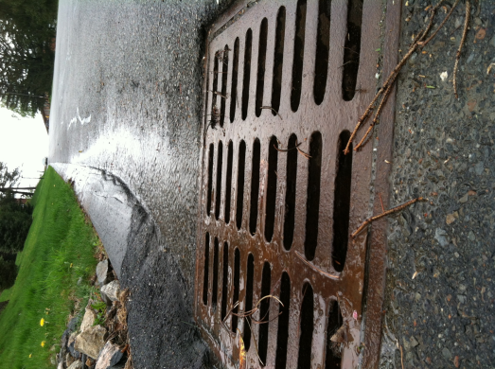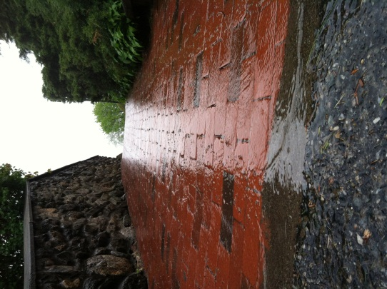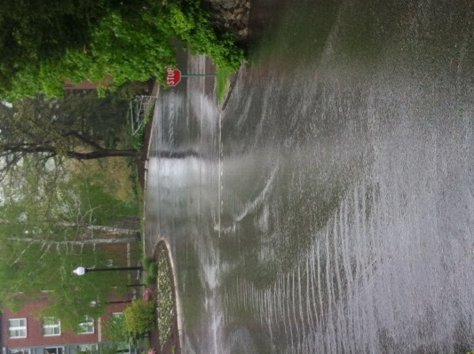
All three of these pictures demonstrate water runoff, specifically on locations found around the College of the Holy Cross Campus.
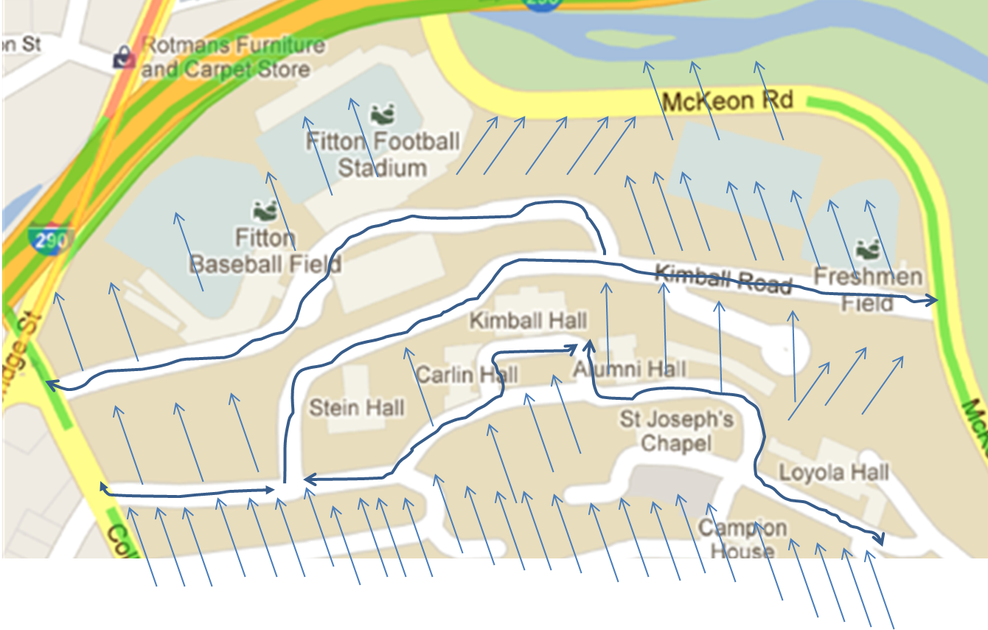
This picture demonstrates the possible water flow that could happen on the lower fourth of campus.
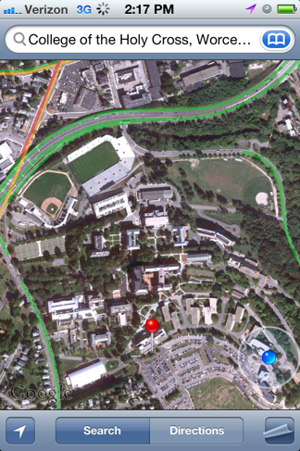
This picture is a satellite image of the lower fourth of campus.
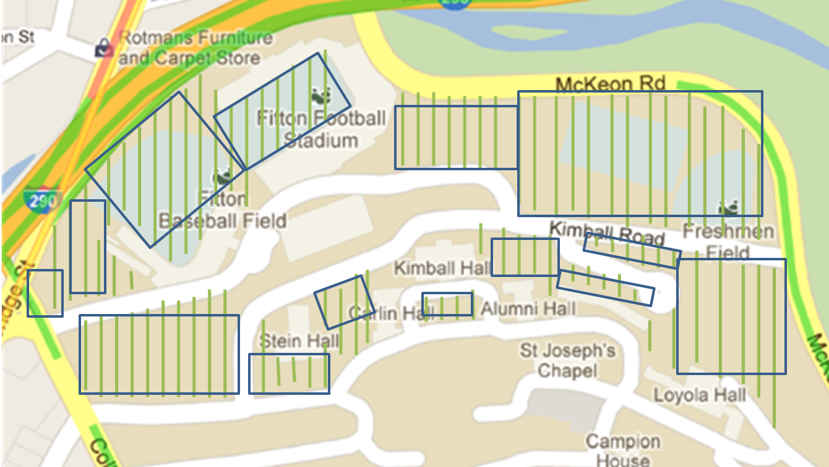
This is a map representing how the grass area was approximated.

Appendix B
Area from Corner of Loyola to Stein Gate:
- .34 km * (1000m/1km) = 340 m
- 539cm * (1m/100cm) = 5.39 m
- 5.39m * 340m = 1832.6 m²
Area’s outside of Kimball, Alumni, and Carlin:
- Kimball
.1km * (1000m/1km) = 100m
37 Footsteps * 24.5cm = 906.5cm * (1m/100cm) = 9.065m
9.065m * 100m = 906.5m^2
- Alumni
.035km * (1000m/1km) = 35m
28Footsteps * 24.5cm = 698.25cm * (1m/100cm) = 6.9825m
6.9825m * 35m = 244.388m^2
- Carlin
.035km * (1000m/1km) = 35m
23Footsteps * 24.5cm = 563.5cm * (1m/100cm) = 5.635m
5.635m * 35m = 197.225m^2
- Overall: 906.5m^2 + 244.388m^2 + 197.225m^2 = 1348.113m^2
Area behind Stein/ Kimball until Williams:
- .35km * 1000m/1km = 350 m
- 45 Footsteps * 24.5cm = 1102.5cm * 1m/100cm = 11.025m
- 11.025m * 350m = 3858.75 m²
Area from Williams to McKeon
- .28km * (1000m/1km) = 280m
- 35 Footsteps * 24.5 cm = 857.5cm * (1m/100cm) = 8.575m
- 8.575m * 280 = 2401 m²
- 3858.75 m² + 2401 m² = 6259.75 m²
Area of Linden Lane to Gate of Kimball:
- .28km * (1000m/1km) = 280 m
- 23 Footsteps * 24.5 cm = 563.5 cm * (1m/100cm) = 5.635m
- 5.635m * 280m = 1577.8 m²
Area of Football Field Road:
Parking Lot: .1km *(1000m/1km) = 100m
Rest of Road: .45km * (1000m/1km) = 450m
Parking Lot: 90 Footsteps * 24.5cm = 2205cm * (1m/100cm) = 22.05m
Rest of Road: 35.5 Footsteps * 24.5cm = 869.75cm * (1m/100cm) = 8.6975m
Parking Lot: 22.05m * 100m = 2205 m²
Rest of Road: 8.6975m * 450m = 3913.88 m²
Overall: 2205 m² + 3913.88 m² = 6118.88 m²
Area of Williams Road:
- Straight Road: .05km * (1000m/1km) = 50m
- Circle: .13km * (1000m/1km) = 130m
- Straight Road: 38 Footsteps *24.5cm = 931cm * (1m/100cm) = 9.31m
- Circle: 26.5 Footsteps * 24.5cm = 649.25cm *(1m/100cm) = 6.4925m
- Straight Road: 9.31m * 50m = 465.5m²
- Circle: 6.4925m * 130m = 844.025m²
- Overall: 465.5m² + 844.025m² = 1309.525m²
Total Area of Roads/ Pavements:
- 1455.3 m² + 1832.6 m²+ 1348.113 m² + 6259.75 m² +1577.8 m² + 6118.88 m² + 1309.525 m² = 19901.968 m²
Grass Area:
- Kimball Road/ Football Road
  - 103m * 210m = 21630m²
  - 100m * 2m = 200m²
  - 100m * 60m = 6000m²
  - 110m * 100m = 11000m²
  - 100m * 50m = 5000m²
  - 50m * 50m = 2500m²
- Grass in front of Stein:
  - 75m * 25m = 1875m²
- Stein Quad:
  - 20m * 50m = 1000m²
- Kimball Quad:
  - 65m * 30m = 1950m²
- Kimball/Alumni:
  - 60m * 50m = 3000m²
- Williams:
  - 60m * 20m = 1200m²
- Williams Road + Kimball Road:
  - 75m * 10m = 750m²
- Area between Kimball Road, Linden Lane, and Football Road:
  - (175m * 85m) – (169.45m^2) – (390m^2) = 14315.55m²
    - (Tennis Courts) (Basketball Courts)
- Total Grass Area: 70420.55m²
Area of Football Stands:
- (40 * 90) + (40 * 40) + (1/2 * 40 * 40) + (15 * 100) = 7500m²
Area of Baseball Stands:
- (60 * 20) + (25 * 60) + (15 * 40) = 3300m²
Area of Tennis Courts:
- 228ft² * 8 = 1824ft² = 169.45m²
Area of Basketball Courts:
- (84ft * 50ft) = 4200ft² = 390m²
Area of Dorms:
- Alumni
  - (25 * 10) + (23 *17) + (25 * 7) = 816m²
- Williams
  - 82m * 13m = 1066m²
- Loyola
  - (35 * 40) + (40 + 5) + (30 + 15) = 2050m²
- Kimball
  - (15 * 10) + (50 *30) = 1650m²
- Carlin
  - (30 * 12) + (18 * 22) + (27 * 10) = 1026m²
- Maintenance
  - 78 * 16 = 1248m²
- Stein
  - (41 * 20) + (20 *35) = 1520m²
- Parking Garage
  - 60 * 20 = 1200m^2
Area of Sidewalk on Linden Lane:
- 280m
- 8.5Footsteps * 24.5cm = 208.25cm * (1m/100cm) = 2.0825m
- 2.0825m * 280m = 583.1m²
Area of Path from Linden Lane to Baseball Stadium:
- .24km * (1000m/1km) = 240m
- 7Footsteps * 24.5cm = 171.5cm * (1m/100cm) = 1.715m
- 1.715m * 240m = 411.6m²
Area of Sidewalk along Kimball Road:
- .24km * (1000m/1km) = 240m
- 7Footsteps * 24.5cm = 171.5cm *(1m/100cm) = 1.715m
- 1.715m * 240m = 411.6m^2
Area of sidewalk in Stein Quad
- .03 km * (1000m/1km) = 30 m
- 12 * 24.5 cm = 294 cm * (1m/100cm) = 2.94 m
- 30m * 2.94 m = 88.2 m²
- .05 km * (1000m/1km) = 50 m
- 12 * 24.5 cm = 294 cm * (1m/100cm) = 2.94 m
- 50 m * 2.94 m = 147 m²
Area of sidewalk from Carlin to Stein Gate
- (.04 km * 1000m/1km) = 40 m
- 5*24.5 = 122.5 cm * (1m/100cm) = 1.225 m
- 1.225 m * 40 m = 49 m²
Area of stairs next to Kimball (left side, then right side)
- .02 km * (1000m/1km) = 20 m
- 5*24.5 = 122.5cm * (1m/100cm) = 1.225m
- 1.225m * 20 m = 24.5 m²
- .06 km * (1000m/1km) = 60 m
- 5*24.5 = 122.5 cm * (1m/100cm) = 1.225 m
- 1.225 m * 60 m = 73.5 m²
Area of stairs by maintenance
- .02 km * (1000m/1km) = 20 m
- 5*24.5 = 122.5cm * (1m/100cm) = 1.225m
- 1.225m * 20 m = 24.5 m²
Area of Shrubs by Linden Lane and Kimball Road
- (11.8872 m * 1.8288 m) + (1.2192 m * 55.7784 m) = 89.7443 m²
Area of Shrubs facing tennis courts along Stein
- (0.6096 m * 15.24 m) + (0.9144 m * 54.1792 m) = 59.1792 m²
Area of Shrubs facing the highway along Stein
- (0.762 m * 24.384 m) = 18.5806 m²
Area of Shrubs facing Carlin along Stein
- (3.048 m * 15.24 m) * 2 = 92.903 m²
Area of Shrubs outside of Kimball
- (4 m * .9144) + (4.8768 m * 4.572 m) + (4.572 m * 4.572 m) = 46.8575 m²
Area of Shrubs facing Kimball road, next to Stein
- (40 m * .6096 m) = 24.384 m²
Area of Shrubs from Alumni facing Williams
- (4.572 m * 15.8496 m) = 72.4644 m²
Area of Shrubs outside Williams, closest to Alumni
- (10.9728 m * 853.44 m) = 93.7572 m²
Area of Shrubs outside Williams, closest to Loyola
- (4.8768 m * 7.3152 m) = 35.6748 m²
Area of Shrubs outside Loyola
- (0.762 m * 6.7056 m) = 5.1096 m²

References
""After the Storm"" Environmental Protection Agency. Jan. 2003. Web. May 2012. <http://water.epa.gov/action/weatherchannel/stormwater.cfm>.
“Blackstone River Valley.” National Park Service. National Park Service, 20 Apr. 2012. Web. 28 Apr. 2012. <http://www.nps.gov/‌blac/‌index.htm>.
Clean Water Act. 33 USC. Sec. 1251. 1972-2012. United States Environmental
Protection Agency. N.p., 13 Apr. 2012. Web. May 2012.
<http://www.epa.gov/lawsregs/laws/cwa.html>.
College of the Holy Cross Arboretum. 3rd ed. N.p.: n.p., 2009. Print.
Does the EPA handle all environmental concerns? United States Environmental
Protection Agency. N.p., 13 Apr. 2012. Web. May 2012.
<http://publicaccess.supportportal.com/ics/support/
kbAnswer.asp?deptID=23012&task=knowledge&questionID=15450>.
Harrison, Roy M., ed. Pollution: Causes, Effects and Control. Cambridge: The Royal Society of Chemistry, n.d. Print.
Mosczynski, Lisa. "New Life of the Blackstone." River Valley Current, 2000. Web.
May 2012. <http://www.nps.gov/blac/naturescience/upload/
newlifeBlackstone.pdf>.

