M.C. Escher: Mathematics and Art
Professor Little
May 9, 2011
Kylee Sullivan
John Macomber
Kevin Sutman

Famous artist and mathematician, M.C. Escher was once quoted as saying: “mathematicians go to the garden gate but they never venture through to appreciate the delights within.” Rarely before had an artist ventured into mathematics for the basis of so many of his or her works. However, as the quotation implies, Escher went as far as he could with math, but realized that he needed to employ artistic abilities to “appreciate the delights within” the “garden.” M.C. Escher was one of the greatest artists in the modern era. His unique style had never been seen before, and it continues to amaze and influence artists to this day. He famously combined art and mathematics using tessellations, strange loops, impossible structures, and more in the exploration of reality and the many ways to distort it. Escher’s dreams influenced his ability to “appreciate the garden within,” and discover the artistic connections that could be made in his work. His wild imagination served as inspiration for his most famous works, but so did the world around him. His visits to Spain, Italy, and Switzerland served as influences from real world places that he combined with inspiration from his imagination. M.C. combined art and mathematics to create his own, original category of art. He explored mathematical ideas and combined them with his fascinations and artistic skill to set himself at the forefront of modern, graphic artists.
Maurits Cornelis Escher was born on June 17, 1898 in the city of Leeuwarden in the Netherlands. He was the youngest son of four; his father was an engineer.2 It seemed he would follow in the footsteps of his father, showing architectural skill from a very early age, along with mathematical and artistic skill. However, his artistic side began to take hold while he was at school. M.C. Escher was a very poor student, and he failed all of his high school exams.2 Instead, he worked more and more on his artwork, continuing to keep mathematical influence in his work. He originally went to school to become an architect, leaning in the direction of his father. He was enrolled in the School for Architecture and Decorative Arts in Haarlem.2 Soon though, he decided he would rather study graphic art instead of architecture. He was influenced to make the decision by his graphic art teacher, Samuel Jessurun de Mesquita.2 His combination of the two disciplines paved his way to becoming one of the most well known artists of the 20th century, and perhaps even in the history of the world. His unique style has inspired and influenced artists around the globe, and his artwork is now prized collections of major museums.
Escher made a series of important trips that influenced and inspired much of the artwork that he created. In 1922, he traveled to the Islamic fortress of Alhambra in Granada, Spain2. It was at the Alhambra that he became enamored with tessellations. The definition of a tessellation is a tiling of plane that fills the whole plane without gaps or overlaps. His visit to the Alhambra was key in the development of his style in employing tessellations in his art. Another important “trip,” was Escher’s time in Italy, which also had a profound influence on his art. In 1924 he traveled to Italy, where he met and married his wife, Jetta Umiker. 2 The couple settled in Rome; however, Escher did not stay put. Instead he traveled around the country, and many of the sites he visited in the scenic country served as inspirations for his various works. He drew a lithograph of the town of Atrani on the Amalfi Coast; his lithograph “Waterfall” was also made in Italy.3 After Italy, Escher and his family moved to Switzerland, possibly because of the fascist regime in Italy and the further militarization of that country leading up to World War II. He continued his work in Switzerland, drawing 62 out of the total of 137 Regular Division Drawings that he drew during his lifetime.3 Drawing from the real world, Escher explored the fascinating artistic style of distorting his surroundings nature of the world, and it seems that his trademark was creating distortions; impossible structures, loops, tessellations, though they are each different in and of each other. He combined mathematics and art in an original style that is known throughout the world. Escher poured his fantasies into his art, preferring to show the wonders of reality through distorting it.
One of the major themes seen throughout Escher’s works of art is the distortion of perception. In many of his lithographs, woodcuts, and mezzotints, Escher put an abstract twist on the realistic three-dimensional perception of a picture on a two-dimensional plane. The basis of Escher’s created warped perceptions depends on the way our eyes work. Human eyes have the ability to either work together or even alone to successfully enable people to have depth perception (the ability to see in three-dimensional even though objects appear in two-dimensional when they strike the retina.) Basic monocular cues such as relative height, relative size, the light and shadow effect, linear perspectives, and interposition can be seen as a means or distortion throughout Escher’s work. Escher’s use of relative height-the natural inclination to view an object higher up in a person’s vision field as farther away- is portrayed in Escher’s piece titled, “Still Life and Street.” Relative size- the natural inclination to view an object that casts a small retinal image as far away- is also seen in Escher’s “Still Life and Street.” This picture accurately portrays reality unlike many of his later works which focus on creating warped perceptions of the world. The light and shadow effect states that dimmer objects appear farther away than lighter ones. This is seen in Escher’s use of concave and convex objects throughout his artwork, especially in his piece named “Concave and Convex.” For example, in Escher’s works, when the light in the picture appears to be coming from the right, it makes objects look lighter and thus they appear to the human eye as convex out. On the other hand, when Escher created a picture in a way that the light appeared to be coming from the left, it made objects look dimmer and so those objects appeared concave in.
Escher played with perception when he used interposition (when one object blocks another and thus appears closer to the viewer) in his pictures, especially in his piece titled “Bond of Union,” where round floating objects block the view of parts of the two peeled heads. Lastly, Escher used the monocular cue of linear perspective- where parallel lines converge with distance- the most throughout his work. Although Escher was fond of using linear perspective throughout his work, it was never the main focus of his pieces, but rather accented and supported the impossible worlds he created.
As mentioned above, Escher was fond of using linear perspective in his artwork. This convergence of parallel lines in the distance creates important points in each of Escher’s pictures. In classical perspective, these specific points can either be called the Zenith or the Nadir point. The name of the point depends on the effect the point has on the viewer’s interpretation of the picture. For example, if the point is the place of convergence of all vertical lines from above, it is referred to as the Zenith. However, if the point is the place of convergence of all vertical lines from below it is referred to as the Nadir. The words Nadir and Zenith can be rooted back to the Arabic influence of mathematics. Nadir and Zenith are in fact Arabic words; Zenith can be translated into English as the “direction of the head” or the “path above the head” whereas Nadir is translated as the point “directly below the observer.” This specific point is also can go by the name of the point of distance. More specifically, the point of convergence to which all parallel lines not parallel to the image plane appear to converge is called the vanishing point. Escher often used this vanishing point as a way to create depth in a two-dimensional plane.
Escher drew inspiration from the world around him to create his pieces of art. More specifically, Escher greatly enjoyed the Italian landscapes that surrounded him on a daily basis and thus drew inspiration from them that he then integrated into his artwork. Even though Escher considered himself an artist, his artwork tended to reflect mathematical influences as well. Two mathematical principles that inspired and had an impact on him are the different types of symmetry groups and crystallography. Escher is known for creating prints that show patterns of symmetry- reflective symmetry, rotational symmetry, or translations. Crystallography is essentially just symmetry on a flat plane, and thus Escher created beautiful and thought-provoking artwork by repeatedly shifting objects to make a pattern (translations), or by turning objects about axes (rotational symmetry), and even by gliding mirror images of an object in a particular pattern throughout a two-dimensional plane (reflective symmetry). Using these principles, Escher transformed mathematical tessellations into art.
While Escher's interest in tessellations can be traced to the visit to the Alhambra, his work in this area had different features from the art he had seen there. As a result, Escher started creating similar pieces of artwork. However, due to religious beliefs, the Alhambra did not show any artwork that depicted any pictures of humans, animals, or plants. Unlike the solely geometrical pieces at the Alhambra, Escher used images of humans and animals to create his tessellations. Escher was most passionate about creating tessellation prints. Unfortunately, Escher’s fans preferred his work that focused on distorting perception.
Nonetheless, Escher continued to create his beautiful tessellations. The technical definition of a tessellation is the “tiling of a plane with figures that fill the plane without any overlaps and gaps.” Escher changed the definition for the purpose of his artwork to “the regular division of a plane.” Originally, tessellations developed from the word “tesserae,” a Latin word, that described small cubed stones that created architectural tiling patterns on the floor in ancient Roman buildings.
Escher’s use of tessellations in his artwork arose after his brother, Beer, introduced him to crystalline structures that he had previously read about. After seeing some of his brother’s work, Beer noticed the similarities between the artwork and crystalline structures. As a result, Beer sent Escher articles about work done by Professor George Polya. In these articles, Escher came across a paper from the 1920’s that was based on work written by a Russian crystallographer in the 1890’s. This paper-Polya’s 17 possible wallpaper designs- outlined the different types of tessellations that can be created. Escher used these 17 different wallpapering patterns throughout his artwork throughout the rest of his career as an artist. In addition to learning about tessellations from Polya, Escher also read other articles written by F. Haag regarding the definitions of how to properly divide a two-dimensional plane. In these articles, it was stated that the “regular division of the plane consist of congruent, convex polygons joined together. The arrangement by which the polygons join each other is the same throughout.” This definition had a clear impact on Escher’s artwork, as it is seen in all of his tessellation pieces. Another trademark characteristic of Escher’s tessellations is their colorfulness. Escher used many different, bright colors to accent his tessellation pieces. This is beneficial to the spectator because sometimes it makes it easier to distinguish what type of pattern the tessellated object is in.

A precursor to Escher’s love for tessellations was his piece titled, “8 Heads.” This was one of the pieces that Escher’s brother, Beer, used to identify the similarities of his knowledge of symmetry and crystalline principles to in previous article she had stumbled upon. The picture shows four different heads that are both vertically and horizontally translated throughout the two-dimensional plane. The first tessellation artwork created by Escher in 1925 is called, “Lions.” In the picture, Escher’s lions are translated in a certain pattern across the two-dimensional plane. The way in which the lions are translated depends on their color; lions of the same color are diagonally translated up/down, (depending on how the viewer sees it) to make the tessellation complete. Escher did not only use the crystalline principle of translation in his artwork, he also created tessellations using rotational and reflective symmetry. For example, in his 99th tessellation, “Flying Fish,” Escher uses rotational symmetry around the point of intersection of four different fish’s fins. Once again, Escher used different colors to enhance to tessellation’s effect on the viewer. An example of Escher’s ability to portray reflective symmetry in his artwork is seen in his piece called “Day and Night.” Although the picture does not consist of exactly 100% reflection, the idea of a reflective tessellation is the foundation of it. The piece of art is roughly reflected vertically at the middle of the picture.
In addition to tessellations, strange loops were used by Escher in his drawings as one of his ways to both paradoxically confuse and, at the same time, open ourselves to the idiosyncrasies of how we compute certain things in our minds and how we view the natural world. A strange loop, according to Escher, “occurs whenever, by movement upwards or downwards through the levels of some hierarchal system, we unexpectedly find ourselves back where we started”. Moreover, strange loops both classify and create themselves in a repetitious pattern. Escher employed strange loops as a way to manipulate our minds because they systematically go against our values of both distance and solving. Strange loops confuse our sense of distance in that our minds automatically think that the father one travels the farther one is from the starting point. However, in a strange loop, the farther one travels from the origin the closer one is to the origin. Strange loops also defy our rational thought process in that, unlike our step by step technique to solve problems, each step does not lead to the solution, but rather back to the initial problem itself. It is as if the step by step propositions laid out by Euclid in The Elements book one do not lead us to the climax of the “Pythagorean Theorem”, but ironically back to Proposition One. Moreover, strange loops distort the way in which we view our natural world. Our natural world presented before us is one boundless freedom in which there are never two things that are perfectly alike. In a way, by drawing strange loops, Escher strives to find real indisputable truth, in that he tries to perfectly categorize and draw out patterns within his pictures. However, like in all of Escher’s paintings, he is trying to push the limits of our own world because on earth indisputable truth and perfection are not achievable. The philosopher Plato used the example of a circle to show that, though we know what a circle is, there is no way one can draw perfect circle. Though never achieving perfection, the strangle loops in Escher’s paintings attempted to recreate an essence in a perfect manner. Such an attempt for perfection by Escher allowed him to both confuse and question our minds inexperienced sense of perfection because perfection is an entity nonexistent in our natural world. Thus, I believe Escher, through strange loops, expressed his desire to manipulate and change the sometimes narrow minded ways many of us view calculating problems, examining distance, and lastly perfection in the natural world.
Examples of strange loops in Escher’s art can be seen in paintings such as “Drawing Hands”, “Concave and Convex”, and “Encounter”. “Drawing Hands” is one of the most overt examples of a strange loop in Escher’s art. The drawing shows a piece of paper out of which comes two hands are ironically drawing one another into existence. The painting clearly illustrates the dimension of a strange loop in that each hand draws the other one into existence. Moreover, the painting, no matter whether moving upward or downward, leads one back to the starting point in which the more one ventures across the hands the closer one gets to the starting point. Also, in many of Escher’s strange loops he used mathematics as a tool to distort images and force the reader to look at the work in more than one way. For example, Escher’s drawing “Concave and Concave” uses complexities in his visual labyrinth that force the spectator to look at painting in more than one way. First, the surfaces within the piece are drawn in such a way that they can be described as a floor, wall, and ceiling all at the same time. Moreover, Escher plays around with the effects of light on certain objects within the piece. If light is coming from the left than it creates the illusion that the objects are concave in. On the other hand, if light is coming from the right than there is the illusion that the objects are concave out.
Escher also uses elements of dreams, a part of Escher’s artistic style that I will go further into in detail, as well as elements of infinity in his portrayal of strange loops. Escher’s painting called “Encounter” incorporates such elements as dreams and infinity in his strange loops. In this painting, Escher portrays, similar to our dreams, both elements of reality and unreality. The elements of reality in the painting can be seen in by the floor which holds the two figures together as well as by the white figures which contain aspects of human beings such as an oval shaped head, two feet, and two legs. The lack of reality in the painting is best seen by the haunting images of the black figures that look nothing like anything of this world. Moreover, the element of infinity is exemplified in the painting by the repetition of the figures which can go on in a pattern forever. Thus, the strange loops done by Escher are unique in that, instead of just blandly showing how one can move both upward and downward and yet end up in the same place, Escher includes paradoxes, illusion, dreams, and infinity to further his goal of pushing the concepts of our mind and natural world.
Escher was inspired to paint and portray elements of his own dream world. Many people’s reaction to first looking at an Escher painting is often to question how he was able to portray such bizarre material. Escher can be quoted saying, “I don’t use drugs, my dreams are frightening enough”. It was in Escher’s search to portray his dream world that mathematics became useful. Such a statement can be made because Escher himself says, “even the wildest fantasy worlds remain subject to the rules of the game…higher laws of logic and mathematical laws help draw the universe and all its opposing sides together”. Thus, Escher wanted to see how far he could go in portraying the thought provoking and sometimes alarming dreams within his mind and did so by using mathematics. Portraying the dream world was “not always necessary for showing different spatial experiences to coincide”; rather dreams presented Escher a way to have fun with his paintings. Escher took great pride and excitement in depicting aspects of different dimensions other than our own as well as showing how far the dream world can be pushed. Paintings by Escher’s such as “Puddle” and “Eye” illustrate Escher’s fascination in portraying different worlds other than our own. The print, “Puddle,” actually is one of the few Escher paintings that seemingly depicts something natural world. In the painting, there is a puddle on a dirt road which contains the reflection of trees, the sky, and the moon at night. In the dirt around the puddle there are indentations of car wheels and footprints of people. Everything within the painting seems like something one would walk across when going about in the natural world. However, there is a mystery within the painting in that the viewer is uncertain where the moon and the trees are in the puddle. Are they really there? After all, should we trust that the image of an image is real? The philosopher Plato described the story of prisoners locked in a cave being fed false images of shadows by their captives which they mistakenly took as the realistic depiction of themselves. Plato, through this story, exemplified his idea that we cannot trust an image of an image because there is no proof over whether the certain image is real or fake. Moreover, what is inside the reflection? Could there be another world within the reflection? Escher wanted to raise these questions for the spectator of “Puddle” to answer as well as open the mind of the spectator to other dimensions and fantasy worlds.
Escher’s painting “Eye” also represents his ability and desire to bring into his paintings both outside dimensions and different perspectives. The painting depicts Escher’s own eye as observed by his own observation of himself in the mirror. In the middle of Escher’s eye (his pupil, to be specific) there is the image of the face of a skeleton which Escher describes as “the one who watches us all” most likely representing death. Many questions arise from the painting in that there is a mystery over who is watching who. No one knows whether it is the artist, death, or someone else looking on. Thus, Escher introduces elements outside of our own world such as death as well as showing the possibility of having three perspectives in a painting all at once. Thus, Escher’s desire to paint stemmed from his aspiration to portray fantasy worlds and outer dimensions in ways that pushed the dimensions of our own natural world.
By our research of Escher’s strange loops and his fascination with dreams I have come to the conclusion that Escher can be categorized as an artist, despite the fact that all his work contains mathematics. Art itself is the depiction of a certain aspect of the world. Major art movements such as the Baroque concerned themselves with the portrayal of human emotion and how such emotion is manifested physically by the body. Escher himself said, “It is human nature to want to exchange ideas, and I believe that, at the bottom, every artist wants no more than to tell the world what he has to say”. Escher’s desire, through his use of tessellations and strange loops and different perspectives based on mathematic principles, was to show how our world and the norms that we accept to be true can be challenged and thought of in a different light. Escher was able to push the norms that we accept as true to the fullest by using mathematics. But, to put it plainly, so what if Escher used mathematics? The root of all his paintings stems from his own longing to question the realms of what we take as reality which, as a result, is more of his own portrayal of the world than anything mathematical.

Mentioned Artwork

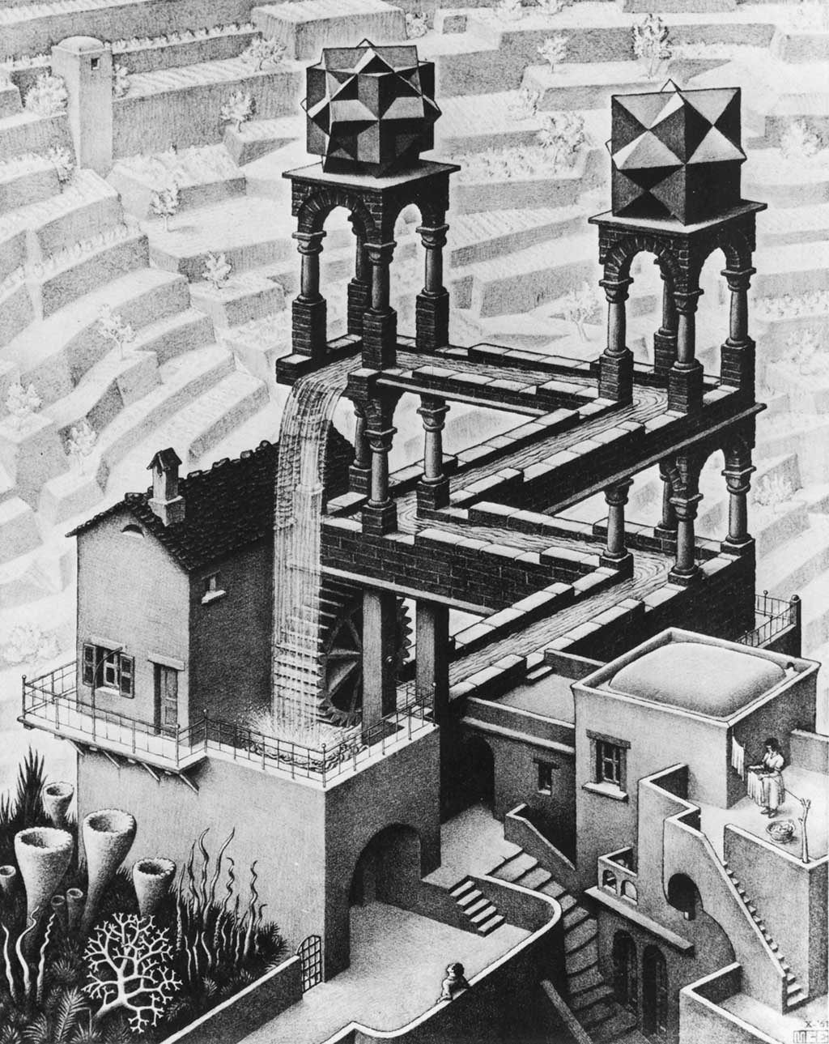
(Waterfall)

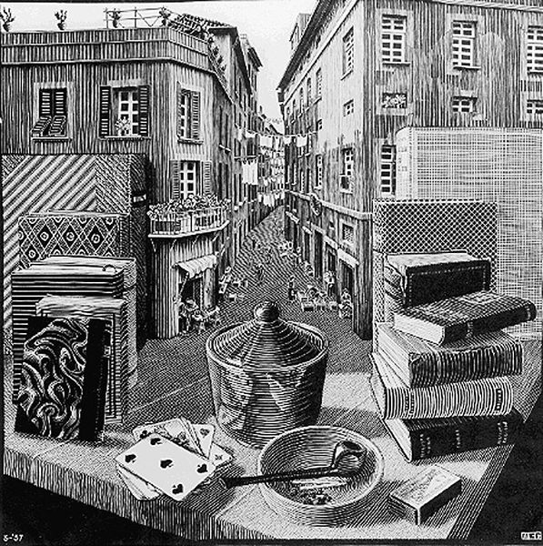
(Still Life and Street)
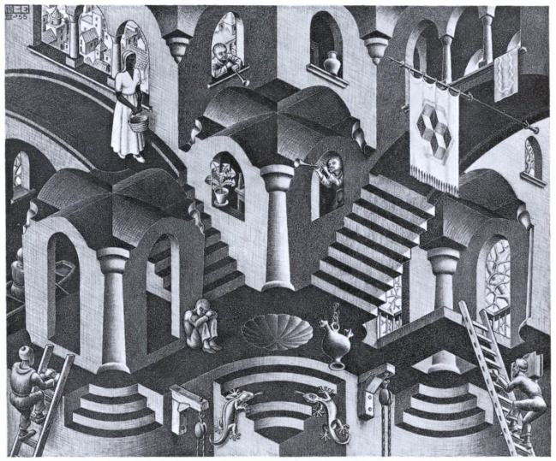
(Concave and Convex)
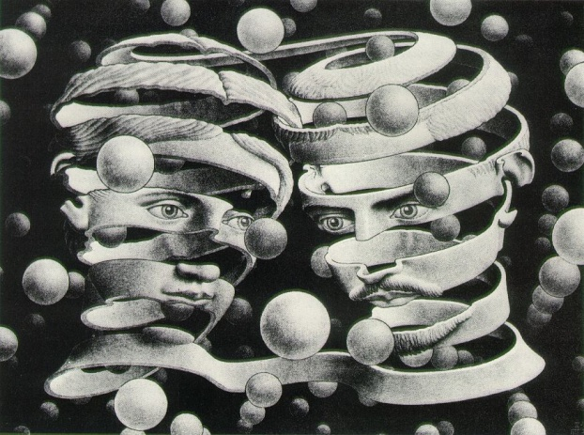
(Bond of Union)
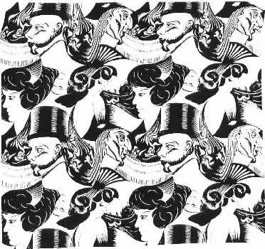
(8 Heads)
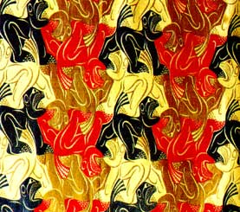
(Lions)
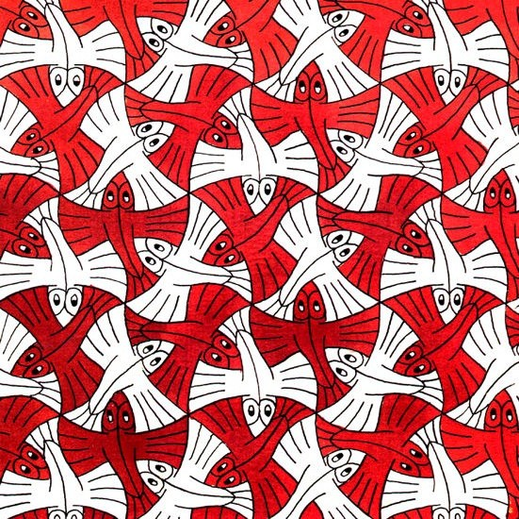
(Flying Fish)
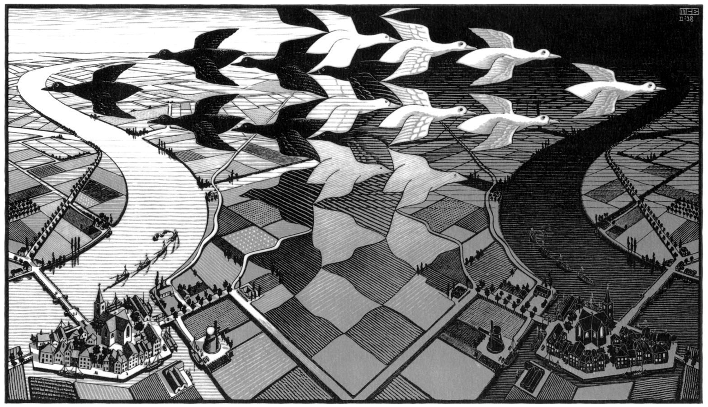
(Day and Night)
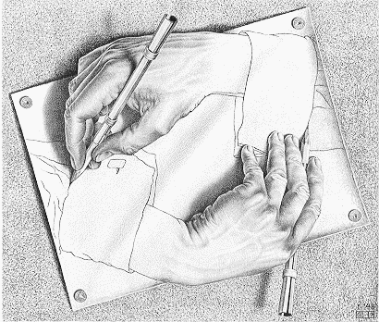
(Drawing Hands)
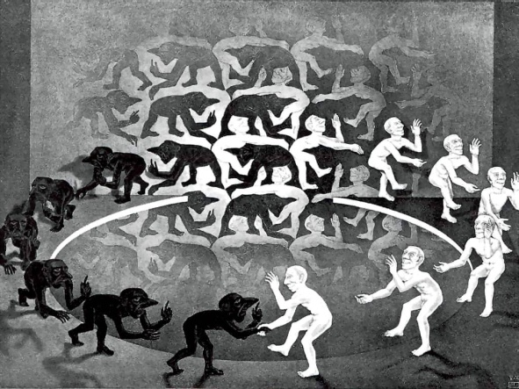
(Encounter)
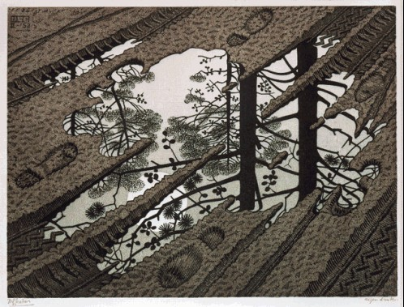
(Puddle)
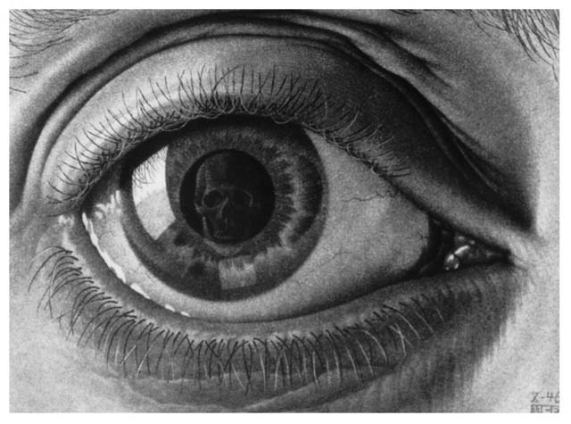
(Eye)

Bibliography
Ernst, Bruno. The Magic Mirror of M.C. Escher. England: Tarquin Publications, 1985. Print.
Coxeter, H.S.M., Emmer, M., Penrose, R., Teuber, M.L. M.C. Escher: Art and Science. Amsterdam: Elservier Science Publications, 1986. Print.
The Official M.C. Escher Website. Web. 07 Apr. 2011. <http://www.mcescher.com/>.
Annal, David. "Tessellations and M.C. Escher." Tessellations - Escher and How to Make Your Own. 30 Oct. 2003. Web. 07 Apr. 2011. <http://www.tessellations.org/index.htm>.
Parker, Allene. “Drawing Borges: A Two Part Invention on the Labyrinths of Jorge Louis Borges and M.C. Escher”. Rocky Mountain Review of Language and Literature Vol. 55, No. 2 (2001), pp. 11-23. JSTOR. EBSCO. Web. 6 Apr. 2011
Senechal, Majorie. “Parallel Worlds: Escher and Mathematics Revisited.” Mathematical Intelligencer 21.1 (1999): 13. Academic Search Premier. EBSCO. Web. 7 Apr. 2011.
Pumfrey, Elizabeth, and Toni Beardon. “Art and Mathematics- Mutual Enrichment.” Micromath 18.2 (2002): 21. Academic Search Premier. EBSCO. Web. 7 Apr. 2011

_{M.C. Escher: Art and Science}
M.C. Escher Official Website Biography tab
2 M.C. Escher Official Website Biography tab
Coxeter, H.S.M., Emmer, M., Penrose, R., Teuber, M.L. M.C. Escher: Art and Science. Amsterdam: Elservier Science Publications, 1986. Print, 96.
Coxeter, Emmer, Penrose, Teuber, 27.
Ernst, Bruno. The Magic Mirror of M.C. Escher. England: Tarquin Publications, 1985. Print, 90.
Bruno, 35.
Bruno, 73.
Coxeter, Emmer, Penrose, Teuber, 25.
Coxeter, Emmer, Penrose, Teuber, 23.
Coxeter, Emmer, Penrose, Teuber, 54.
Coxeter, Emmer, Penrose, Teuber, 39.
Parker, Allene. “Drawing Borges: A Two Part Invention on the Labyrinths of Jorge Louis Borges and M.C. Escher”. Rocky Mountain Review of Language and Literature Vol. 55, No. 2 (2001), JSTOR. EBSCO. Web. 6 Apr. 2011 pg. 11
Parker, pg. 13
Parker, pg. 15
Parker, pg. 15
Parker, pg. 14
Parker, pg. 17
Parker, pg. 17
Parker, pg 16
Parker, pg. 20

