IMI Zebra Zero

HCTL-PA

Integrated Motion Inc. (1997)

750 Series Inline resistor packs (type 1, both and 8-pin and 10-pin versions):

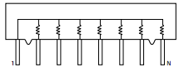

UMNL Universal Mate-N-Lok 5-pin power connector:  
<http://www.jameco.com/webapp/wcs/stores/servlet/Product_10001_10001_496536_-1>

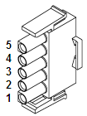 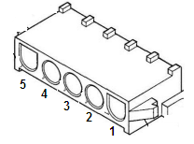

40-position and 10-position shrouded header for IDC Ribbon cable connector socket:

<https://www.jameco.com/webapp/wcs/stores/servlet/Product_10001_10001_1576327_-1>

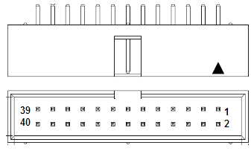

EAC SD 1A05A Relay: Hex Inverter (High Voltage)

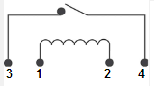 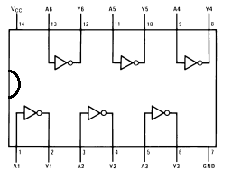

Quad AND: Octal inverted Tri-state Line Driver:

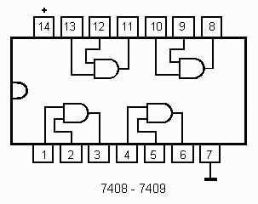 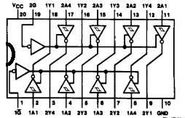

7805CT Linear Voltage Regulator +5v output 1.5A max: (typical application)

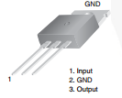 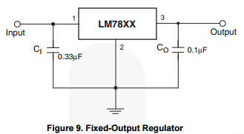

TIP 125 PNP Darlington Power Transistor:

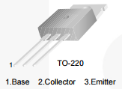 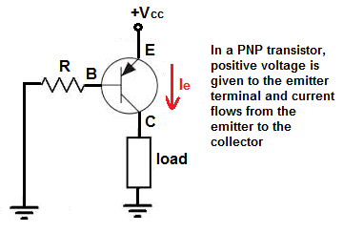

TIP 120 NPN Darlington Power Transistor:

 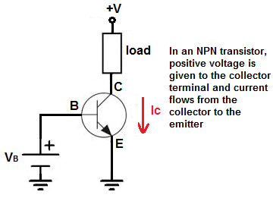

**HEDS 5500 Optical Quadrature Encoder**

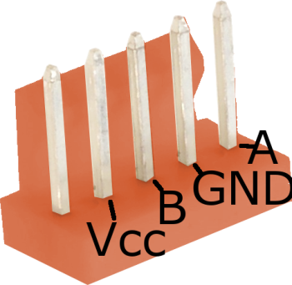

**DE0 Expansion Header Pinout: ~~Rainbow Ribbon Cable~~ Zebra Control Header Pinout**

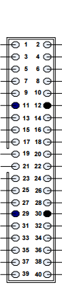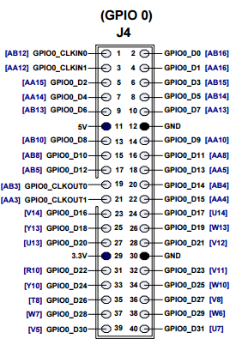

Encoders

Ground

**relay?**

**(hack:3.3v in)**

**v4  
d4**

**v5**

**d5**

**v6**

**d6**

**v7**

**d7**

Encoders

**A4**

**B4**

**NC4**

**A5**

**B5**

**A6**

**B6**

**NC6**

**A7**

**B7**

**Gnd4**

**Vcc4**

**NC5**

**Gnd5**

**Vcc5**

**Gnd6**

**Vcc6**

**NC7**

**Gnc7**

**Vcc7**

**1**

**3**

**5**

**7**

**9**

**11**

**13**

**15**

**17**

**19**

**21**

**23**

**25**

**27**

**29**

**31**

**33**

**35**

**37**

**39**

**1**

**3**

**5**

**7**

**9**

**11**

**13**

**15**

**17**

**19**

**21**

**23**

**25**

**27**

**29**

**31**

**33**

**35**

**37**

**39**

**DE0-Nano Expansion Header Pinout:**



**DE0 Nano / Zebra Adapter Board**

DE0 NANO GPIO0

n/c b0 b1 b2 b3 +3v b4 b5 b6 b7 d0 d1 d2 d3 +5v d4 d5 d6 n/c n/c

39 37 35 33 31 29 27 25 23 21 19 17 15 13 11 9 7 5 3 1

40 38 36 34 32 30 28 26 24 22 20 18 16 14 12 10 8 6 4 2

n/c a0 a1 a2 a3 gnd a4 a5 a6 a7 v0 v1 v2 v3 gnd v4 v5 v6 v7 d7

AXIS 4 - 7

d7 v7 d6 v6 d5 v5 d4 v4 +3v n/c b7 a7 n/c b6 a6 b5 a5 n/c b4 a4

39 37 35 33 31 29 27 25 23 21 19 17 15 13 11 9 7 5 3 1

40 38 36 34 32 30 28 26 24 22 20 18 16 14 12 10 8 6 4 2

gnd gnd gnd gnd gnd gnd gnd gnd gnd gnd +3v gnd n/c +3v gnd +3v gnd n/c +3v gnd

AXIS 0 - 3

d3 v3 d2 v2 d1 v1 d0 v0 +3v n/c b3 a3 n/c b2 a2 b1 a1 n/c b0 a0

39 37 35 33 31 29 27 25 23 21 19 17 15 13 11 9 7 5 3 1

40 38 36 34 32 30 28 26 24 22 20 18 16 14 12 10 8 6 4 2

gnd gnd gnd gnd gnd gnd gnd gnd gnd gnd +3v gnd n/c +3v gnd +3v gnd n/c +3v gnd

**15-pin Joystick Connectors**

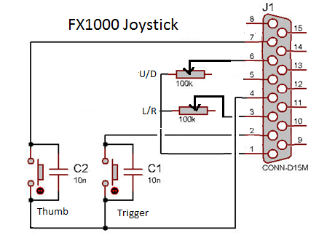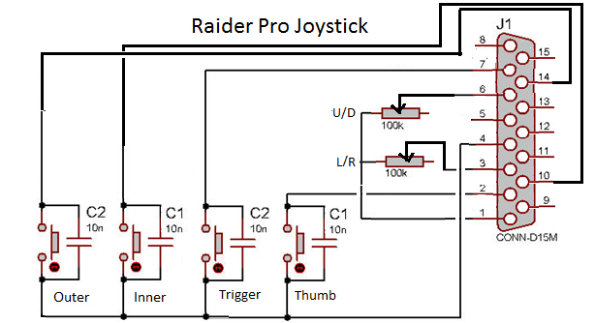

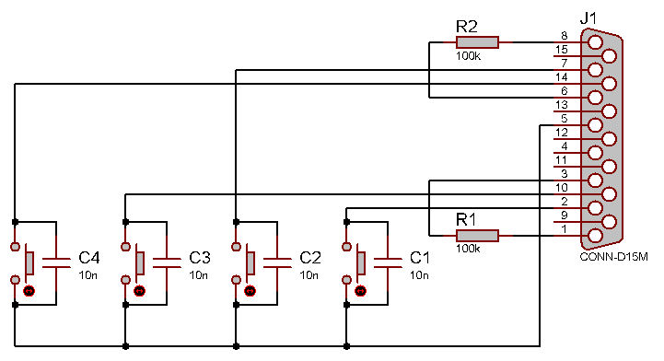 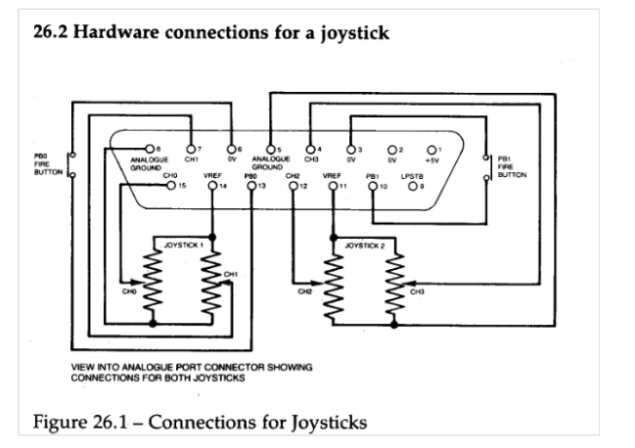

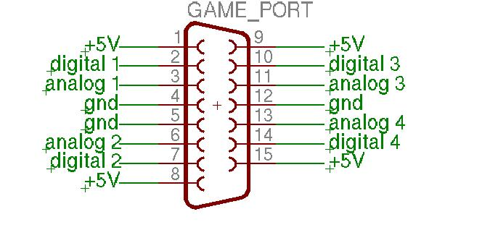

**DE0 Nano 13x2 Expansion Header: DE0 Nano 40-pin Expansion Headers:**

