MATH 136-03, Spring 2019

Computer Lab #1
Fun with Solids of Revolution

DUE DATE: Friday, March 15th, start of class.

In this lab, you will investigate solids of revolution and the relationship between their volume and surface area. You will utilize the software Maple to draw various 3D graphs obtained by revolving a function about the x-axis. Then, using some integration commands in Maple, you will compare the volume V and surface area S of a given solid seeking to discover a well-known lower bound for the quantity S^{3/2}/V.

It is required that you work in a group of two or three people. Any help you receive from a source other than your lab partner(s) should be acknowledged in your report. For example, a textbook, web site, another student, etc. should all be appropriately referenced. Please turn in one report per group, listing the names of the members of the group at the top of the page. For this lab, you do not need to type in your answers and can simply fill in the blanks provided. Be sure to answer all questions carefully and neatly. There are four graphs to be turned in for this report.

Begin by loading the package plots using the command with(plots): Placing a colon (instead of a semi-colon) after a command in Maple suppresses the output.
Now, define your first function $f(x) = sin x$ by typing
f := x → sin(x):
Running the command

tubeplot([x,0,0,x=0..Pi],labels=[x,y,z],radius=f(x),axes=boxed);

will draw the solid obtained from revolving f(x) around the x-axis from 0 to π. Click on the solid obtained and drag the mouse to rotate the solid in different directions. This can be very useful for visualizing the 3D graph. Try changing the range to 0 to 2π. What solid is obtained? Why? Play around with the x-range (the x=0..Pi option) to obtain different solids.

Now go back up to where you defined f(x) and change it to f(x) = $\sqrt{x}$ using the sqrt(x) command or the Expression template on the left. Replace Pi with 2 in your tubeplot command, and re-execute the command. Notice in what direction the 3D picture is oriented. Play around with orientation by clicking on the graph and dragging the mouse. Note that this solid is open at one end while the previous one was closed at both ends. Why does this happen?

We can think of solids of revolution as using a certain amount of surface area to enclose a certain amount of volume. This leads to the natural question, “What is the maximum volume V possible using the minimum amount of surface area S?” Which function over what interval will achieve this? Alternatively, we could ask, for a given volume of 1 unit, what solid will have the least possible surface area? This is similar to the classical calculus problem: What are the dimensions of the fence that encloses the most area with the least amount of fence?

We can start to answer this question by studying the ratio $S^{3/2}/V$ . It turns out that, no matter what solid you study, this ratio is bounded below by a certain value. Your job is to FIND THAT VALUE (the smallest possible value) and to investigate this fact using several examples.

NOTE: The reason for the 3/2 power is because volume is measured in terms of some dimension, say r, cubed (think of a cube or a sphere), whereas surface area is measured in terms of r² (think of a square or a circle). Thus, if we divide S raised to the 3/2 by V, we will get $(r^{2})$^{3/2} divided by $r^{3}$so that the r's cancel out. (This concept is known as geometric similarity and $S^{3/2}/V$ is a dimensionless quantity.) The resulting constant is a way of comparing the volume and surface area for a particular solid, neglecting the actual size of the solid.

Lab Exercises:

1.) Fill in the following table: (give your answers to seven decimal places)

$$f(x)$$ | $$[a,b]$$ | $$S$$ | $$V$$ | $$S^{3/2}/V$$
$$\sqrt{x}$$ | $$[0,2]$$
$$\sin{x}$$ | $$[0,π]$$
$$x^{2}(1-x^{2})$$ | $$[0,1]$$

Pick three additional, different functions and intervals and fill in the table for them. Remember, your ultimate goal is to find the smallest possible value of $S^{3/2}/V$ so be smart about what functions and intervals you choose. Don’t just do this arbitrarily.

2.) Include a print out of the tubeplot command for the first three functions in the list above. Attach your plots to the end of this lab.

3.) Based on your experimentation above, what is the smallest possible value of $S^{3/2}/V$ ? Give the EXACT value of this minimum (no decimals) and show how you obtained it. What shape gives this minimum ratio? An actual proof of this fact is nontrivial and involves a subject called differential geometry (combining calculus and geometry!)

Hints for completing the table:

a.) Define your function $f(x)$ first. To change from one function to another, just execute (hit return) the command defining your new function and then run the commands with $f(x)$ in them.

b.) Define two dummy variables a and b: a:=0: and b:=4: (for example).

c.) Execute your tubeplot command with x=a..b instead of typing in new numbers.

d.) Use the evalf(int(...)); command to find the volumes (as decimals) using Maple. Note that you can choose the integral sign from the Expression template to help set up the integral. The evalf(stuff) command will give a numerical value of whatever is inside the parentheses.

To find S use the command:

s:=evalf(int(2*Pi*abs(f(x))*sqrt(1+diff(f(x),x)^2),x=a..b)+Pi*f(a)^2+Pi*f(b)^2);

Make sure $a$, $b$ and $f(x)$ are defined correctly before you use this command! A similar but simpler command can be used to find the volume V.

e.) You can then use the command s^(3/2)/v; in Maple to find the ratio.

f.) With everything defined in this order, it makes it easier to change between functions. Just type in your new function, hit enter, then do the same for a and b. Then re-execute the rest of your commands for new graphs and new values of V and S, etc. This way you only need to change a and b once instead of in every formula.

Note: Why is the command line for S so complicated? In order to find the total surface area of the solid, we need to find the surface area of the “side” surface given by
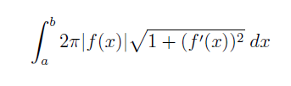
and the surface areas of the end discs if they exist. For instance, $sin(x)$ over $[0,π]$ doesn’t have any end disks since it touches the x-axis at both endpoints, but the square root of x plot has the large circular disk at the end because the function is still above the x-axis when we cut it off, and if we slice a solid of revolution, we get circles. The surface areas of the end disks are just surface areas of a circle with radius equal to the height of the function at that point$, f(a)$ or $f(b).$ So, the area is $π(f(a))$² and $π(f(b))$² for any end disks that may exist. The formula in the integral above is of the form $2πr$ * arc length (note that absolute value is required to obtain a positive radius). In other words, we can find the surface area by integrating the product of the circumference of revolution over the distance traveled by the function, its arc length.

4.) Find the function that generated the solids in each of the figures on the next page. Give the function $f(x)$ and the interval along the $x$-axis that is used to generate each solid of revolution (four total) when rotated about the $x$-axis. You may have to play with the range along the $x$-axis and with the orientation of the solid to figure these out. The functions used to generate each figure are standard mathematical functions you know. Pay attention to the range on the x-axis and think about the role that the roots of $f(x)$ play.

5.) Design your own fun and artistic solid of revolution! Pick a function and an interval and create your own special solid of revolution. Points awarded for creativity and imagination. Print out a plot of your special solid (in color would be good) and give it a name, along with the function and interval used to create it. We will vote as a class for the most innovative and artistic solid. The winner may even receive a 3D replica of their solid generated by a 3D printer!!
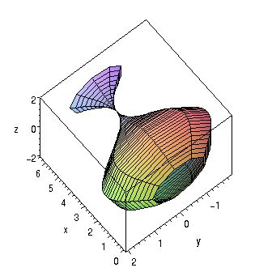
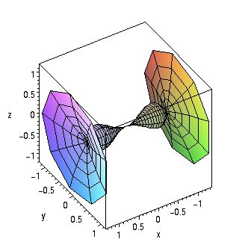
a.) Genie Bottle b.) Tie-fighter

f(x) = _______________ Interval: ________ f(x) = _____________ Interval: _________

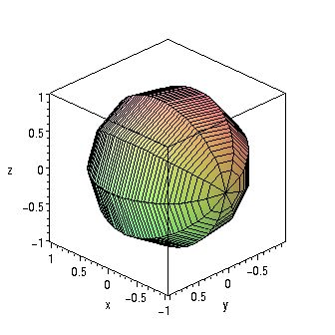
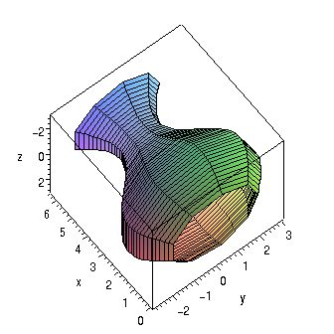

c). Sphere d.) Open Vase

f(x) = _______________ Interval: _______ f(x) = _____________ Interval: ________

