Game Theory Final Exam

Due Saturday, May 15 by 12:00 noon.
Same ground rules as the midterm – consult only me, quote sources.

Office hours May 3 – May 14:

Wed. May 5 10:30-12
Fri. May 7 10:30 – 12
Mon. May 10 2 – 4
Thurs. May 13 2 - 4
or by appointment.
Midterm and problem set 5 can be picked up Friday.

Gambit Exam Questions:

To show that Gambit was used to solve the given problems, use a screen shot for both the extensive form and normal form games. A screen shot can be done by selecting the desired window for the screen shot and clicking ALT + PRINT SCREEN. Then, Paste the screen shot in Microsoft Word. You can crop the screen shot after you paste it, to save paper.

1.) Magic Square Games. A magic square is an n x n array of the first n integers with the property that all row and column sums are equal. Solve the given 4 x 4 Magic Square Matrix using Gambit.

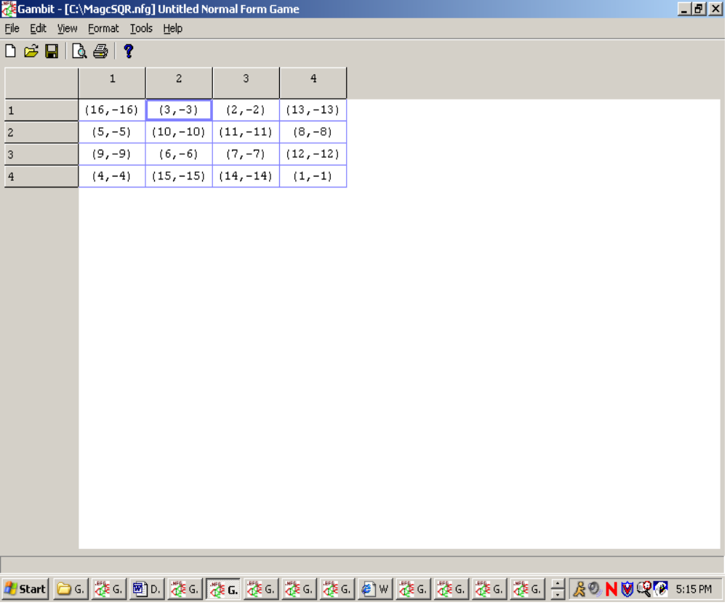

2.) Solve the Silver Dollar Game from Class. Player II hides a shiny new Sacagawea in one of two rooms. Player I then searches for the coin. If Player I searches room 1, then he has a probability of ½ of finding the coin. If player I searches room 2,
he has probability of 1/3 of finding the coin. If Player I finds the silver dollar than Player II pays Player I a $1. If Player I does not find the coin, then the payoff is $0 for both players. Using Gambit, diagram the game in extensive form, convert it to normal form and solve. Solution should include both Tree and Matrix.

Surreal Numbers Exam Questions:

3.)
Find the value of this game using the properties of Hackenbush trees.

4.) Draw a Red-Blue Hackenbush game that has a value of ω + ¼ with an advantage of blue.

Voting Theory I Exam Questions:

5.) All-Time Baseball Award Rankings

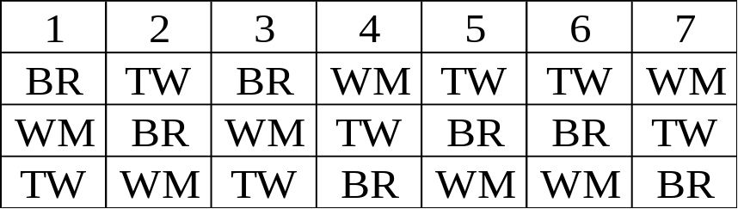

Willie Mays = WM
Babe Ruth = BR
Ted Williams =TW

(a) Draw the geometric interpretation of the voting results (an equilateral triangle).
(b) Find who wins under the plurality method.
(c) Who wins in the Borda count voting method with 5-3-1 point scale?
(d) Is there a Condorcet winner?

6.) Borda Count Manipulation

Suppose that voters 1 through 4 are being asked to consider three different candidates—A, B, and C—in a Borda count election. Their preferences are:

1 | 2 | 3 | 4
A | A | B | C
B | B | C | B
C | C | A | A

(a) Find a Borda weighting system—a number of points to be allotted to first, second, and third preferences—in which candidate A wins.
(b) Find a Borda weighting system in which candidate B wins.

Voting theory II Exam Questions:

7.) Using the profile p = (2,6,0,5,0,7) with labeling as on the handout (e.g., p₁ is“A > B > C”), compute for the Borda count (1,s,0) the tallies for s = 0 and s = 1.Where in the triangle do these points lie? What does the geometry of the procedureline say about other possible positional outcomes?

8.) Suppose the profile in question 7 changes to p = (2,6,0,5,4,3). Compute the s = 0, s = ½ and s = 1 tallies. Where in the triangle do these three tallies lie? What does the geometry of the procedure line say about other possible positional outcomes?

Auctions Exam Questions:

9.) Consider a second-price sealed-bid objective-value auction with only two
bidders, I and II. Suppose the seller only accepts bids of $25, $50, and $75. Bidder I
values the item at $50 and knows that bidder II values it at either $50 or $75 with
equal probability. Show that, regardless of II’s valuation, I’s dominant strategy for the auction is to bid his true valuation.

10.) Explain how both the winner’s curse and Vickrey’s Truth Serum are reflected in your answer to problem 9.

