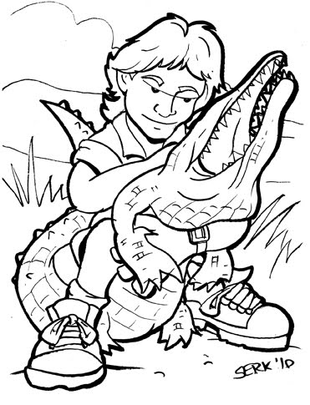
Name: ___________________________________________________ Period: _______ Date: _________________________________

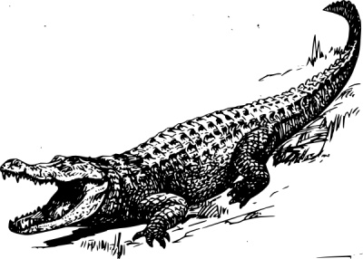
CRIKEY CROCODILE
CALAMITY

Do you remember the “Crocodile Hunter,” Steve Irwin? He was the guy on Animal Planet, with the Australian accent, that would wrestle with huge crocodiles in swamps! Well, before he passed away, God rest his soul, he showed me how to play this game…

Steve was always one for excitement! He loved to get the blood pumping. So, one day, while on a trip in Australia, I visited him at the Zoo in Queensland. I was looking for some excitement, and who would come to Australia without visiting the zoo of the “Crocodile Hunter”? But nothing could prepare me for what Steve had in store. As I entered the zoo, Steve welcomed me with open arms, “Welcome, welcome,” he said in his accent. “Right this way. I have set-up a little game for us to play. I am interested to pick your mathematical brain.”

I was syked! Anything to do with math I love, hence I knew I was ready for him. As we walked to the crocodile exhibit, he led me behind the scenes. All I could think was, how cool is this…seeing a crocodile up-close and personal ? Then came his explanation of what was about to GO DOWN!!!

Game Instructions:

- A crocodile awaits with 21 sticks affixing its mouth open.
- Only two players can play the game.
- Someone is chosen to go first.
- Sticks can be removed in increments of one (1) or two (2) each turn.
- The person to draw the last stick loses…0_0

What was I to do??? I could not back down from this challenge. Not only was this a test of character, but most importantly, my math skills. But who could think of math with their hand in the mouth of a ten foot crocodile? Was there a way to guarantee that I would win? Clearly Steve knew what he was doing, but I was at a complete loss. Yet, FEARLESS and HOPEFUL that Steve would not let anything happen to me, I took the challenge!!!
Activity:

Question: Is it possible to formulate a strategy that will ensure that you will ALWAYS win
this game?

Predictions: (Done individually)

- What do you think happened to Ms. Hernandez and why?
- Do you think it is possible to formulate a winning strategy that ensures victory or not?
- What do you think the strategy will entail and why? (1-3 sentences)

Trial Runs: (Done in pairs/partners)

Play three (3) – four (4) games with your opponent and record your moves below. Follow the rules detailed on the front page. The person to go first is player A.

Name of Player A: ________________ Name of Player A: ________________ Name of Player A: ________________

Name of Player B: ________________ Name of Player B: ________________ Name of Player B: ________________

GAME ONE (1) GAME TWO (2) GAME THREE (3)
Move  # | Player A  Picked | Player B  Picked | Move  # | Player A  Picked | Player B  Picked | Move  # | Player A  Picked | Player B  Picked
1 |  |  | 1 |  |  | 1
2 |  |  | 2 |  |  | 2
3 |  |  | 3 |  |  | 3
4 |  |  | 4 |  |  | 4
5 |  |  | 5 |  |  | 5
6 |  |  | 6 |  |  | 6
7 |  |  | 7 |  |  | 7
8 |  |  | 8 |  |  | 8
9 |  |  | 9 |  |  | 9
10 |  |  | 10 |  |  | 10

- Did you notice anything as you played? Describe your findings

- What happened when you went first versus your opponent? Does going first matter?

- What do you need to know or explore further to start formulating your solution?

Further Investigation: (assume that you will be the next to pick in the table below)

# Sticks Left | If you choose one, what will happen? | If you choose two, what will happen? | Notes
1
2
3
4
5
6
7

- What do you notice?

- Can you predict what will happen if there were 8 or 9 sticks left?

- How can you use this information to help you with your solution?

Solution/Answer: (Done individually)

Write-up your answer to the question posed to you at the beginning of this activity. You will write as much as you can (no less than a 6-8 sentence paragraph, but no more than a page) to explain what your winning strategy is. REMEMBER, this is a SERIOUS situation, thus use all the information gathered to help you. Your HAND depends on the accuracy of your strategy. There is VERY LITTLE room for error. Thus, your argument must be convincing!

Extra Credit:

Play this game with someone else (outside of the classroom) at least twice. Record what happened to show that you won both times. Illustrate one of the games in a drawing.

Extension(s):

- Write about how your strategy would change if you could only pick two (2) or three (3) sticks each turn.
- Write about how your strategy might change if three (2) people could play the original game.
Cherisa Hernandez South High Community School
ITQ Workshop
College of the Holy Cross
Summer 2012
Geometry Grade 10
Logic/Proof Writing College & Honors Level

Objectives: SWAB…
- Explain in writing, their strategy for winning the game.
- Organize thoughts logically to build a sound argument.
- Find patterns to help them predict future moves.
- Apply some rules of logic and proof writing to develop their strategy.

Rationale:
My goal here is to introduce the concept of logic and proof writing in a fun way that will grab and hold on to the students’ attentions. Although, there is no specific framework in the geometry curriculum that explicitly states this skill, it is a very important one that is used EVERYDAY in all mathematics classrooms world-wide. The skills that will be learned during this lesson are important for students to have. This activity shows that something as simple as a game can be modeled using math, which in-turn can help in making an important decision that can be validated with proof. Proving a statement to be true is done all throughout geometry. Furthermore, learning the skills to do this becomes even more important in college. My hope is that this introduction will get students familiarized and more comfortable with the concepts of logic and proof-writing. The skills learned here will also be used n future units when speaking about transversals, congruence of angles, congruence of triangles, etc.

Frameworks: MA-Common Core
- G-MG. → Apply geometric concepts in modeling situations.
- G-CO. → Prove geometric theorems.

Accommodations:
- Handouts for all students
- Projection of Material on the board
- Read everything aloud
- Scaffolding questions
- Define unknown words (Word wall)

Materials: All handouts, extra lined paper for additional work, sticks, E.L.M.O., and chalk board.

ACTIVITIES (Time): | STUDENT is doing: | TEACHER is doing (Teacher Notes):
Bell-ringer, BR  (5-10mins) | Enter and begin the bell-ringer on the board. Offer answers to the questions that were put on the board. | Writes bell-ringer on the board. Walks around to check last night’s HW and take attendance. Answers any questions about the HW and or BR. (Most likely there would not have been any HW since this activity will be the beginning of a new topic/unit). When students are finished, the class will talk about the questions.
Reading of the problem  (10 mins) | Volunteer to read passages from the first page. Ask clarifying questions about the story, vocabulary, or anything else important to understanding the story. | Facilitate the reading of the passage. Answer all important clarifying questions. Then lead students into the activity that follows.
Prediction  (5 mins) | Write answers to the questions in predictions part. Individually | Walking around making sure that everyone is writing something for each question.
Trial Run  (15-20 mins) | Pick opponent/partner and begins data collection. | Walking around making sure that students are completing the task correctly. Answering questions and clarifying instructions.
Wrap-up/Exit Slip  (5 mins) | Answer the questions in the Trial Run section. Students will show this upon exiting the classroom. | Walking around making sure that everyone is writing something for each question. Explaining what the HW is for the following day. (HW would already be written on the HW Board).

Homework: Further Investigation.

Assessment(s): The final product of the written solution.

Reflection/Refinement(s):

